Woodrow First School



RELATIONSHIPS AND SEX EDUCATION POLICY

This policy was produced by the PSHE leads at Woodrow First School in consultation with the Head teacher, parents and governors.

September 2020
(To be reviewed September 2021)

Relationships Education Principles
To embrace the challenge of creating a happy and successful adult life, pupils need knowledge that will enable them to make informed decisions about their wellbeing, health and relationships and to build their self-confidence and belief. Everyone faces difficult situations in their lives, these subjects can support young people to develop resilience, to know how and when to ask for help, and to know where to access support.
The focus in First school should be on teaching the fundamental building blocks and characteristics of positive relationships, with particular reference to friendships, family relationships and relationships with other peers and adults. This starts with pupils being taught about what a relationship is, what friendship is, what family means and who the people are who can support them.

Woodrow First School considers that Relationships and Sex Education (RSE) is an integral part of the Personal, Social and Health Education (PSHE) curriculum and is also linked to the science curriculum. We aim to offer pupils a carefully planned programme within a safe, comfortable atmosphere and in a relaxed relationship between teacher and pupil. The programme is set within a moral framework and matched to pupil’s levels of maturity. This policy reflects the requirements of the DCSF Sex and relationships Guidance.
We also teach RSE through other subject areas such as science, P.E and R.E. In R.E children reflect on family relationships, different family groups and friendship. They learn about rituals and traditions associated with different religions and talk about the emotions involved.
Since RSE incorporates the development of self-esteem and relationships, pupils learning does not just take place through the taught curriculum but through all aspects of school life including the playground. It is important then that all staff understand that they have a responsibility to implement this policy and promote the aims of the school at any time they are dealing with children.

Rationale and Ethos
Our school is committed to safeguarding and promoting the welfare of children and young people and expects all staff and volunteers to share this commitment.

Our Vision and Aims
Our vision is to be a place of great love and great learning where everyone thrives on encouragement and support.
We aim to be a vibrant school where expectations are high, Individuality, creativity and independence are fostered and everyone learns in a happy, safe and supportive environment.
As part of this vision we aim to deliver a high-quality Personal, Social, Health and Economic (PSHE) curriculum in which we deliver accurate, relevant and age appropriate information about relationships- one of the core strands of PSHE. This will ensure that our children may achieve their full potential and leave our school prepared for the demands of society in their future.
We aim to teach children about relationships in an engaging, meaningful and age-appropriate manner through a carefully considered spiral curriculum which takes into account the emotional. Physical and social maturity of our children. The relationships strand of our PSHE curriculum has been carefully considered and is constantly being reviewed so that it is inclusive and meets the needs of each and every one of our children, including those with special educational needs or disabilities.
Teachers make Relationships Education lessons engaging, interesting and fun through a variety of teaching methods and resources, including role-play, group work, discussions, and use of appropriate film clips, books and websites.

Roles and Responsibilities.
The Role of the School and Other Members of the Community The school liaises with external agencies regarding the school RSE programme, and ensures that all adults who work with children on these issues are aware of the school policy, and that they work within this framework. We encourage other valued members of the community to work with us to provide advice and support to the children with regard to health education. In particular, members of the Local Health Authority, such as the school nurse and other health professionals, give us valuable support with our sex education programme. Health professionals are expected to work within the school’s RSE policy and on the instructions of the Head Teacher.

The Role of Parents

The school is well aware that the primary role in children’s RSE lies with parents and carers. We wish to build a positive and supporting relationship with the parents of children at our school through mutual understanding, trust and co-operation. In promoting this objective we:

• Inform parents about the school’s RSE policy and practice

• Answer any questions that parents may have about the RSE of the child.

• Take seriously any issue that parents raise with teachers or SIB members about this policy or the arrangements for RSE in the school.

Legislation

What is Relationships and Sex Education?
Relationships Education is a statutory component of the PSHE and Citizenship curriculum in Primary Schools from September 2020 which involves learning about the many strands of ‘relationships’ and ‘growing up’ including: family relationships; friendships and relationships with peers and adults; healthy and unhealthy relationships; staying safe; the characteristics of positive relationships; relationships online and the emotional, social and physical aspects of growing up.
At Woodrow First School we believe that relationships Education equips our children with the understanding, knowledge and skills they will need to succeed and thrive. Teaching about relationships enables our pupils to safely negotiate making new friendships, recognise potential threats to their wellbeing and develop meaningful relationships with others throughout their lives.

The importance of celebrating diversity within Relationships Education.
We strive to promote equality through all aspects of our Relationships teaching, as such our curriculum promotes tolerance and acceptance.
Just as encourage our children to celebrate their many different talents, strengths and aspirations we also aim to promote the celebration of diversity among cultures, traditions and religions. As an extension of this pupils are taught about diversity amongst family structures and relationships. ‘The Equality Act – 2010’; ‘The Marriage Act-2013’). This ensures that every one of our pupils has the chance to develop the self-esteem and confidence they deserve in order to grow into understanding, accepting and respectful adults. Ofsted also fully support the notion that children should be taught about different families and relationships that typify growing up in modern Britain. We use a variety of teaching materials and age appropriate resources to try to fulfil this.

Who delivers the Relationships Education Curriculum?
All Relationships Education lessons are taught by teachers who are trained in delivering the specific content of the lessons. Clear parameters will be established in class and special consideration will always be given when teaching particularly sensitive material. Staff will be fully aware of the children in their class and how they might respond and access appropriate material to support.

Curriculum Design
Relationship Education –Subject Content
‘Relationships’ Education becomes a statutory component of the PSHE and Citizenship curriculum in Primary Schools from September 2020.
Through Woodrow First School’s Relationships and Sex Education Provision we aim to ensure all pupils leave our school with:
• The knowledge and understanding of a variety of relationships;
• The ability to identify any concerns they have about a relationship;
• coping strategies and an awareness of how and where to seek support;
• An understanding of their rights and responsibilities within a range of relationships; • an awareness of the process of growing up and the changes they and others will experience;
• An understanding of the characteristics of positive relationships.

As part of the children’s statutory Science Curriculum in Year 2, children learn that animals, including humans, have offspring that grow into adults. They are also introduced to the concepts of reproduction and growth (but not how reproduction occurs). The Relationship strand of our PSHE Curriculum supports this learning. We are committed to ensuring that the children receive factually accurate biological information about their bodies. With this in mind, we begin to teach children some of the correct anatomical terminology for the parts of a human body in Key Stage 1.

Recent government guidance strongly suggests that ‘All children, including those who develop earlier than the average, need to know about puberty before they experience the onset of physical changes.’ We support this statement and believe that children are ready to receive honest, open and factual education about relationships and growing up. As part of the Relationships Curriculum, during Year 4 children will learn accurate information about puberty, their changing bodies and how to look after them. This is always done in a safe and secure environment with their class teacher.

Safe and Effective Practice
All classes make available a class ‘question box’ which gives children the option of writing down their questions and receiving an answer that is not provided in front of the whole class. Distancing techniques are employed so children are able to discuss fictional characters and scenarios, rather than discuss their own lives and experiences.

Safeguarding – Keeping Children Safe
At Woodrow First School, we aim to foster and maintain a safe environment within which all pupils feel able to ask questions and discuss issues openly (although no pupil or teacher will have to answer personal questions or forced to take part in discussions.) For any child wishing to discuss something confidential relating to content of the lesson, an opportunity will be given. In line with the school’s Policy for Safeguarding and Child Protection, Woodrow First School is committed to safeguarding and promoting the welfare (both physical and emotional) of every pupil both inside and outside of the school premises. We implement a whole-school preventative approach to managing safeguarding concerns, ensuring that the wellbeing of pupils is at the forefront of all action taken.
In addition, Woodrow First School staff have received training on the new statutory guidance; ‘Keeping Children Safe in Education,’ which came into force in September 2019 and which details fresh guidance for ‘Teaching online Safety in school’.
All Staff will exercise their professional judgement in order to keep their pupils safe. Ground rules are agreed within Relationships Education for each class. This ensures a safe environment for group discussion and exploring delicate topics. Information given, and the views expressed by the pupils, will be treated in confidence where possible. However, pupils will be informed that 100% confidentiality cannot be assured. If any child makes a disclosure of a safeguarding issue - as with all such instances - the teacher will inform the Designated Safeguarding Lead (DSL) in accordance with Woodrow First School’s policy on Safeguarding and Child Protection.

Engaging Stakeholders Relationship Education – Parent & Carer Partnerships
At Woodrow First School we believe clarity is essential and welcome any discussion with Parents and Carers which will inform conversations at home about ‘Relationships’. We endeavour to have a strong partnership with parents and carers and will always aim to be transparent and communicate what is being taught when. We believe that together we can address misconceptions they may have gained about these topics from the media or from their peers. Children are naturally curious about their bodies and other people. By answering questions and teaching them the correct scientific vocabulary, we can help them understand their bodies, their feelings and other people. Our collective aim must be to ensure that our children recognise potential threats to their wellbeing and develop meaningful relationships with others throughout their lives. If any parent or carer has any queries or concerns about the subject content or delivery of any aspect of Relationships Education, then they should ask to speak to the PSHE Lead or a senior member of staff who will be able to provide more specific information on curriculum and resources that are used to teach this strand of the PSHE Curriculum.

From September 2020, Relationships Education will be statutory for all children, in all primary schools. This mean that parents and carers cannot withdraw their child from these lessons.

Monitoring, reporting and evaluation.
Staff who deliver the Relationships Curriculum will critically reflect on their teaching and best practice can be shared at PSHE reviews, training sessions or staff meetings. The PSHE Leads will have regular informal meetings each term to monitor planning and children’s work to help her provide further relevant training opportunities. Comments on children’s learning and progress in Relationships Education as part of their learning in PSHE should be reported to parents and carers at parent consultations. Discussion takes place informally at parent consultation sessions and formally on their end of year school report in July.

Relationship Education – Where to find information
Our inclusive ‘Relationships Education’ curriculum supports the objectives set out by the PSHE Association which meet the statutory requirements for Key Stage 1 and 2 from September 2020. It forms a core part of our comprehensive ‘Personal, Social, Health and Economic (PSHE) & Citizenship Education curriculum. How Relationships Education fits into the wider PSHE & citizenship Scheme of Work can be viewed online on our school

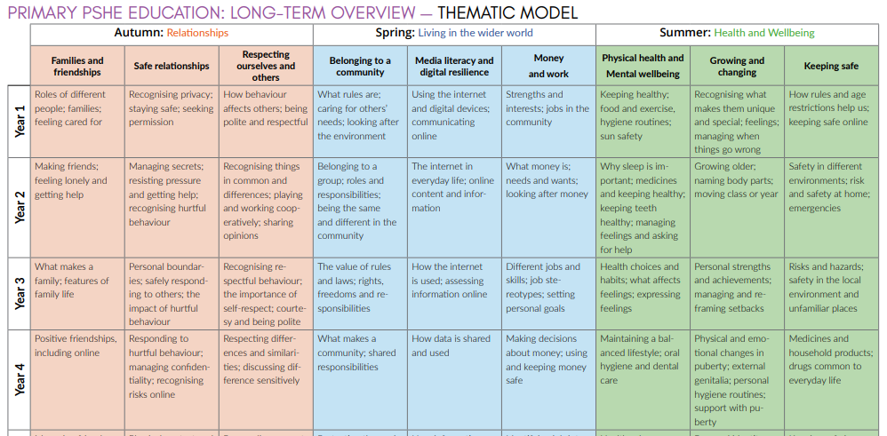

Appendix 2: By the end of First school pupils should know

TOPIC | PUPILS SHOULD KNOW
Families and people who care about me | - That families are important for children growing up because they can give love, security and stability  - The characteristics of healthy family life, commitment to each other, including in times of difficulty, protection and care for children and other family members, the importance of spending time together and sharing each other’s lives  - That others’ families, either in school or in the wider world, sometimes look different from their family, but that they should respect those differences and know that other children’s families are also characterised by love and care  - That stable, caring relationships, which may be of different types, are at the heart of happy families, and are important for children’s security as they grow up  - That marriage represents a formal and legally recognised commitment of two people to each other which is intended to be lifelong  - How to recognise if family relationships are making them feel unhappy or unsafe, and how to seek help or advice from others if needed
Caring friendships | - How important friendships are in making us feel happy and secure, and how people choose and make friends  - The characteristics of friendships, including mutual respect, truthfulness, trustworthiness, loyalty, kindness, generosity, trust, sharing interests and experiences and support with problems and difficulties  - That healthy friendships are positive and welcoming towards others, and do not make others feel lonely or excluded  - That most friendships have ups and downs, and that these can often be worked through so that the friendship is repaired or even strengthened, and that resorting to violence is never right  - How to recognise who to trust and who not to trust, how to judge when a friendship is making them feel unhappy or uncomfortable, managing conflict, how to manage these situations and how to seek help or advice from others, if needed

TOPIC | PUPILS SHOULD KNOW
Respectful relationships | - The importance of respecting others, even when they are very different from them (for example, physically, in character, personality or backgrounds), or make different choices or have different preferences or beliefs  - Practical steps they can take in a range of different contexts to improve or support respectful relationships • The conventions of courtesy and manners  - The importance of self-respect and how this links to their own happiness  - That in school and in wider society they can expect to be treated with respect by others, and that in turn they should show due respect to others, including those in positions of authority  - About different types of bullying (including cyberbullying), the impact of bullying, responsibilities of bystanders (primarily reporting bullying to an adult) and how to get help  - What a stereotype is, and how stereotypes can be unfair, negative or destructive  - The importance of permission-seeking and giving in relationships with friends, peers and adults
Online relationships | - That people sometimes behave differently online, including by pretending to be someone they are not  - That the same principles apply to online relationships as to face-to face relationships, including the importance of respect for others online including when we are anonymous  - The rules and principles for keeping safe online, how to recognise risks, harmful content and contact, and how to report them  - How to critically consider their online friendships and sources of information including awareness of the risks associated with people they have never met  - How information and data is shared and used online

TOPIC | PUPILS SHOULD KNOW
Being safe | - What sorts of boundaries are appropriate in friendships with peers and others (including in a digital context)  - About the concept of privacy and the implications of it for both children and adults; including that it is not always right to keep secrets if they relate to being safe  - That each person’s body belongs to them, and the differences between appropriate and inappropriate or unsafe physical, and other, contact  - How to respond safely and appropriately to adults they may encounter (in all contexts, including online) whom they do not know  - How to recognise and report feelings of being unsafe or feeling bad about any adult  - How to ask for advice or help for themselves or others, and to keep trying until they are heard  - How to report concerns or abuse, and the vocabulary and confidence needed to do so  - Where to get advice e.g. family, school and/or other sources

14

