Spring 1 2024
Health and well being
Healthy lifestyles
Mental health

Tuesday | Thursday
9.1 Different ways to keep healthy  https://www.youtube.com/watch?v=1gUbdNbu6ak | 11.1 sleep
16.1 Sleep | 18.1 Medicines
23.1 Hygiene | 25.1 vaccinations and immunisations
30.1 Teeth / dental care | 1.2 Teeth / dental care
6.2 Mental health  What is mental health? Watch the video. | 8.2 Mental health

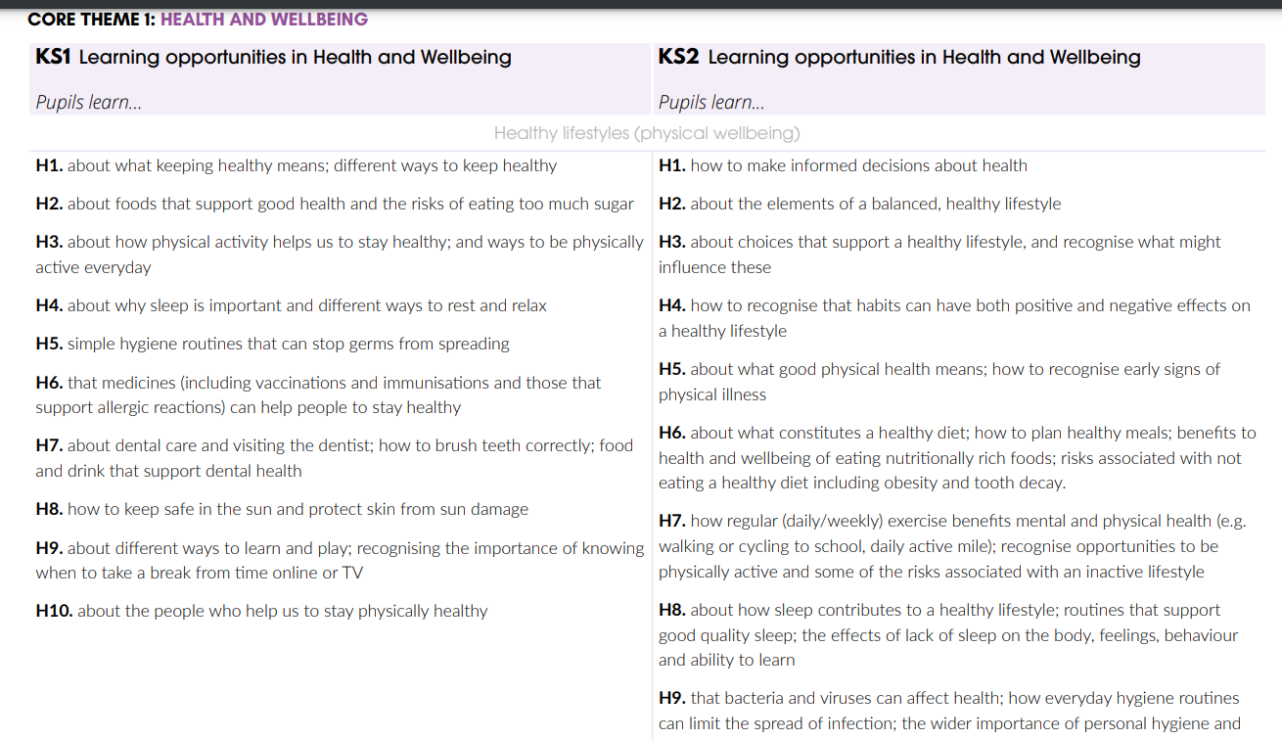
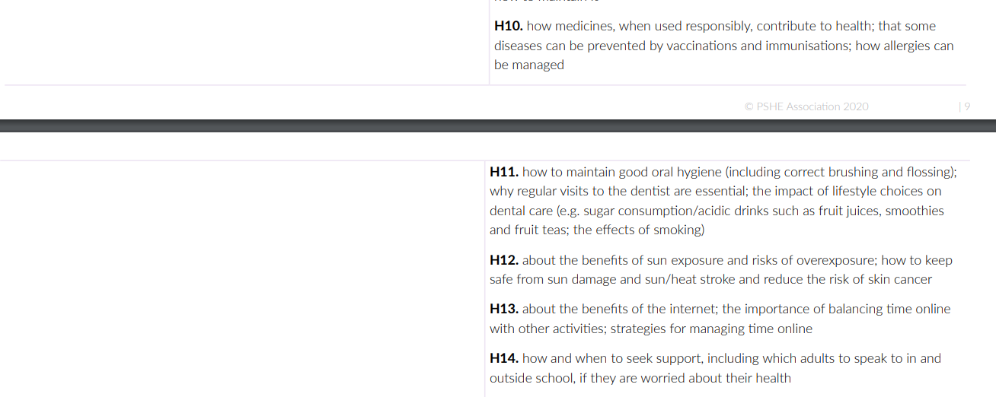
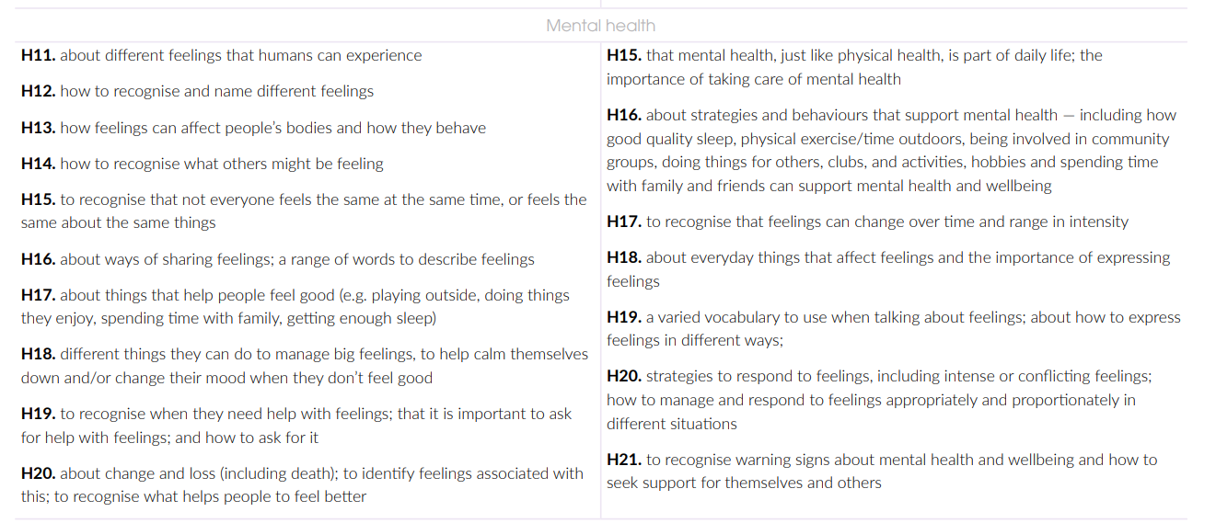

Spring 2 2024
Health and well being
Mental well being
Ourselves growing and changing
Keeping safe

Tuesday | Thursday
20.2 5 ways to wellbeing.  https://www.youtube.com/watch?v=yF7Ou43Vj6c | 22.2 Read Happy a children’s book of mindfulness.
27.2 introduce mindfulness activities and talk about how to try them through the week. | 29.2 read The Worry Tiger
5.3 Year 1 wellbeing  Discover that it is ok to make mistakes. Learn to count to 10 in Japanese. How does it feel to learn something new? https://video.link/w/vl6426c29a97898 | 7.3 Read The most magnificent thing.
12.3 Keep learning  https://www.bbc.co.uk/teach/class-clips-video/pshe-ks2-keep-learning/zdv2xyc | 14.3 Perseverance  Building blocks game  https://video.link/w/vl645391b203a62  What have you persevered with this week?  Perseverance jar- write down things that you have tried hard with this week.
19.3 https://video.link/w/xWYuoSqdSRk  Practice makes perfect- skipping | 21.3 Whistle for Willie  Not giving up when things are hard.



