Total amount carried over from 2019/20: £15,115
Total amount allocated for 2020/21: £ 18,260
How much (if any) do you intend to carry over from this total funding for 2020/21: £33,375
Total amount allocated for 2021/22: £18,200
Total amount of funding for 2021/22: £51,575.00 - To be spent and reported on by 31st July 2022: £37,817.17

In the Summer Term 2021 we took part in the Sports England active survey. We are using the findings from the report to influence our action plan for this academic year:

Successes:  - “At Woodrow First School, 77% of pupils do an average of 60+ minutes a day of moderate to vigorous activity across the week, (in school and out of school), meeting the Chief Medical Officer’s guidelines for levels of physical activity amongst children and young people.”  - WFS are above the national average, with national figures from 2019/20 showing only 43% of children and young people are meeting these requirements.  - 84% of children in Year 1-4 said they were happy at school. National figures for wellbeing from 2019/20 show this to be 75%; we are above these statistics. | Take away statements:  - 39% of children in Year 3 and 4 agreed strongly that they enjoyed taking part in exercise and sport  - 42% of children in Year 1 and 2 agreed strongly that they loved play sport, with 53% saying they enjoyed being active.  - There was a higher percentage of children reporting they take part in rugby in and out of school compared to football.
Next Steps:
We will continue to offer opportunities to be moderate to vigorously active for 60+ minutes across the school day. We need to focus on the enjoyment children are gaining from these opportunities.

We will achieve this by considering these questions:
- How could we get more pupils doing activity in school time throughout the week?
- How can we encourage more pupils to be active outside of school?
- Are there any particular groups of pupils who need to be more active?
- How do we involve pupils in choosing the activities on offer? Do we ask which they want more/less of?

Successes:  - 67% of our children were swimming in school when the report was conducted, compared to 16% nationally.  - WFS are above the national average, with national figures from 2019/20 showing only 43% of children and young people are meeting these requirements.  - 84% of children in Year 1-4 said they were happy at school. National figures for wellbeing from 2019/20 show this to be 75%; we are above these statistics. | Take away statements:  - 43% of our children reported that they went swimming out of school hours when the report was conducted, compared to 28% nationally.  - 48% of pupils reported they can swim 25m unaided, compared to 52% nationally.
Next Steps:
We offer termly, or half termly swimming, from Nursery to Year 4.
We will achieve this by considering these questions:
- What could the school do to support pupils to meet the National Curriculum swimming requirements?
- Are there any groups of pupils who need more support to meet the NC swimming requirements?

Physical Activity: To raise the profile of physical activity within school hours and the community

Future related costs: Play Leader training ( £100), stock replenishment ( £500)
Intentions | Implementation | Impact | Continued/Additional Intentions for Academic Year 2022-2023
PE & sport participation/attainment | Ensure these improvements are sustainable by… | Evidence of pupils’ PE and sport participation and attainment | Next steps
How could we get more pupils doing activity in school time throughout the week?

To encourage active play during break times and lunchtimes | Implement plans for enhancing PA for KS2 with Sports Stars. Their focus will be to encourage the use of the running track/gym equipment, with a focus on self- improvement and competition.  KS1 will focus on a multi-skill approach. | Measure by…  Observations/comments from the children when using the space and equipment.  The children really enjoy using the equipment and the track at play times and we have noticed an increased number of children are doing this independently after sessions with the coach at lunchtime.  Pupil Voice  “I love using the gym equipment, especially when the Cody (sports coach) gives us challenges.” Year 3 Pupil.  “I beat my lap time on the track – it used to be 3m43s but now it’s 3m10s!” Year 4 Pupil. | To train up 20 year 4 play leaders in September 2022.  Continue to promote the use of the gym equipment and track within class time and at play and lunch times – Set weekly challenges, class teachers to record lap times at the start of the year and monitor improvement. set challenges within year groups.
To encourage active play during break times and lunchtimes | Liaise with KS managers on playground stock. Not just sports equipment. Staff encouraged to consider den building/imaginary play for those ‘turned off’ by competition/traditional sports. Outdoor stage to be built in KS1 quad with pegs for hanging materials- a learning space for PA & imaginary thinking | Measure by…  Qualitative data from teaching staff (PA during playtime, behaviour, use in lesson times for Mantle etc) and children (enjoyment, imagination, creativity)  Due to supply issues we were unable to create an outdoor stage for KS1 this academic year. However a stage has now been incorporated in to the final plans of the outdoor classroom which will hopefully be complete Autumn 2022.  All classes within the school have a box of their own equipment which they take out with them at playtimes which has worked really well this year.  Class teachers Views  “The children love the tyres and find so many different ways to use them!” Year 1 Class Teacher.  “Adding the hanging cloths to the den building area has been a real success... the children would happily play for hours in there!” Year 2 Class Teacher.  “I think each class having their own playground equipment has worked really well this year, it is great to see them making up different games to play with it all.” Year 4 Class Teacher.  Student Voice  “I love using the playtime equipment… we make up our own games.” Year 4 pupil.  “I like making up dances using the pom poms.” Year 3 pupil.  “I love rolling the tyres down the hill… we race them!” Year 2 pupil.  When using the den building/hanging cloth area.  “We like to make houses, next playtime we are going to try and make a roof.” Year 1 pupil  “I like making boats and tree houses.”  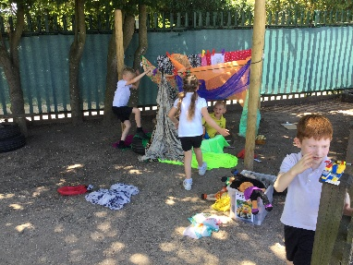  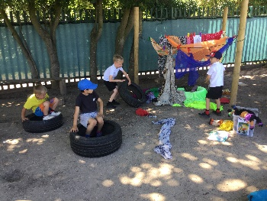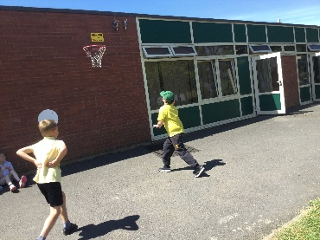  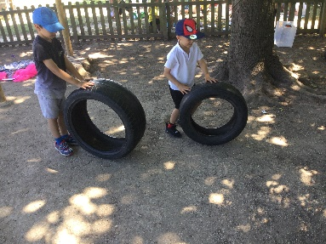 | Each class to be allocated £50 to replenish playtime equipment.  Invest to ‘loose part play’ equipment for children to build and promote imaginary play across KS1 and 2  Set up planting areas in KS1 and KS2.
Are there any particular groups of pupils who need to be more active?

Provide targeted support to involve and encourage the least active children  Hiring qualified sports coaches and PE specialists to work alongside teachers to enhance or extend current opportunities offered to pupils - teachers should learn from coaches the necessary skills to be able to teach these new sports and physical activities effectively. | Sports Stars to provide a range of activities besides football. Each year group bubble to have time with the coaches on rotation. Focus on using the track, gym equipment and a variety of sport and multi skills games. | Measure by…  % of children participating with the coaches, pupil voice on the activities being run.  Time with the sports coach was split across the week and lunch time period in class bubbles, Children enjoy these sessions and as the type of activity has diversified across the year we have noticed more children taking part.  Student Voice  “I like playing with the coach because he lets us play lots of games.” Year 1 child. “I like playing with the sports coach as we get to play games that I have never played before, like Swedish long ball.” Year 4 child “Its fun when I play with Cody because I get to play with children I don’t normally play with.” Year 2 child  Data  Year 1 – 64%  Year 2 – 51%  Year 3 – 58 %  Year 4 - 72%
 | In the Spring Term we are using our CPD PE provider to work alongside us in a different way. The teacher will be using their CPD knowledge gained from the past several years to deliver the PE sessions to the majority of the class. The CPD coach will work alongside the teacher, planning specific steps to support those children who are least active in lessons as a result of having gaps in their ABC skills and/or having not developed age related social-emotional-cognitive skills. | Measure by…  Teachers agreed that using the coach to work with groups of children on specific skills resulted in increased progress and participation – both in the children working with the coach and the rest of the class working with the teacher. It has also allowed class teachers to see how beneficial it can be when any extra support staff that may be available to them are used to support specific groups of children.  Teacher Voice  Children were able to be coached to accurately and safely execute a forward roll. Children from the small focus group are able to maintain higher levels of engagement and commitment to more challenging shapes/balances/routines due to being coached and scaffolded in a smaller group (Year 1 Class Teacher)  The small group approach helped the children to make progress within the sessions. It enabled them to become more engaged because the coach was able to respond quickly to their needs. (Year 2 Class Teacher)  I noticed a real difference in the enthusiasm and focus of the small group of children working with the P.E. coach. By focusing on specific skills broken down in to smaller steps, though still linked to the whole class teaching, it enabled these children to make some really good progress. (Year 4 Class Teacher)  The sports coach worked with 5 of my more confident children, making sure that they had tasks that would challenge and extend their learning. This allowed me to focus on ensuring all the other children in my class were able to access the session. (Year 3 Class Teacher ) | Teachers to continue to access the whole school bank of PE lessons to ensure progression across the year groups.  Teachers to use the assessment data from previous class teacher to inform and adapt plans where necessary to make sure any gaps in age related skills are continued to be focused on in the next academic year.  Liaise and support teachers to effectively use any extra support staff members within their PE sessions to focus on small groups of children working on specific skills.
 | IMoves was purchased in the Autumn Term, primarily to support the planning of dance. | We have been trying to find the most effective planning to support the early years for a number of years. This resource not only supports the planning of dance, but it is also pitched perfectly to match Nursery and Reception expectations.  Nursery Teacher: I have used the Imoves to teach dance and found this perfect for nursery. The planning was easy to read and the layout good. The dance fitted in with the curriculum we are covering in class for literacy related to rhyme so I found links between different areas of learning. This allowed the children to transfer their knowledge to a different area. The planning was easily adaptable for my children who are working within birth to 4. On reflection I am now considering ways in which to bring the PE session into our outdoor learning/enhanced continual provision so the children have opportunities to take the skills and continue them at other opportunities throughout the week.  Reception Teacher: The resources are well paced and at the exact level for our children. We have currently only used the 'fundamental skills' to teach the basics of ball skills and is working great. They are pacey, but at the level our children can cope with. I will be very keen to see how the other units work and hope they are at the same level as this one. I like that they are 'pick up and go' plans unlike when we did the other PE when it seemed to have LOTS to prep.  Reception Teacher: I have enjoyed using some of the 'quick blast' videos to try and give the children a movement break when it is needed. I have also found the short yoga based videos really useful to try and calm the children ready for a carpet session, particularly when they have come in from outside. In Reception we have found the PE planning really useful. It allows us to pick plans that are relevant to the skills the children need to cover. It also provides us with some progressive lessons integrating skills that perhaps we may have missed if we were planning purely ourselves. The plans well aimed at the EYFS age range and can be adapted to suit the children and the areas they need more support with easily.  Year 1 Teacher: Year 1 have used the dance sections on I Move and Lou and Yasmin are just starting to use the gymnastics planning. The year ones loved the dance sessions, they liked the voice overs and the music. The planning had some nice ideas. | Continue iMoves subscription for next academic year. Key stage 2 to trial using some of the skills based sessions.
How can we encourage more pupils to be active outside of school?

Actively encourage pupils to take on leadership or volunteer roles that support the delivery of sport and physical activity within the school | When bubbles can mix, Y4 Play Leaders to have training in running and encouraging children to participate in activities during lunchtimes. Until then…  Begin weekly PA’s for the weekly school newsletter to promote being active with families and friends outside of school.  Led by Y4 Play Leaders | Measure by…  Identify the percentage of children uploading challenges to Facebook, showing teachers  We were unable to implement this as play leader training was unable to go ahead due to COVID procedures within the school. | Train up 15 year 4 pupils to be play leaders.
Raise the profile of physical activity by inviting local clubs and companies into school to build community links. | Shaun Smith, a street dance coach in the local community, was booked in April 2021 to visit school October 2021. He is going to deliver an inspiring assembly, workshops with the entire school, ending with a final whole school performance. The aim will be to promote PA in the local community.  Jump Rope UK, a group of local Olympic skippers, are booked in to run some whole school workshops in the summer term. The aim of these session will be to promote PA in local community (with links to Jump Rope UK’s extra-curricular activities) and to teach children some new skipping skills. | *Shaun cancelled during the week of the event unfortunately. We will seek other alternatives.  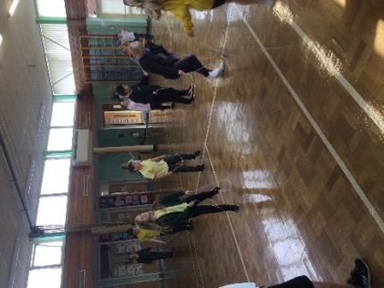  The children really enjoyed these sessions and it was great to see them continue to practise their skipping skills at playtime.  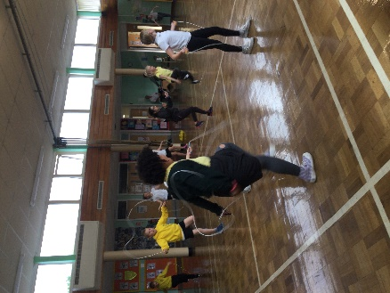  Pupil Voice  “I didn’t realise that skipping could make you so sweaty!” Year 3 pupil.  “I can’t believe I can actually skip!” Year 4 SEN pupil.  “Before I wasn’t a good skipper but now I am.” Year 2 Pupil  “I never used to like skipping but I do now.” Year 1 Pupil. | Continue to foster the schools relationships with local clubs within the community.  Next year we have a local football club coming into school to run an after school club for 10 weeks.
 | Provide an opportunity for our children to perform on a real stage, for a real purpose, by participating in ‘Gotta Dance 2021’. | Measure by…  The opportunity to perform on a real stage, to a real audience, was such a wonderful experience for the children. Every child wishes to have the opportunity to participate in the experience next time (Class teachers)  I loved putting on a real costume and putting all out hard word into a dance/ I would love to do it again/ It was so much fun. I was nervous when we were waiting backstage, but I felt so proud after we did it. (Pupil Comments) | The whole school were inspired by the performance that we have already had huge interest for ‘Gotta Dance 2022’, so much so we are taking two dance troops instead of one.
 | Rugby seemed to be more popular than football on the pupil voice of Sports Active Survey. Historically it has always been football. Seek local rugby clubs and players from ‘Worcester Warriors’ to run taster session and after school clubs. | Measure by…  Identify the % of children taking part in rugby clubs/competitions, pupil voice  We contacted Worcester Warriors who agreed to come in to school and run a 6 week block of sessions for our year 3 children. These sessions were a great success and class teachers and children  After the sessions had ended 30 of the year 3 (52%) children took part in a Key stage 2 Rugby Tournament against other schools in the area. Our children were very happy to come first!  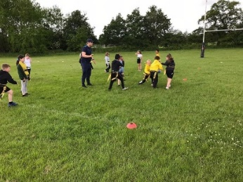  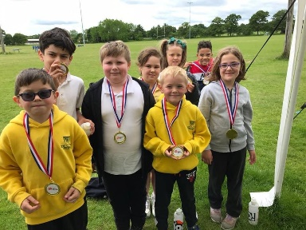  Pupil Voice  “I loved doing the Rugby tournament. I learned loads of new things.” Year 3 Pupil.  “I was so proud of myself and our team for getting first place!” Year 3 Pupil. | Continue to work with Worcester Warriors next year.
Introduce a new range of sports and physical activities to encourage more pupils to take up sport and physical activities. | Trial each year group having a PA experience each year.  Year 4- OAA two day visit Bell Heath (as previous years)  Year 3- Trip to a live game/theatre  Year 2- OAA day visit  Year 1- Walk across the Lickey Hills  Nursery/Reception- Welly Walk | Measure by…  Pupil voice  Due to continuing COVID protocols within the school the Year 1 – 3 trips were unable to go ahead.  68% of the year 4 cohort took part in a 2 day residential stay at an OAA centre in Belbroughton. This was a fantastic experience for the children and allowed them to take part in a wide range of physical activities that they would not normally have access to.  Pupil Voice  “I loved Bell Heath, I still can’t believe I got to the top of all 3 climbing walls.” Year 4 Pupil  “I faced my fears and managed to do the high ropes, even though I was afraid.” Year 4 Pupil  “I just want to do it all over again!” Year 4 Pupil. | Continue to look at ways to introduce a wide range of sports and physical activities.  Trial each year group having a PA experience each year.
How do we involve pupils in choosing the activities on offer?
Do we ask which they want more/less of?

Introduce a new range of sports and physical activities to encourage more pupils to take up sport and physical activities. | Y4 Play Leaders will work on the pupils’ level to gain knowledge of the types of activities they prefer/like to see for after school clubs/lunchtimes.  Use the Smooga to separate areas to accommodate activity areas (once bubbles go). This space will also be used for competitive sports at times. | Measure by…  % of interest from the Year 4 cohort wanting to be a Play Leader  Qualitative data from children participating in Play Leader activities (enjoyment, favourite clubs), % of children attending such events.  We were unable to implement this as play leader training was unable to go ahead due to COVID procedures within the school. | Continue next year
Physical Education: To provide high quality PE and physical literacy from Nursery to Year 4, appropriate to their experiences and starting points.
Future related costs: CPD, Lunchtime and After School Package (£, Annual Inspection of PE Sports Equipment (£100, Swimming equipment (£), £240.00 book allocation
Intentions | Implementation | Impact | Continued/Additional Intentions for Academic Year 2022-2023
PE & sport participation and attainment | Ensure these improvements are sustainable by… | Evidence of pupils’ PE and sport participation and attainment | Next steps
What could the school do to support pupils to meet the National Curriculum swimming requirements?

Raise attainment in primary school swimming to meet requirements of the national curriculum before the end of KS2 - every child should leave primary school able to swim.  Provide staff with professional development, mentoring, appropriate training and resources to help them teach PE and sport more effectively to all pupils, and embed physical activity across your school. | Order a class set of float disc arms bands to support swimming progression.  The EYFS units of the support videos are currently being edited by the ASA. Once these videos are available I will be buying into these for EYFS staff.  Update ASA assessment requirements  The ASA swimming expectations have been updated. I have updated our plans and assessment accordingly. Some of the expectations in EYFS were too hard and some in the upper parts of the year were not progressive enough (deemed as further progress when this was an expectations for the unit). Staff to use new updated assessments and see how this reflects progress and attainment. | Measure by…  Looking at end of year data about who can swim age related distances.  Quantitative data from 2020-21 reports.
 |  | All teachers agree that the planning, videos and assessment support tools have really helped them to teach swimming more effectively. As the NC requirements are aimed specifically for end of Key Stage 2 children we have had some difficulty linking these with the ASA swimming requirements for each year group and this is reflected in the end of year data.  In foundation stage 56% of the cohort met the end of year objectives with 60% able to travel 3m using arms and legs without assistance (with swimming aid)  In Year 1 53% of the cohort met or exceeded the end of year objectives with 24% able to swim 10m without an aid.  In Year 2 58% of the cohort met or exceeded the end of year objectives with 28% able to swim 10m without an aid.  In Year 3 64 % of the cohort met or exceeded the end of year objectives with 48% able to swim 7m without an aid.  In year 4 19% of the cohort met or exceeded the end of year objectives with 33% of children able to swim 12m without an aid. | .As a school we need to agree on specific distance expectations for each year group to allow us to assess children’s progress more effectively.  The stage 4 ASA requirements are very in depth and movement specific. We need to look at ways that these can be taught effectively - Possibly using staff expertise and increasing curriculum swimming time.
 | Support the development of swimming in and out of school hours.  MC is undertaking his PE apprentice with us and also training as a lifeguard, alongside another member of staff.  We know of a swimming teacher who could run swimming after school clubs from Nursery to Year 4. MC would shadow the teacher and when he has passed his course, he will then lead the sessions with another trained lifeguard being present. | Measure by…  % of children participating in the club  % of children making further progress in curriculum swimming.  MC and HM completed their life guard training.  We were unable to run an afterschool swimming club due to staff shortages and COVID restrictions. | To look at the possibility of running an afterschool swimming club.  To increase the amount of curriculum swimming lessons across Key stage 1 and 2.
Hold active lessons and teaching to impact whole school development | To support Jimbo Fun and Smart Moves, replenish fine motor skill resources for each Key Stage. | Measure by…  Due to staff shortages and child illness these interventions were not completed at consistently as planned across Key stage 1 and 2.  In Foundation Stage 18 children were assessed using Jimbo Fun. All of these children were in need of some intervention either in a 2:1 or 1:1 ratio according to the Jimbo fun assessment. 88.9% (16/18) of these children achieved their early learning goal in physical development at the end of their Reception year. | Liaise with Key Stage managers and SENCO regarding the Jimbo Fun and Smart Moves interventions to ensure that there are adequate members of staff and equipment for these sessions to run.
 | To complement the SDP to improve reading, allocate each class £20 to buy books for their book corners about sporting heroes, competitions, new/varied sports (not football) | Measure by…  pupil voice  This has been ordered in Spring 1. We aim to repeat the opportunity in the Autumn term.  The books have been a huge success and the children (and teachers!) have all enjoyed finding out about different athletes and sports.  Pupil Voice  When reading a book about Wilma Rudolph:  “I love how people told her she couldn’t do it, but she could!” Year 4 pupil.  “It shows you that if you keep going you can get good at anything, even if people tell you to stop.” Year 4 pupil.  “It inspires me to get better at gymnastics so I can be like the people in the book.” Year 4 pupil.  Sportopedia Book.  “I like this book, it tells you all about the different sports you can play.” Year 1 pupil  “I love looking at the pictures. It makes me want to be good like them.” Year 1 pupil. | Continue to allocate £20 to each class to buy books about sporting heroes, competitions and new/varied sports.
Are there any groups of pupils who need more support to meet the NC swimming requirements?

Raise attainment in primary school swimming to meet requirements of the national curriculum before the end of KS2 - every child should leave primary school able to swim. | To stretch those who are close to achieving the Year 6 NC requirements of swimming 25m unaided, we will be taking a group of children to a larger pool. These swimming teachers have expertise that can give them to the final push to achieve this before transitioning to middle school. Selected pupils to go for a term- yet to be arranged. | Measure by…  % of children attending who can swim 25m unaided, beginning to tread water and partake in self-rescue as part of the Year 6 swimming curriculum.  We were unable to secure a slot in the local swimming pool for these sessions to happen.
How could we get more pupils doing activity in school time throughout the week?

Introduce a new range of sports and physical activities to encourage more pupils to take up sport and physical activities | C4Life Breakfast club?  Wellbeing intervention support for children identified with mental health challenges | Due to staff shortages these interventions were unable to go ahead. | Look at introducing a C4life Breakfast club.  Speak with SENCO to discuss the implementation of a wellbeing interventions.

Health & Wellbeing: To raise the profile of physical literacy opportunities in the community and maximise opportunities for this during the school day.
Future related costs: Planter Areas (£3000), Gym equipment/Imaginary play designs (£10,000), Wellies, overalls and possible storage units (£3500), KS1 Stage area (£800),
Intentions | Implementation | Impact | Continued/Additional Intentions for Academic Year 2022-2023
PE & sport participation/attainment | Ensure these improvements are sustainable by… | Evidence of pupils’ PE and sport participation and attainment | Next steps
How could we get more pupils doing activity in school time? Are there any particular groups of pupils who need to be more active?

Embed physical activity into the school day through encouraging active break times and holding active lessons and teaching. | The KS1 planting area is rotting. Create a stage for imaginary play during continuous provision. Add adjoining planters for chn to grow their own food and see the benefits of a healthy diet and preparing food. Create a KS2 planting area for healthy lifestyle curriculum links. | Measure by…  Progress linked to curriculum areas  Observations of how children are they using the space and equipment provided.  Due to supply issues we were unable to create an outdoor stage for KS1. A stage will now be incorporated in to the outdoor classroom. The planters have been delivered and these will be set up once the outdoor classroom is complete.  Most of the boat of the EYFS playground has been removed and new equipment purchased. | Continue to liaise with IW regarding improvements to EYFS playground.  Invest to ‘loose part play’ equipment for children to build and promote imaginary play across KS1 and 2
 | The boat on the EYFS playground, that promotes imaginary play, is rotting. They need things to climb, pull tunnel under and over.
 | We are lucky to have an outdoor classroom being built on our premises. Use the premium to buy some wellies and outdoor suits to use the classroom all year round, with appropriate sizes for EYFS, KS1 and KS2. | Measure by…  Opportunities to strengthen curriculum learning link, qualitative data of being in the outdoors.  Due to COVID the building of the outdoor classroom was delayed. This will now hopefully be completed by Autumn term 2023 | Once the outdoor classroom has been completed purchase some wellies and outdoor suits to use in the classroom all year round.
Adopt an active mile initiative | Use the track to build stamina and improve fitness that has decreased since lockdown. Reintegrate Woodrow Winners to encourage competitive track running in each class. | Measure by…  Most classes have access to the track and gym equipment daily during classroom ‘breaks’ with all children using the track at least twice a week.  Teacher Voice  “I have noticed a real difference in the children’s stamina since the start of the year… At the start most children in my class could not complete 1 lap without stopping, now they can all do at least 2 laps.” Year 2 teacher  “It makes a real difference to the children’s attention when we have a track break.” Year 3 teacher.  Pupil Voice  “I like using the track because we challenge our friends and that has helped me build up my speed.” Year 4 pupil.  “I like it when we do the track and I have my fitness tracker on – I always try and beat my last track time!” Year 3 pupil.  “I like the track because I like to run really fast.” Year 1 pupil.  “I have got better at running round the track because I used to be the same as my friend but now I am faster.” Year 1 pupil. | Reintegrate Woodrow Winners to encourage competitive track running in each class.
Adopt an active mile initiative | To create a sport sanctuary/add additional PA opportunities to track. Place gym equipment around the track with tyres in between/ramp to walk along/stepping stones/cause and effect to get something across (team task). Place shapes that incorporate into a game- fence to climb over/castle with a door to go through of different heights. | Measure by…  Due to the proposed position of the outdoor classroom the gym equipment had to be moved in the summer term. This has now been repositioned. | Once the outdoor classroom has been completed look at how the gym equipment/track can be extended or adapted to encourage use.

School Sport: Increase pupil participation in sports competitions from a wider range of sports, in and out of school hours.
Future related costs: Transport to school events (£20), PE & Sports Grant SLA 2020-21 (£500)
Intentions | Implementation | Impact | Continued/Additional Intentions for Academic Year 2022-2023
PE & sport participation/attainment | Ensure these improvements are sustainable by… | Evidence of pupils’ PE and sport participation and attainment | Next steps
How could we get more pupils doing activity in school time throughout the week?
Are there any particular groups of pupils who need to be more active?

Increase and encourage participation in the School Games | Take part in local events when Covid % decreases  Use CPD time as an assessment opportunity by having intra-sport competitions. | Measure by…  % of children attending such events.  Due to COVID procedures and not mixing of bubbles children did not participate in any local competitions until the Summer term.  52% of the Year 3 cohort took part in a rugby tournament in June 2022.  52% of the Year 4 cohort took part in a Tennis festival in June 2022. | Increase the number of local competitions and festivals that the children take part in next academic year.
Organise more sport competitions or tournaments within the school | Woodrow Cross Country- Spring  Woodrow Olympics – Summer  Woodrow’s Got Talent (Dance)- Autumn. Use I-Moves resource to support planning | Measure by…  Due to COVID procedures and not mixing of bubbles children did not participate in any competitions of tournaments within the school till Summer 2.  All children participated in a year group sports day where they raced against their own classes and their other year group class. | Continue to look at ways to include more school competitions and tournaments within school.
Provide staff with professional development, mentoring, appropriate training and resources to help them teach PE and sport more effectively to all pupils, and embed physical activity across your school. | MC is beginning to shadow teachers/CPD coaches across the school in readiness to deliver after school clubs independently. | Measure by…  Outcome of the course  MC’s course will be complete in December 2023.

