Planned funding for academic year 2019-20: £18,277 Actual spend as at Spring 2020: £12,170
Proposed funding for academic year 2020/21: £ 18,267

Physical Activity: To raise the profile of physical activity within school hours and the community

Actual costs: Urban Strides (£3575), Play Leader Training (£100)
Future related costs: Urban Strides (rest of sessions from allocated spend stated above), ‘Gotta Dance’ T-Shirts/transports (£500), Play Leader training ( £100), stock replenishment ( £500)
Intentions achieved before  Covid 19 school closure | Implementation | Impact | Continued/Additional Intentions for Academic Year 2020-2021
The effect of the premium on pupils’ PE and sport participation and attainment | We will ensure these improvements are sustainable by… | Evidence of pupils’ PE and sport participation and attainment | Next steps
Raise the profile of physical activity by inviting local clubs and companies into school to build community links. | Urban Strides, a street dance company, visited our school once a half term. They worked with Nursery to Year 4. Each session was progressive so every child enriched their dance curriculum entitlements beyond their own PE lessons.  A local skipping club also visited us for a day to demonstrate new skills and techniques to children of all abilities from Year 1 to Year 4. This provided an opportunity for children to join a club the in local community. | Teachers: “I love how they got the children moving for the entire session. They divided the room and ensured everyone was active. I like this structure for my PE lessons” “The sessions were engaging and relevant in order for the children to keep up with the pace.”  Children: “I really enjoyed the music.” “I was sweating! I remembered what we did before and I was better... I didn’t fall.”  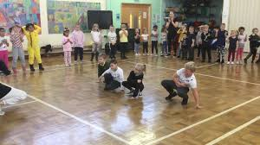  “I can’t wait until Jenny comes back. I love that the teachers dance with us too. It makes it so much more fun.”  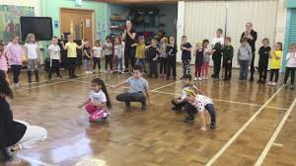  One child in Year 2 attended a ‘taster’ session at the club in the community. | Seek out local street dance clubs in the local community through assemblies/workshops to promote PA in the community.  Measure by…  Identify the percentage of children who decided to take part in a street dance in the local community.
Invest in PE kits and appropriate footwear so children can participate in physical activities throughout the school day, and in the community. | We have invested in a Woodrow logo outdoor kit for children to purchase.  We have also invested in sets of swimming and PE Kits, from Nursery to Year 4, for children without their kit. | More children are having the ability to swim during their designated allocation in the school timetable. They are able to access the same broad and balanced curriculum as their peers by having appropriate kit.  A new PE Kit Policy was agreed by the Governors in Spring 1 (see website). Parents will be given a reminder letter if their child forgets their PE Kit. If this continues a further warning letter is issued. A meeting with the head teacher is organised if missing kit persists. We have seen a reduction in the number of children forgetting their kit. | Have high expectations that children have their PE kits in school and support families to ensure this is achievable.  Measure by…  Half termly updates from staff regarding the number of cases where PE kit has been borrowed and/or meetings with the head teacher.
Continue to subside clubs to ensure more children have the opportunity to be physically active outside of the normal school day. | Clubs continued to be offered at a reduced cost.  Use staff expertise to un clubs free of charge. | Autumn/Spring paid clubs continue to be full for KS1 and 2.  There was a dance club running in the Spring Term in preparation for dance events. Every child (27 from Year 1 and 2) attended every week and were enthused by having the opportunity to perform at the Palace Theatre. | Continue to work with P&E sports to facilitate this.  Continue dance club ready for the rearranged ‘Gotta Dance’ show 2021.  Measure by…  Club attendance.
Continue ‘Play Leader’ training with the next cohort of Year 4 children. | Sessions were run in the Autumn Term. We had keen interest in the role this year. | 40% of the Year 4 cohort were interested in the Play Leader role (25 applicants).  Leaders were successfully leading games for Nursery, Reception and Key Stage 1 children, but they felt that they needed to work on  improving the speed of setting up time in order to maximise time permitted to lead games. As a result MC, a volunteer during Friday lunchtimes, has been asked to check in on the team every week and to oversee how the sessions are running. LA also delivered training sessions with the Play Leaders to maximise their time, space and resources with the children they play with. LA/JD have observed that more children are accessing such activities during the time allocated at playtimes as a result and not waiting for activities to start. The play leader feedback said that the training helped overcome this issue. | Continue using MC to support the leaders weekly.  Begin weekly PA’s for the weekly school newsletter to promote being active with families and friends outside of school.  Measure by…  Take photo evidence to support observations, interviews with lunchtime supervisors and Play Leaders to monitor success of the training. Half termly data collection of children interacting with the Play Leaders.
Pupils will see physical activity as an enjoyable option during their playtimes and learning times. They will understand the importance of the Olympic Values linked to their physical health, and as a result their wellbeing will improve. | JD continues to liaise with EYFS manager on the developments of the outside area.  JD has liaised with the KS1 manager to ensure there is ample opportunity for imaginative play.  LA has liaised with the KS2 manager to ensure there is ample opportunity for PA that interest boys and girls alike. | The EYFS area has been evolving over the past two years. Appraisal targets have focused on the use of the outside area. The profile of using the outdoors, alongside the resources bought, have been raised.  On KS1 playground we have ample opportunities for children to be active: lye on scooters, running track, trim trail, fitness equipment, mud kitchen and building resources for imaginative play such as Lego and Stick a Bricks, balls, skipping ropes, building den equipment and materials. | Liaise with KS managers on playground stock.  Implement plans for enhancing PA for KS2 with P&E Sports. KS1 to continue with multi skill approach. KS2 focus to avoid smooga activities that attract only football for the boys. Encourage the use of the running track/gym equipment, with a self- improvement and competitive focus.  Measure by…  P&E Sport collect data from lunchtime. JD to analyse.

Physical Education: To provide high quality PE and physical literacy from Nursery to Year 4, appropriate to their experiences and starting points.

Actual costs: P&E Sports CPD Silver Package (£1984), Year 4 Swimming (Spring Term 2020: £1575), Year 4 Swimming (Transport for spring Term 2019: £130), Playground and Sports equipment (£2103), Annual Inspection of PE Sports Equipment (£40), Real PE CPD (£2695), Supply cover (£682)
Future related costs: CPD/PPA Silver Package (Summer term 2020: £1104), After school swim club (£450), PE Storage (£680), Playground and Sports equipment (£300), Annual Inspection of PE Sports Equipment (£40), Real PE CPD (£2695), Supply cover (£1000)
Intentions achieved before  Covid 19 school closure | Implementation | Impact | Continued/Additional Intentions for Academic Year 2020-2021
 | We will ensure these improvements are sustainable by… | Evidence of pupils’ PE and sport participation and attainment | Next steps
Implement CPD timetable for Y2, 3 and 4 to develop CPD opportunities for dance and gymnastics. Children will have a deeper understanding of the skills associated with dance and gymnastics.  Children will be more confident to participate in festivals and perform in school events/lessons. | Timetable arranged for the academic year. Staff to use their I-pads to record sessions and make notes on planning to support colleagues entering this year group.  (On school One Drive, staff only). | Year 4 had their floor & apparatus gymnastics unit this half term. Year 2/3 have had their dance unit this term.  Both have had a significant impact on practice; staff had regular team teaching and reflective opportunities to develop their practice with experienced & qualified coaches.  “I feel more confident teaching dance than before due to the breakdown of each session.” “I am more aware of how to build the foundations of skills in preparation for a performance each week.”  A ‘nervous’ Y2 child enjoyed the dance PE lessons and Urban Strides visits so much, she wanted to join the Spring Dance club and perform on a theatre stage. This was a huge confidence boost for her. | Focus on using teaching assistants effectively within PE Lessons.  Measure by…  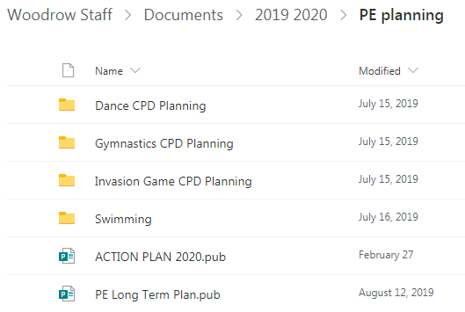  Repeat the, questionnaires, interviews with the children and staff at different points during the implementation of our findings.
In addition to our structured whole school swimming programme covering Nursery to Year 4, our Year 4 cohort have experienced an enrichment opportunity to swim in a deeper pool in preparation for middle school. This was an 11 week programme covering 60 children. | The entire staff participated in swimming training in the Autumn Term to refresh their understanding of key swimming techniques and progression. | The training sparked lot of discussion in terms of how we can further support our children when swimming:  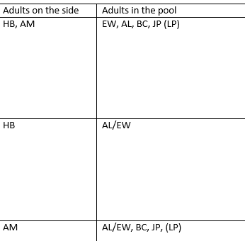  Across EYFS and KS1 we have rotated staff so more adults are in the water to support emerging swimmers.  (Section of adapted plan as a result of CPD) | Invest in other floating supporting aids, other than arms bands, as the training stated this hinders the actions needed for swimming.  Invest in goggles to encourage more able swimmers to progress with their swimming technique.  Measure by…  Looking at end of year data about who can swim age related distances.  Continue conversations with P&E Sports about swimming clubs being run after school.
To ensure teachers deliver high quality PA,PE and PL by providing better storage for PE resources | Seek out options for storage in the main hall and share these ideas with colleagues during a staff meeting. | JD has ordered x2 large storage trolleys. Both have multi skill resources in them such as bean bags, cones, bibs and quoits whilst also containing outside and inside balls. Staff have stated this has really aided their lessons because all of the resources are in one place and can be wheeled out during and after sessions. The PE area is much tidier too as a result. | Have high expectations that children and colleagues store equipment away as it was found, with an aim to replenish less stock than previous years.
Implement CPD for Nursery, Reception and Y1 Real PE with the focus on supporting the Ofsted target to support opportunities for letter formation. | Arrange for REAL PE to lead and then team teach with specific colleagues on implementing the planning and resources in action. | Staff have been involved in this training since the Autumn Term, with Nursery beginning their CPD in the Spring Term.  Staff have reported many benefits of the approach so far:  “The children are more active for the full hour and they are out of breath much more than before.”  “The ‘cogs’ have been a real eye opener for me. Not only are my PE lessons about physical activity now, they are also about their personal skills: building resilience, team work, listening to instructions– all skills need to develop their own games and play games as they get older.”  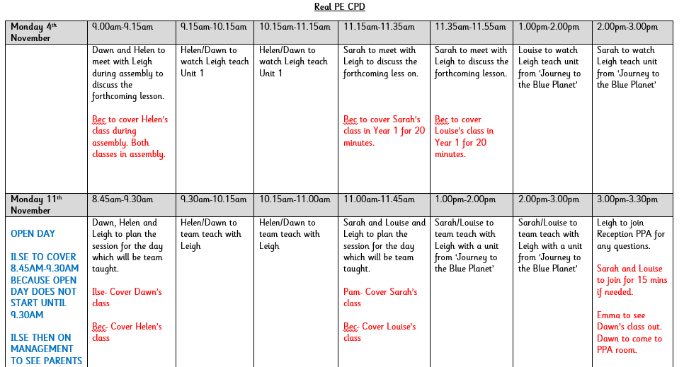  After an initial concern, it is clear the approach fits in with the objectives of the EYFS curriculum. | During the training the instructor was able to access music through his phone as opposed to stopping sessions by going to the laptop. Explore options for Bluetooth speakers that can play music through our school-pads.  CPD to be completed. New staff are now in the year group, so we will need to review where we are, what we need and how we can move forward.  Measure by…  Repeat the, questionnaires, interviews with the children and staff at different points during the implementation of our findings.  Look for a three year impact plan once this approach is established, to monitor the impact of physical education and activity upon academic achievement.

PE and Health & Wellbeing: To raise the profile of physical literacy opportunities in the community and maximise opportunities for this during the school day.
Actual costs:
Future related costs: Loose Parts start-up £12,487 (£8000 contribution from PE & Sports Grant )
Intentions achieved before  Covid 19 school closure | Implementation | Impact | Continued/Additional Intentions for Academic Year 2020-2021
 | We will ensure these improvements are sustainable by… | Evidence of pupils’ PE and sport participation and attainment | Next steps
Begin to explore the possibilities of ‘Jungle Agility’ that has been recommended by Tracey Freer. They are KS 1 and 2 resources with physical activity challenges. Use this to add to the school newsletter to raise the profile of physical activity within the community to our parents. https://outlook.office.com/owa/?realm=woodrow.worcs.sch.uk&exsvurl=1&ll-cc=1033&modurl=0&path=/mail/inbox | After trying to order this it appears it is no longer in stock; despite phone calls to the supplier. | Use Play leaders to generate their own ideas instead- they will have more ownership over it this way. | Measure by…  % of children completing PE homework– shared on school Facebook Page and in class.
Invest to ‘loose part play’ equipment for children to build and promote imaginary play across KS1 and 2.  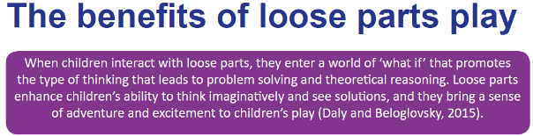  Huge physical and mental health benefits.  There is a growing body of evidence (Hyndman, Benson, Ullah and Telford, 2014) of the benefits of playing with loose parts including:  • Increasing levels of creative and imaginative play  • Children play co-operatively and socialise more  • Children are physically more active  • Curriculum outcomes occur through informal play with loose parts (Wagland, 2015)  • Loose parts facilitate communication and negotiation skills when added to an outdoor space (Maxwell, Mitchell and vans, 2008)  Time in nature aids psychological well-being in children (Wells and Evans,2003) | Following on from TED Day talks in September, a team of TAs and teachers created a team to explore the idea further.  We have also had a representative from the scheme come and discuss options with the head teacher and colleagues. | Colleagues have attended Ledbury Primary school to see Loose Parts Play in action. Colleagues said:  “We really liked it. We need a good bank of resources to be refreshed and for someone to be in charge of this so the resources are safe to use.”  Discussions are ongoing to make the initiative cost effective and sustainable. There is a start-up cost, but then resources would need replenishing with the help of the community. | Time to train dinner ladies and teaching staff to engage with the activities and children. Behaviour at the case study school improved, yet this was over a ten year scale. We need a sustainable and achievable long term plan as a staff.  Identify sub groups of children from each key stage using the pedometers pre and post this intervention. Identify activity levels, interests and feelings towards being active at Woodrow to improve attitudes through a triangulation approach.  Measure by…  Repeat the pedometers, questionnaires, interviews with the children at different points during the implementation of our findings.
We are lucky to have an outdoor classroom being built on our premises in the Summer Term. | Use the premium to buy some wellies and outdoor suits to use the classroom all year round, with appropriate sizes for EYFS, KS1 and KS2. |  | Building work dependent upon Covid 19.

School Sport: To take part in School Games Programme – Qualification for sports award and increased pupil participation in sports competitions from a wider range of sports, in and out of school hours.
Actual costs: Transport to school events (£100), PE & Sports Grant SLA 2019-20 (£500)
Future related costs: Transport to school events (£250), PE & Sports Grant SLA 2020-21 (£500)
Intentions achieved before  Covid 19 school closure | Implementation | Impact | Continued/Additional Intentions for Academic Year 2020-2021
 | We will ensure these improvements are sustainable by… | Evidence of pupils’ PE and sport participation and attainment | Next steps
Application to Schools Games Programme | Continue such correspondences by attending any PE meetings during this next academic year. This will ensure opportunities are maximised and staff can plan around attending these events. | Due to the continued work with Urban Strides and the CPD discussed above, particularly in terms of dance, our children will have a deeper understanding of the skills associated with dance. Children will be more confident to participate in festivals and perform in school events/lessons. | Continue with pre-planned events from last academic year.
Continued funded and non-funded afterschool clubs from Reception to Year 4 | Ensure more children have the opportunity to access PA outside of their curriculum entitlement.  Clubs continued to be offered at a reduced cost. | Invite Reception to join Year 1 and 2 after school clubs, to promote a love for PA from a younger age. | Continue.

