The funding has been provided to ensure impact against the following OBJECTIVE:
To achieve self-sustaining improvement in the quality of PE and sport in primary schools. It is important to emphasise that the focus of spending must lead to long lasting impact against the vision (above) that will live on well beyond the Primary PE and Sport Premium funding.
It is expected that schools will see an improvement against the following 5 key indicators:
Department for Education Vision for the Primary PE and Sport Premium
ALL pupils leaving primary school physically literate and with the knowledge, skills and motivation necessary to equip them for a healthy, active lifestyle and lifelong participation in physical activity and sport
Evidencing the Impact of Primary PE and Sport Premium
-Guidance & Template-
- the engagement of all pupils in regular physical activity – kick-starting healthy active lifestyles
- the profile of PE and sport being raised across the school as a tool for whole school improvement
- increased confidence, knowledge and skills of all staff in teaching PE and sport
- broader experience of a range of sports and activities offered to all pupils
- increased participation in competitive sport
Under the new Inspection Framework, Ofsted inspectors will assess how effectively leaders use the Primary PE and Sport Premium and measure its impact on outcomes for pupils, and how effectively governors hold them to account for this. Improvements should enhance, rather than maintain existing provision. For example, where schools are using their funding to employ specialist coaches, these should be deployed alongside class teachers rather than displacing them, in order for their impact to be sustainable and to enable the upskilling of existing teachers.
You should ensure that information about your use of the premium is available on your school website in order to keep parents and others informed. This should be clear and easily accessible and we recommend that you upload the following template to your website for this purpose.
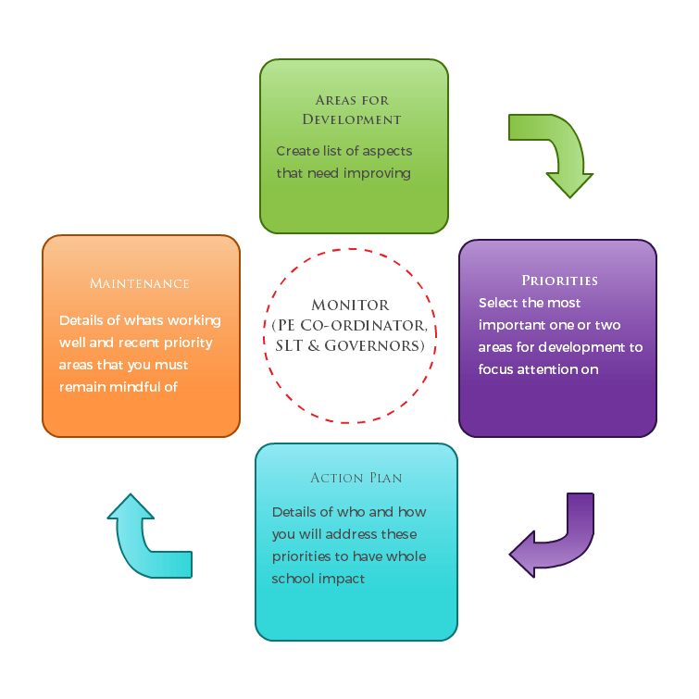
Primary Physical Education and Sport premium planning and actions should show how use of funding contributes to this vision through identified school priorities which can be measured through reference to key outcome indicators. It is important that the main drivers for improvement are those identified by the school through their self-review. Each school should aim to achieve the following objective:
OBJECTIVE: To achieve self-sustaining improvement in the quality of PE and sport in primary schools.

Please see Figure 1 (below): A process model to support your thinking:

HOW TO USE THE PRIMARY PE AND SPORT PREMIUM
Schools must use the funding to make additional and sustainable improvements to the quality of PE and sport they offer. This means that you should use the premium to:
- develop or add to the PE and sport activities that your school already offers
- make improvements now that will benefit pupils joining the school in future years
For example, you can use your funding to:
- hire qualified sports coaches to work with teachers
- provide existing staff with training or resources to help them teach PE and sport more effectively
- introduce new sports or activities and encourage more pupils to take up sport
- support and involve the least active children by running or extending school sports clubs, holiday clubs and Change4Life clubs
- run sport competitions
- increase pupils’ participation in the School Games
- run sports activities with other schools
You should not use your funding to:
- employ coaches or specialist teachers to cover planning preparation and assessment (PPA) arrangements - these should come out of your core staffing budgets
- teach the minimum requirements of the national curriculum – including those specified for swimming.

SECTION 1 – EVALUATION OF IMPACT/LEARNING TO DATE

In previous years, have you completed a self-review of PE, physical activity and school sport? Yes
Have you completed a PE, physical activity and sport action plan/ plan for the Primary PE and Sport Premium spend? Yes
Is PE, physical activity and sport, reflective of your school development plan? Yes
Are your PE and sport premium spend and priorities included on your school website? Yes
Vision: ALL pupils leaving primary school physically literate and with the knowledge, skills and motivation necessary to equip them for a healthy, active lifestyle and lifelong participation in physical activity and sport.
Objective: To achieve self-sustaining improvement in the quality of PE and sport in primary schools against 5 key indicators:
- the engagement of all pupils in regular physical activity – kick-starting healthy active lifestyles
- the profile of PE and sport being raised across the school as a tool for whole school improvement
- increased confidence, knowledge and skills of all staff in teaching PE and sport
- broader experience of a range of sports and activities offered to all pupils
- increased participation in competitive sport

Use the space below to identify what your use of the Primary PE and Sport Premium has been to date, and priorities for the coming year:
SECTION 2 – REFLECTiON: WHAT HAVE WE ACHIEVED AND WHERE NEXT? 2015/ 2016

Key priorities to date: | Key achievements/What worked well: | Key Learning/What will change next year:
Engaging all pupils in regular physical activity- kick starting healthy, active lifestyles | Accessing competitions through Trinity Sports Partnership allowed more children to enjoy sport and build confidence in physical ability. Children were very proud and enthused to take part in school competition.  Woodrow Winners intervention has seen an improvement in physical activity levels (See sport grant premium summary for further details). Y2 boys had significantly increased their step count during lunch times and morning break times. Y1, Y2, Y3 and Y4 girls had increased their step count during lunch times and morning break. With a significant increase for Y4 girls in terms of their lunch time activity.  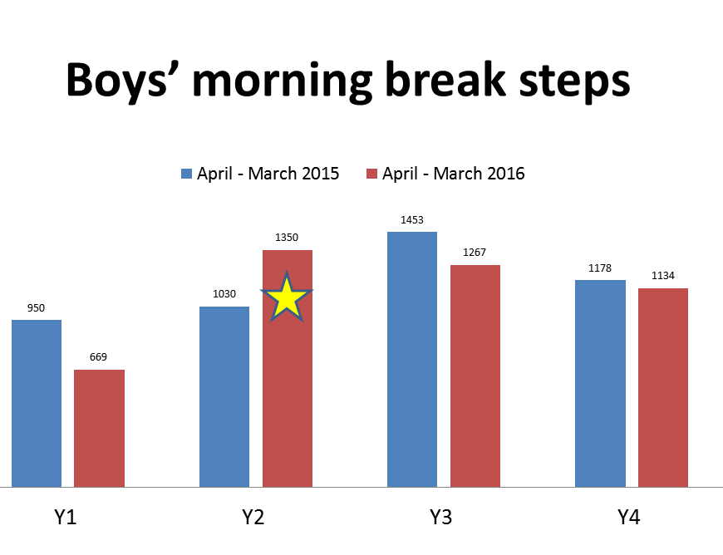  Year 2 percentage increase of %  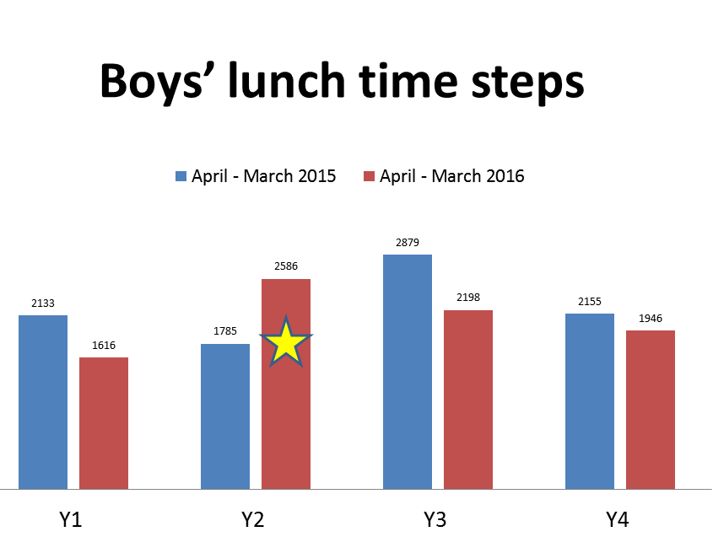  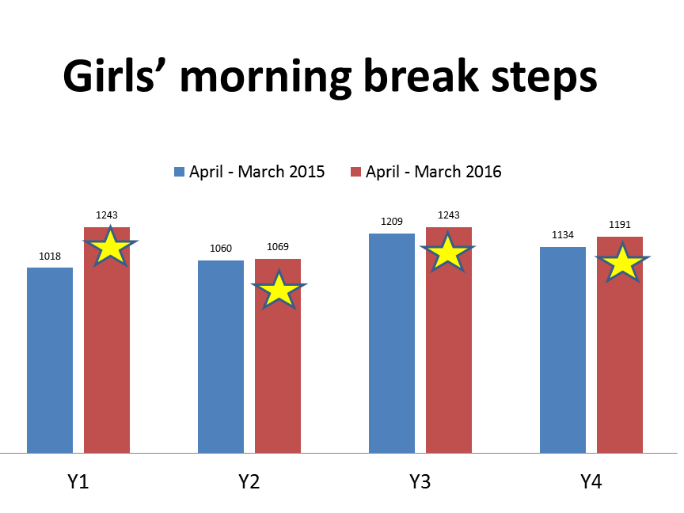  Year 2 percentage increase of %  Year 1 percentage increase of %  Year 2 percentage increase of %  Year 3 percentage increase of %  Year 4 percentage increase of %  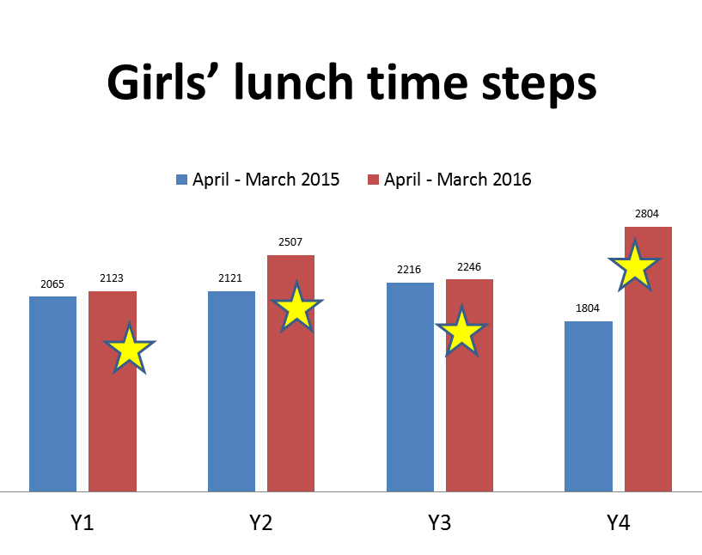  Year 1 percentage increase of %  Year 2 percentage increase of %  Year 3 percentage increase of %  Year 4 percentage increase of % | The partnership has provided good, engaging opportunities for the children and chance to engage in physical activity against children in the wider community. Value for money as a vehicle for developing NC aims of competitiveness and cooperation. Continue next year.  Continue to work with Newman University to undertake pedometer data to identify target groups for next year. To continue to monitor the impact of physical activity, we will begin to monitor whether progress in physical development in the Early Learning Goals transfer into children opting for healthy lifestyle choices as they enter Key Stage 1 & 2. Explore the PA levels of the Early Years to develop the outside area & introduce the Woodrow Winner initiative.  Promote curriculum links to geography through the idea of Woodrow Around the World. Children to have a purpose for their running to see how far they travel throughout the year.  Introduce a ‘Park Run’ with parents and children to share the running track with the local community.
The profile of PE and sport being raised across the school as a tool for whole school improvement | PE project being mentored by the SLT when undertaking Level 6 PE Leadership & Management Course alongside NPQML Qualification. All staff using the newly built running track to ‘run/walk a mile’ everyday; raising the importance of physical activity. The track has enabled a wider range of activities to take place during lunchtimes and break times due to the increased space. The opportunity for clubs can also change; a football club can run alongside a cross country club.  Weekly Woodrow Winner slot to celebrate the children showing the elements that make a WW. The children thought about the Olympic Values and shared these with the lunchtime supervisors. | Continue to review subject alongside school strategic plan and policy to ensure PE has a focus when developing a whole school approach to physical activity.
Increased confidence, knowledge and skills of all staff in teaching PE and Sport | PE Leader to continue supportive links with Newman University to implement team teaching opportunities and upskill staff. Continue to reflect on PE Audits to identify developmental targets for the year. | Ask stakeholders in the school to complete PE audits to identify areas for continued professional development that inform the action plan.  Particular focus on swimming next year to evidence the expenditure of pupil premium on facilitating our swimming pool. AfPE Conference also mentioned that schools may be asked to publish whether children can swim 25m by the end of KS2. CPD opportunities to continue.  Continue regular training sessions with lunchtime supervisors to value their support by sharing the WW pedometer results and plan next steps.
Broader experience of a range of sports and activities offered to all pupils. | Through the involvement with the school partnership, a coach trained in Tri Golf offered free taster sessions in preparation for a competition with local schools.  P&E Sports offer a broad range of after school clubs to the children; staff offer free clubs too. We looked at the children accessing clubs and noticed predominance in year 2 maximising spaces in the lower half of the school. As a result we have restructured the clubs and are now seeing an increase uptake of Reception children. Clubs are very popular now with a waiting list often being apparent.  Maximise the facilities of trim trail, track, coaches and lunchtime supervisors during leisure time for children to have the opportunity for physical activity. | Continue to build community links and clubs so that all children have the opportunity to access free and paid clubs.  Continue to listen to pupil voice to keep the clubs and activities offered at lunchtime current to their interests.
Increased participation in competitive sport | Through the partnership we have ensured all children from Year 1 to Year 4 have taken part in competitive sport and/or festivals. The children have enjoyed taking part and through the school website have increased the positive image of sport through termly newsletters and Facebook statements.  “I loved the Bollywood Dancing at the big school. I enjoyed the music and dancing with my friends.”  “All of the Year 2 children thoroughly enjoyed the multi skills morning. There were a variety of activities to try and they all came back with a huge smile on their faces.”  “The OAA was a great day. The children enjoyed working as a team and enjoyed trying something that they have not yet experienced before.”  “The improvement in cross country this year has been amazing. We have had more children an increase of 4 girls and 5 boys in the final heats.” | Continue to analyse the pupil premium children to ensure they are having equal access as others to participate in such experiences.  Continue to access the partnership and seek competitive opportunities through the after school clubs.

SECTION 3 – PLANNING YOUR PROVISION AND BUDGET FOR THE COMING YEAR
Use the template below to plan how you intend on spending your Primary PE and Sport Premium funding this academic year, to include which of the 5 key indicators that priority relates to. The greyed out boxes allow you to re-visit this section later in the year to review and plan next steps.

Step by step guidance notes to support completion of the template to achieve self-sustaining improvement in the quality of PE and sport in primary schools:
Step 1: Confirm the total fund allocated
Step 2: Review activities and impact to date either using the template you used last year or the space provided at the top of the template
Step 3: Confirm your priorities in terms of impact on pupils and enter into column B to detail your school focus (e.g. improved the quality of children’s physical literacy at key stage 1)
Step 4: Cross reference these with the 5 key indicators for the Primary PE and Sport Premium by selecting the aspect(s) that this relates to (e.g. increased confidence, knowledge and skills of all staff in teaching PE and sport) and select these from the drop down menu in column A
Step 5: Complete column C to outline key actions to achieve these outcomes (e.g. whole staff training)
Step 6: Complete column D to detail funding allocated to this priority (e.g. £100)
Step 7: Complete column F to show how you plan to evidence the impact of this spend on young people
Step 8: Identify when you revisit this template to update with actual spend, impact and sustainability next steps (greyed out columns E, G & H)
Step 9: The greyed out columns will be useful when reviewing your school’s spend later in the year to confirm actual spend and impact to support further plans for the future and sustainability.

Academic Year:  2016/2017 |  | Total fund allocated:  £9105
PE & Sport Premium Key Outcome Indicator  Reviewed Half Termly Quality assured by Tracey Freer | School Focus/ Impact on pupils | Actions to Achieve | Planned Funding | Allocated Funding | Evidence | Actual Impact (following Review) on pupils | Sustainability/  Next Steps
1. the engagement of all pupils in regular physical activity – kick-starting healthy active lifestyles | Engage all pupils and promote a healthy lifestyle for all.  Broad range of PA opportunities during the school day | Offer free and paid clubs from Reception; encouraging a love of PA from an early age that can be built upon through their school career.  Continue to build on Newman University research to analyse PA in Year 1 to 4. Use this to inform the Woodrow Winners Timetable for lunchtime activities.  Introduce WW in EYFS to develop lunchtime PA across the school.  Introduce ‘Woodrow around the World’ to run a mile each day.  JD to have release time to evaluate the impact of the running track on the children’s PA through the entire school day. | Resources at lunchtimes  P&E Sports Club shortfall of costs  KS1 Playground development  Boxes for storage/armbands replacement | £610.00  £71.00  £820.00  £504.00 | Pupil Voice:  “I really like the trim trail. My favourite part is the wobbly bench. We can use it everyday” (Year 2)  “I really enjoy working with the play leaders. They play fun games with us and help us when we find things hard.” (Year 1)  “We have football nets now. I love playing matches on the field with my brother and my friends.” (Year 4)  Running track:  All year groups participating in the run a mile. We are on the way to America now and are currently in the sea! | Positive pupil voice regarding opportunities during lunchtime.  Increase in laps across the school for Woodrow around the World because we have travelled a long distance from Woodrow.  Children are busier since the Play Leaders have started with dinner ladies reporting less behaviour incidents.  Running Track: Woodrow around the World: Whole school ethos and commitment to this initiative, as stated in the PE Policy. Shared commitment to PA with staff as role models promoting PA benefits to health. Ownership of children to calculate miles achieved so they are invested in the initiative. Couch to 2K Club in KS1: 8 families & 15 chn attended the club in Year 1 & 2. The children who attended the club now adopt the method of maintaining stamina that was practiced.  Staff noticed a considerable change in the children’s stamina when engaging in higher level activities at Malvern including a sustained inclined climb of the Malvern Hills. . | Couch to 2K Club in KS1: Parents are keen for this to be a whole school club so they can attend with siblings. Look to possibly continue throughout the year with adult support.  Track- Consider how is it used differently in the summer compared to the winter.
2. the profile of PE and sport being raised across the school as a tool for whole school improvement | Opportunity to develop personal and social skill development through Play leaders during playtimes | Play leaders to promote sport and PA in KS1 and EYFS; gaining leadership qualities in preparation for middle school. Training delivered by Karen Pearson, followed by termly training with dinner ladies.  Run a Year 4 Sports Committee to promote pupil ownership towards school sport and PA.  Increase parent engagement in KS1 to be more physically active at home | Play Leaders Training  Overtime pay for lunchtime supervisors  Cross Country Kit  Release of a Level 3 TA to run the session  Goodie Bag of resources | FREE  £95.00  £112  FREE- covered within school  £26.00 | Play Leader & P&E Sports:  At The average head count of children interacting with the leaders on Reception/KS1 side are 45 children. On KS2 side it is 35 children.  “I really enjoy playing games with the older children.”  “They show me how to do things and make it fun.”  “I love the bag of things to use and play with.”  Sports Committee: 23/46 of Year 4 applied for this role.  Cross Country: More children this year than ever before have reached the finals. Semi-finals heats (Girls-1st, 2nd, 3rd, 5th, 7th, 9th) (Boys- 1st, 4th, 5th)  All boys within the top 20.  Parent Workshop Summer Term  7 families from KS1 attended every 5 sessions in the Summer Term. | Play Leaders: In their application the play leaders showed their understanding of the WW qualities and demonstrate this to the children during lunchtimes (as evidenced by discussions and observations with lunchtime supervisors). They are now coaching the next cohort; inspiring them to take on the role next year. Applications have started for 2017-18.  Sports Committee: Involved in the training day; discussing with the lunchtime supervisors the games that the children would like to play during lunchtimes. Interest and involvement in collecting Sainsbury’s School Games Vouchers and collating figures.  Parent Workshop  “Great getting time to spend playing games with the kids….great to interact with each other and other parents that they might not normally talk to.”  “Rhys and I have had a really lovely time doing the activities…lots of ideas for the 6 week holidays.”  “Suhanna is so happy with the goodie bag…thank you!”  See book for further evidence  JD was asked to speak externally at a Head Teacher’s conference about the success using the sports premium funding to support our children. | Play leaders/Sports committee- Continue play leaders and sports committee next year; consider meetings with play leaders and lunchtime supervisors more regularly to share experiences and next steps. This will ensure pupil voice is stronger.  Work towards inspiring the future leaders by delivering a sport committee assembly. Consider sharing new play leader activities so children have an increased awareness of the choices that they can make at lunchtimes.  Parent Workshop:  Consider continuing the work on parental engagement in KS2.
3. increased confidence, knowledge and skills of all staff in teaching PE and sport | Develop creative ideas to teach physical development in the EYFS  Following the success of Woodrow Winners in KS1 and 2, train EYFS lunchtime supervisors | Aspire to work with 3 FS teachers to develop creativity and progressive planning in Nursery and Reception (gymnastics, multi skills and dance).  Karen Pearson to lead training using Change for Life cards and resources. Termly training with lunchtime supervisors and informal drop-ins to evaluate success and next steps. | Training cost from Aspire  Play Leaders Training  Overtime pay for lunchtime supervisors | £1085  FREE  FREE- covered within school | Aspire-Teacher Voice: See report attached below.  Lunchtime Supervisor Voice “I feel more confident with the games I can deliver for this age range.”  The course showed me the games I can try with limited space and resources.”  “It was nice to have the Year 4 children alongside us in the training to make it more pupil led.” | Aspire- The programme has enhanced teacher confidence to plan lessons creatively linked to cross curricular themes. The Foundation Stage manager and I feel that staff assessment has always been strong, yet also feel that teachers have developed more ways to deliver the assessment targets creatively, whilst ensuring differentiation and challenge to support the diverse needs of the children (using the STEP principle).  Lunchtime Supervisor Voice:  See above statistics. | Foundation Stage- To use the ideas gained to support specific steps in the ELGs e.g. moves around avoiding objects as opposed to teaching too many at once
4. broader experience of a range of sports and activities offered to all pupils | Offer a variety of free and paid sports clubs to the children at lunch and afterschool | Plan and run a variety of sports for all children.  Explore the possibility of a table tennis community coach (following the grant awarded for a table tennis table with resources and activity pack)  Provide Year 4 children with experience in a deeper swimming pool before entering middle school. | P&E Sports Club short fall costs  Table Tennis contribution  Transport  Cost of Coaches | £71.00  £262.50 (£300 grant awarded)  £665.00 | See outcome indicator 1 for lunchtime impact.  Afterschool Clubs: Based on an average of 20 spaces per club  Autumn 1  Reception, Year 1 ‘Play Fun’: 75%  Year 2,3,4: ‘Basketball’: 55%  Autumn 2  Reception, Year 1 ‘Multi Skills’: 100%  Year 2, 3, 4 ‘Team Games’: 40%  FREE Dance Club, Year 1 & 2: 100% (33 spaces)  Spring 1  Reception, Year 1, 2 ‘Football: 70%  Year 3 & 4 ‘Gymnastics’: 80%  FREE Performing Arts Club, Year 3 & 4: 100% (33 spaces)  Spring 2  Reception, Year 1: Gymnastics: 100&  Year 2,3,4: Tennis: 60%  Summer 1  Reception, Year 1: Summer Sports: 90%  Year 2, 3, 4: Cricket: 80%  Summer 2  Reception, Year 1: Multi Skills: 100%  Year 2, 3, 4: Rounders: 100%  FREE Couch to 2K Club Year 1 & 2: 75% (15 children, 8 families)  All year 4 attended for 6 weeks at Studley. Each child progressed regardless of their ability. | Afterschool Clubs:  Initially we subsidised any shortfall in the cost of the coaches to encourage participation. Now these are self-funding regular activities across all year groups as they are being at fuller capacity.  A member of staff remains behind during the session to quality control it. Regular meetings are held with P&E sports to discuss arrangements, what has gone well and what to improve on. Children continue to have ample opportunities to participate in PA at lunchtime and after school and experience competition against themselves and others. Clubs are well attended with most clubs at full capacity. The opportunity for free clubs allows all children to have equal opportunity to access broad and balanced extra-curricular activities.  Tennis Table- It has now been installed on the KS2 playground. To maximise the resource it needs to be timetabled more effectively next year.  Swimming-Swimming is offered for all year groups for a minimum of a term and a half per year at Woodrow, giving children the opportunity to develop water confidence, a life skill and develop their physical coordination. The impact is that they have had the opportunity to experience something outside of their normal curriculum opportunities. | Free Clubs-Continue free clubs for all children to participate.  Following the success of the club attendance, it has been noticed that an increase of Pupil Premium children access the clubs. This will be monitored more closely next year.  Tennis Table- Timetable the use of the tennis table more effectively next year by creating a staff rota during playtimes and lunchtimes.  Swimming- CPD for staff to maximise the opportunities for progression in the time and space that we have in lessons.
5. increased participation in competitive sport | Children participate in competitive sports in and out of school  Continue to access Trinity Sports Partnership to offer a broad, balanced curriculum | Attend partnership competitions.  Continue to challenge the ways we can engage less active children through WW, competitions and festivals whilst encouraging competition against themselves and others | Trinity sports partnership  Transport to events  Supply cover | £1000  £525.00  £809.00 | Achievement of a Sainsbury’s School Games Award (Bronze)  Attended-  KS1: Multi Skills, Dance  KS2: Kurling, Hockey, Cross Country, Tennis, Tri-Golf, Invasion Skills and Games Festival, OAA activities  More children are accessing competitive opportunities more regular than previous years. | Equal opportunities to access the same events as other pupils in the area.  Consistent liaison with local high schools and engagement with their sports leaders.  A raise in aspiration and interest to become part of the sport committee after attending such events. | Relationship with the sport leader of the high school is to improve in order to request dates in advance. This will ensure opportunities are maximised and staff can plan around attending these events.

Completed by: Joanne Dodds
Date: 01/06/2016
Review Date: 01/06/2017

After every update, please remember to upload the latest version to your website.

Developed by 

