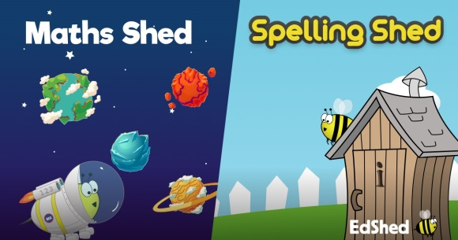
Year1, you can now access Maths Shed and Spelling Shed for free.
The website is https:// play.edshed.com
There are games to practise number bonds, times tables and spellings.
Username
Type: 2020 y1 your first name the initial of your surname
NO SPACES OR CAPITALS
For example:
Jim Smith | Fred Davies-Banks | Lilly-May Tucker
 |  | 
2020y3jims | 2020y3fredd | 2020y3lillyt

Password
Type the number of your birthday, the first 3 letters of the month you were born in and your teacher’s initals
NO SPACES OR CAPITALS
Eg Jim was born 8th September and is in Mrs Paxton’s – 8seplp
Mrs Paxton – lp Mrs Ryall - sr

As you play you earn points.
These points can be used to improve your avatar – click on your avatar to do this.
Turn this into 
You will also be able to see your position in the Woodrow School league

