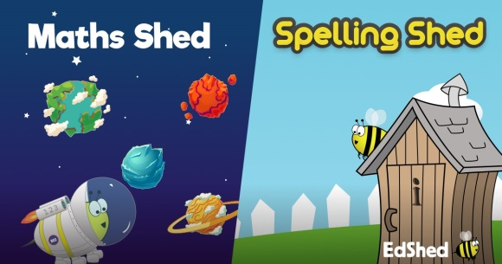
Key Stage 2, you can now access Maths Shed and Spelling Shed. (Year 3, you know these from year 2, but you now have new logins.)
You can access both sites for free by using the web address below.
The website is https:// play.edshed.com There are games to practise times tables and spellings.
Username
For Year 3:
Type: 2020 y3 your first name the initial of your surname
NO SPACES OR CAPITALS
For example:
Jim Smith | Fred Davies-Banks | Lilly-May Tucker
 |  | 
2020y3jims | 2020y3fredd | 2020y3lillyt

For Year 4:
It is the same as Year 3 just type 4 not 3!
Password
For everyone:
Type the number of your birthday, the first 3 letters of the month you were born in and your teacher’s initals NO SPACES OR CAPITALS
Eg Jim was born 8th September and is in Miss Hinton’s class – 8seplh
Mrs Howie – sh Miss Capron-Tee – mct Miss Hinton/Mrs Allmark – lh Mr Benney - sb

As you play you earn points. These points can be used to improve your avatar – click on the avatar to do this.
You will also be able to see your position in the Woodrow School league

