Home Learning due to the Corona Virus
In the event of school closing, you may want your child to do some learning at home. Here are some possible areas to explore together.
This website has a great sequence of learning that can be used if desired, it also have lots of lovely links. Click on the EYFS area of learning.
https://www.robinhoodmat.co.uk/learning-projects/
In nursery we have been learning about the world around us, the shops we have and in particular the vets.
Perhaps your child could practise their vet skills at home? They could look after their teddy bear, checking their temperature and listening to their heart with a stethoscope. The children are encouraged use their imagination, anything could be used aa a thermometer or a bandage for a cut.
Reading
Continue to share books with your child. This is a really important area of their learning. There are some lovely videos of books been read to children on the internet as well as lots of free e books available for a variety of different age groups. I will post the links below.
https://www.worldbookday.com/wbdtv/
https://www.bbc.co.uk/cbeebies/stories?page=2
https://www.bbc.co.uk/cbeebies/games/age-and-needs/pre-school
https://www.oxfordowl.co.uk/for-home

Phonics
In pre-school the children are working through their understanding of the sounds around them. They are recognising different sounds in the environment and exploring them
There are some great on line games which support the development of these skills. I will put some links below, but try typing in phase1 phonics games on YouTube. There are lots of free games on there.
https://www.phonicsplay.co.uk/Phase1Menu.htm

We have started listening to s of the jolly phonics songs. The link for all of the sounds can be found here.
https://www.bing.com/videos/search?q=jolly+phonics+songs+in+order&view=detail&mid=E438DBEC55C3A8034BB7E438DBEC55C3A8034BB7&FORM=VIRE

Messy play
This is a really important area to explore with children in pre-school. It helps develop their fine motor and gross motor skill. This helps them understand the world around them. There are lots of different ideas on Pinterest and Facebook. Below are a few pictures and links however there are many, many more to find online.
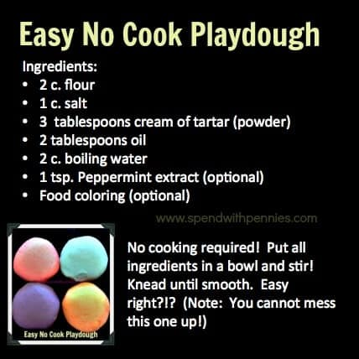
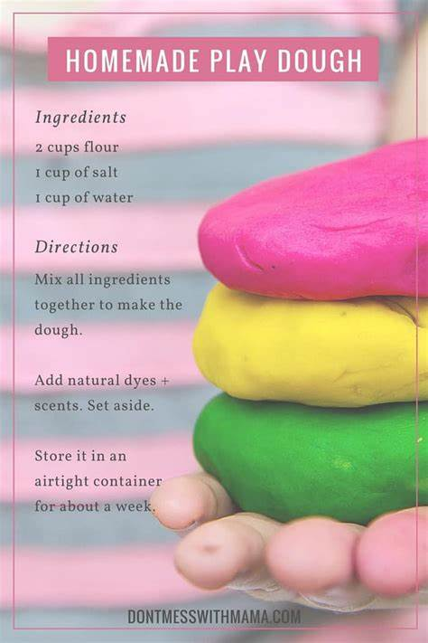
I have also attached some playdough recipes.
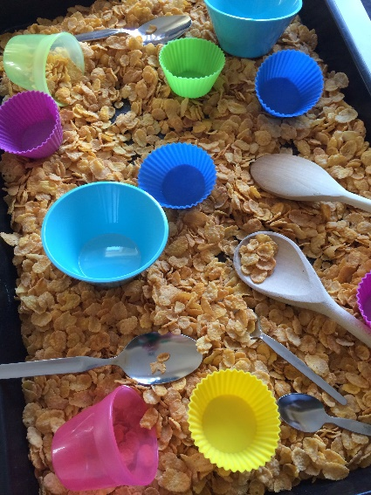

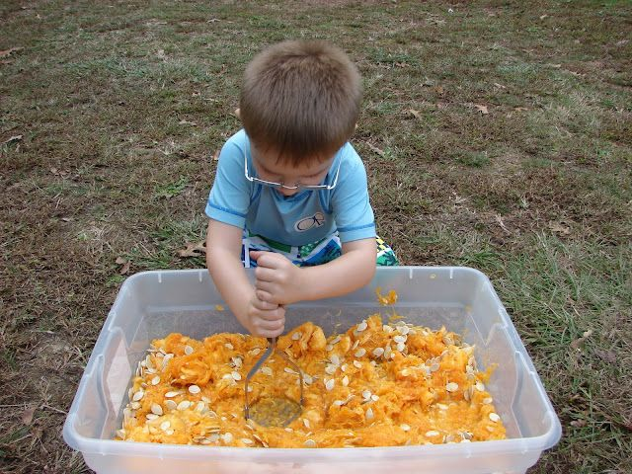
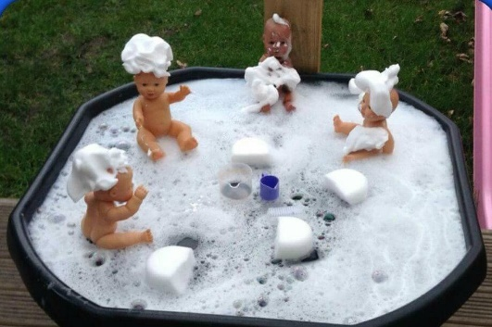

Writing
Giving children the resources to make marks is important at this age. They may have pen and paper or you may be able to put some flour on a table which they can use their fingers to explore and write their names.
Below are some pictures of activities you may want to try at home.
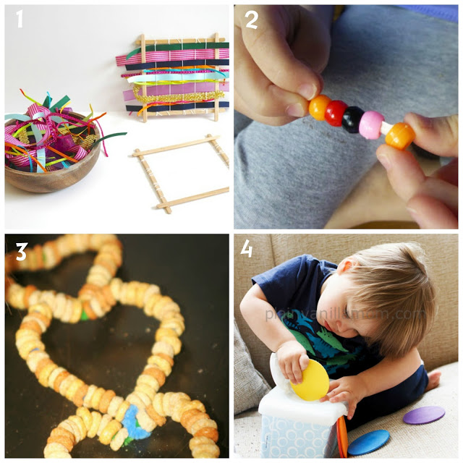
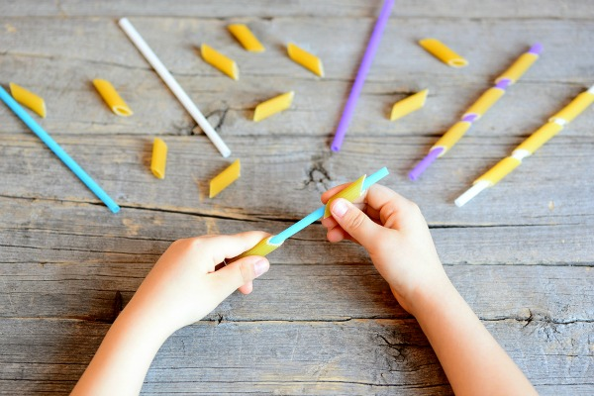

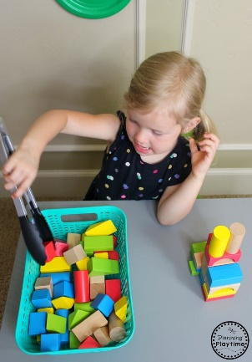
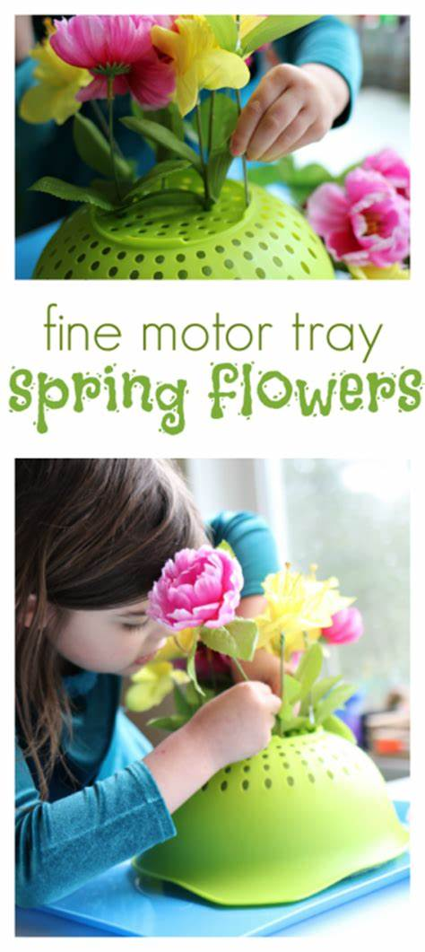
Physical
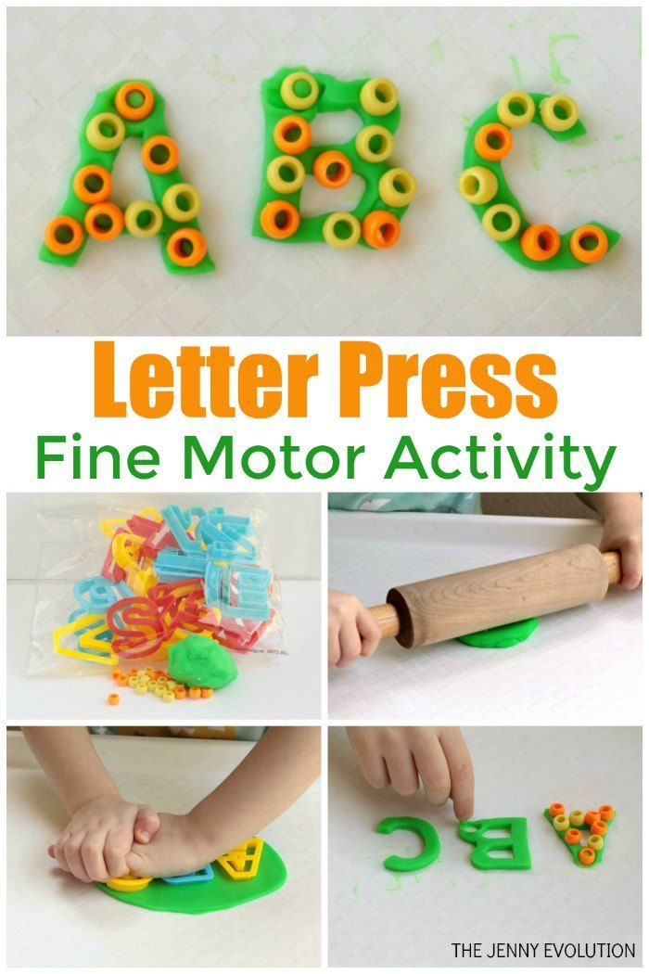

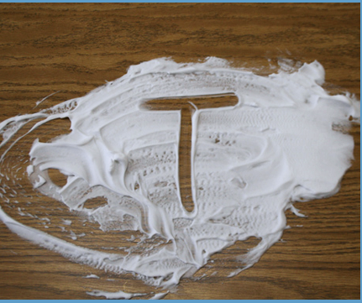

Pre -writing shapes
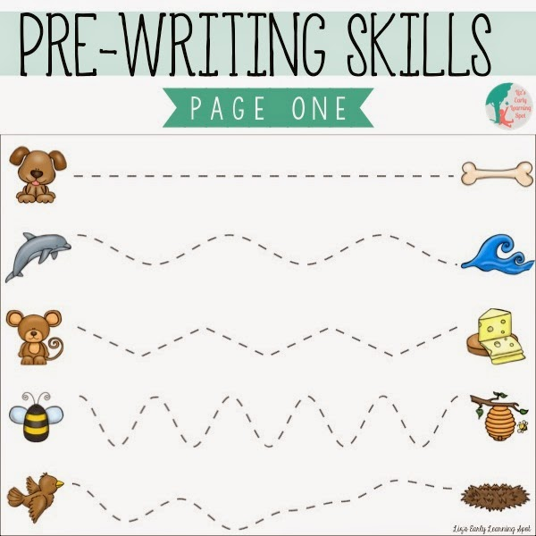
Below are the pre writing shapes that we concentrate on in Nursery. They are important to try and master before children are forming letters correctly.

Physical development
It is important for children to develop the movement of their whole body. This helps their muscles gain strength and also keeps them fit. Here are some online videos that might help.
https://www.cosmickids.com/
You tube – yoga for little ones
You tube – Joe wicks for Children
Toilet training
If your child is struggling with toilet training. This may be a good time to try or continue at home.
https://www.nhs.uk/conditions/pregnancy-and-baby/potty-training-tips/
https://www.nct.org.uk/baby-toddler/potty-training/top-tips-for-night-time-potty-training-success

Maths
There are some hints and tips on this site to help with lots of different age groups.
https://www.oxfordowl.co.uk/for-home/maths

Counting as you play is really important. Perhaps count the star jumps as you exercise or the number of raisins they are eating for snack?
- Counting from 1 to 20. Go on a number hunt around the house. Can you find the number? Name the number. Make a number snap game. Make 2 sets of numbers on paper/card and play a game of snap.
- Recording numbers from 1 to 20. Writing in sand in a tray, painting numbers, writing in gel/foam on a tray.
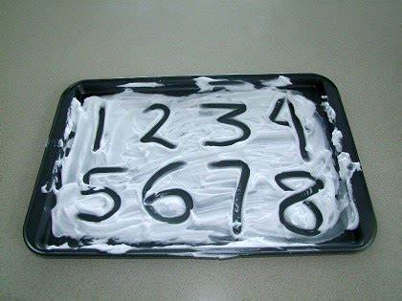
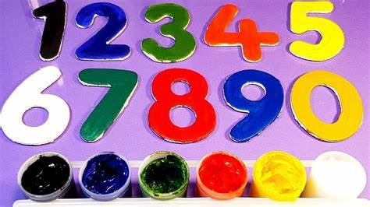
- Using the language more or less. Counting out fruit from a fruit bowl onto 2 plates. Which plate has more which has less? Counting the children’s toys/bricks. Show me what more looks like, show me what less looks like.
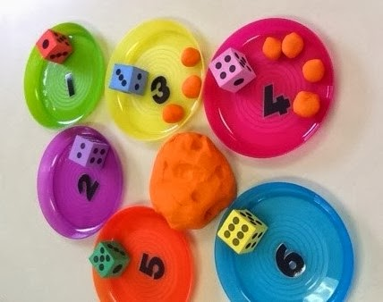
Making play dough and matching play dough shapes to numbers.
- Adding numbers together and taking numbers away. Count out 3 apples on one plate and 2 on another. How many are there altogether? Use the children’s toys and resources to make number adding games. Build 2 towers one with 5 bricks and one with 7 bricks. How many are there altogether? What would one less be? The children can take one away and count to find the answer.
- Matching a number and the quantity. Have a number to 5 can they give that number 5 apples etc.
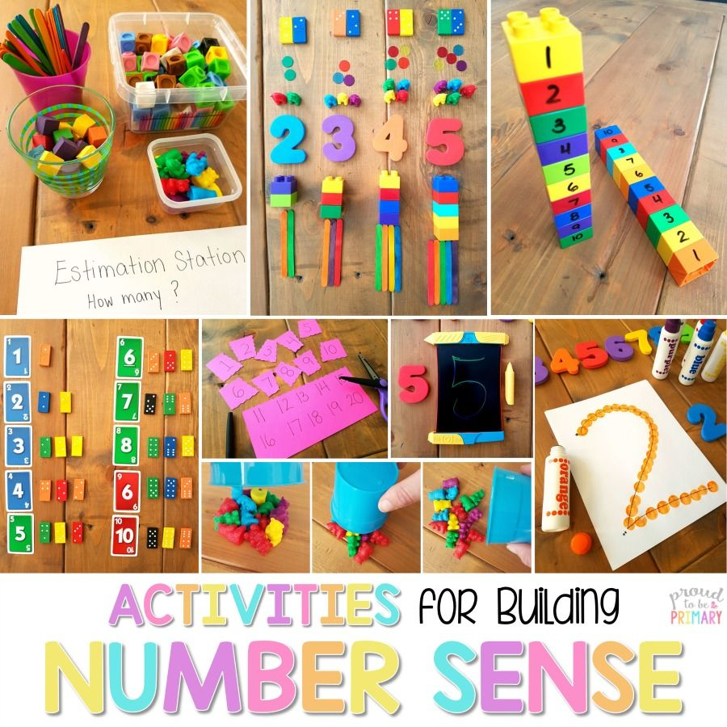
- Matching the same quantity together “which has the same?

Shapes
- Have a shape hunt around the house? What shapes can you find? What are they called?
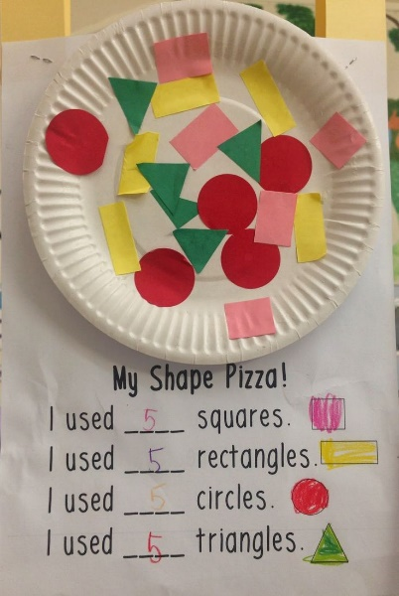

Can you make a shape pizza or a shape lollipop?

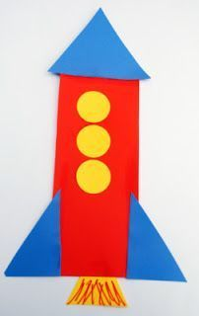

What shapes do you use to make a rocket? Or a car or an aeroplane?



