Build objects to retell a traditional tale
What to do  - Tell a traditional tale together which will lend itself to the play: try Goldilocks, or The Three Little Pigs.  - Talk about the story and what objects are important to remember if we want to tell it to someone else (3 different sized bowls, chairs and beds or three houses made from different materials).  - Make the objects together, talking about features that will be important, e.g. chair size.  - When you have made the objects, look at them and talk about how hard or easy it was to make them and what you are pleased about.  - Then retell the story together, using the constructed toys in the play. | What you need  Lego, Duplo, Magnetico, Meccano, blocks or any other construction equipment you have.  Small world figures to act in the stories  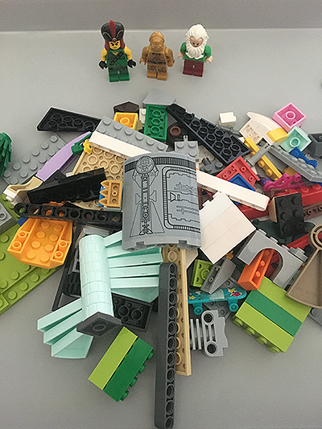
Extension  Explore using different building materials, e.g. twigs or food items (dry spaghetti, brick shaped biscuits, etc.)  Try a different story, Rapunzel, Jack and the Beanstalk, etc.  Photograph the constructions and write instructions together, so that someone else could try making your items. | Questions to ask  What objects are important in the story?  How could we make them?  How many beds will we need? Will they be all the same?  What did we make that chair from?  What was tricky about making the bowls? How would you make them another time?  Can we tell the story using what we have made?

Build a tower as big as you!
What to do  - Talk about building tall structures with construction toys.  - How tall do you think we can build a tower? Up to your knee/tummy/as tall as you are?  - Help your child as they explore building and supporting the structure, while getting it as high as possible.  - Praise your child as the tower reaches different height milestones. Photograph each stage as you go, in case of collapse.  - Celebrate the efforts of your child and their determination to build a tower as tall as they are. | What you need  This can be Duplo, Meccano, blocks, Stickle Bricks or any other construction equipment you have.  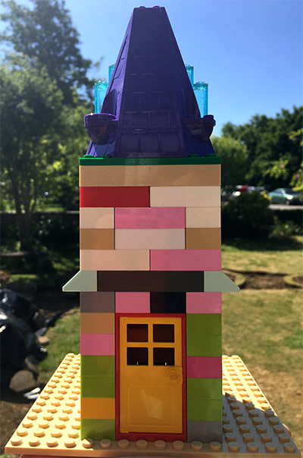
Extension  Try building towers as tall as other household members. Ask a faraway family member how tall they are and build a tower for them.  Try building a tower from junk materials. How will these need fixing together? | Questions to ask  How tall can we build a tower?  How tall are you?  Can we build one the same height as you?  How can we make it sturdy?  How high is it now? Is it tall enough?  What is the difference between your height and the tower?  How many blocks did we need?

Build a structure from twigs and tape

What to do  - Collect sticks and twigs together. This could be during a walk.  - Talk about the different colours, textures, shapes and sizes.  - Show the masking tape and how it can be ripped easily and used to make temporary fixings, easily pulled off again in order to reposition it.  - Allow your child to explore the different structures and shapes they can make by fixing the twigs together. If they need help thinking of ideas, suggest they make an animal/building/gadget etc.  - Ask them to tell you about what they have made, what it does and how it works. | What you need  Sticks and twigs  Masking tape  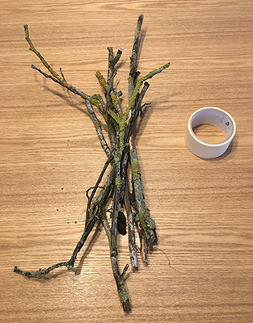
Extension  Encourage your child to make different things. If they want a record of what they have made, offer to photograph anything they feel proud of. They might want to write a label for it or instructions for its use.  Show your child how to make a triangle from three sticks taped together at their ends. Can they make a different triangle/shape? | Questions to ask  What different sticks have we collected? What colours/textures/shapes are they?  What could we make with them?  How could we fix them together?  What have you made? How does it work?  How could you add a handle?  How many sticks have you used? How many more do you need?

