Build a structure from twigs and tape

What to do  - Collect sticks and twigs together. This could be during a walk.  - Talk about the different colours, textures, shapes and sizes.  - Show the masking tape and how it can be ripped easily and used to make temporary fixings, easily pulled off again in order to reposition it.  - Allow your child to explore the different structures and shapes they can make by fixing the twigs together. If they need help thinking of ideas, suggest they make an animal/building/gadget etc.  - Ask them to tell you about what they have made, what it does and how it works. | What you need  Sticks and twigs  Masking tape  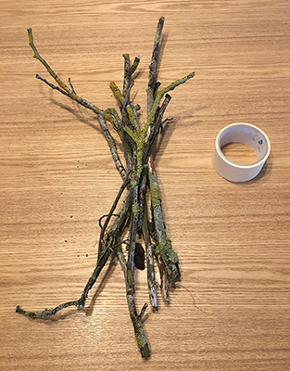
Extension  Encourage your child to make different things. If they want a record of what they have made, offer to photograph anything they feel proud of. They might want to write a label for it or instructions for its use.  Show your child how to make a triangle from three sticks taped together at their ends. Can they make a different triangle/shape? | Questions to ask  What different sticks have we collected? What colours/textures/shapes are they?  What could we make with them?  How could we fix them together?  What have you made? How does it work?  How could you add a handle?  How many sticks have you used? How many more do you need?

Build a house for an animal

What to do  - Set up the construction equipment.  - Explain the task clearly. They are to build a home for an animal of their choice. Discuss which animal this might be?  - Talk about what its home looks like.  - Give an incentive for your child to persevere and make something really special. E.g. take a photo and send to a grandparent or other favourite relation. | What you need  This can be Lego, Duplo, Magnetico, Meccano or any other construction equipment you have.  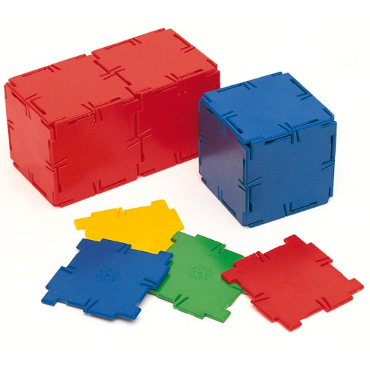
Extension  Set a challenge – e.g. can you create a nest for a bird? Can you create a two-level house for a hamster? What about a split-level cage for a monkey? | Questions to ask  How many pieces have you used – more than 20 or fewer than 20?  What shape are the most useful pieces?  Why is this home good for this animal? Tell me about the animal.

Set up a construction site and do some building
What to do  - Set up a construction site together. This could be inside or outside.  - Put on protective clothing.  - Make safety signs to warn other workers to wear hats and goggles.  - Cone out the area.  - Draw up some plans for what you are constructing. You might be building a school, bridge or a house for a story character.  - Get digging, levelling, measuring, hammering, building, sanding, etc.  - Have a tea break. Who has some biscuits?  - Order more materials, discussing how long your planks need to be or how many sacks of sand. You may need a list! | What you need  Any of the following will help to make fun imaginative play:  Hard hat, goggles and hi-vis jacket, cones, small or large building blocks, play tools, digger toys, large paper and pencils, measuring tape/ruler, pieces of wool, large tray with sand or soil  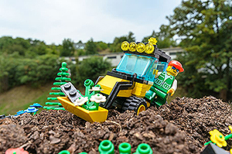
Extension  Deal with first aid needs. Wash and dress a cut, wrap a sprain with a bandage or call an ambulance for broken bones.  Be a building inspector. Take a clipboard and do some careful measuring and checking. Give the work a mark out of 10.  Drive a digger, roller or crane. You may need to make a control box from recycling with buttons and switches. | Questions to ask  What do we need to keep safe? How can we tell others?  What are we building today? Do we have some plans?  What tools do we need? Where shall we put the walls? How long is this doorway?  Who fancies a cup of tea? How many biscuits shall we have each?  How many sacks of sand shall I order? Do you know the telephone number?

Enjoying rhyming stories

What to do  - Choose a book which has a strong rhyming pattern.  - Read a few pages and ask your child to listen for the rhyming words. Can they hear them? Can they find them on the page?  - Can your child anticipate the end word in each line using the rhyming line which comes before? Can they join in?  - Choose a pair of rhyming lines. Can you think of words to swap in for the final word, e.g. ‘Where are you meeting him?’ ‘Here by these rocks, and his favourite food is roasted fox [socks].’ | What you need  Rhyming story books, e.g.  Rhyming picture books by Julia Donaldson (The Gruffalo, The Snail and the Whale)  Rhyming picture books by Nick Sharratt (Shark in the Park, Don’t Put Your Finger in the Jelly, Nelly!)  Oi Frog books by Kes Gray and Jim Field  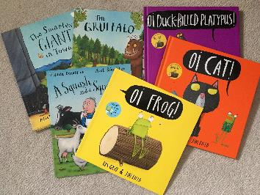
Extension  Collect pairs of rhyming words from your reading. You can play matching games with them or think of new words to add to the chain. | Questions to ask  Can you hear the words which rhyme?  Can you find the rhyming pairs?  Can you join in with the rhyming words?  What word could we swap this one for? How will the story sound now?
Some online versions
Stickman https://www.youtube.com/watch?v=o3lCfKhsOsY
Shark in the Park https://www.youtube.com/watch?v=nWRwBRVeGQs&t=25s
Kes Gray‘s books https://www.youtube.com/channel/UCoOhtVZl1EUE-o3rFpBghNg

