Day 1: Phase 2 Phonics. Can you sound out each letter in the word and blend the sounds together? Read the word and talk about the meaning of the word. Can you speak a sentence with the word in? E.g I put vegetables in the pan.

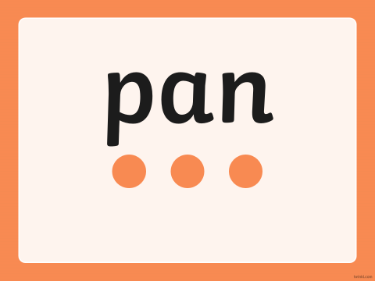
Why does this word have a capital letter? Remember names begin with capital letters.
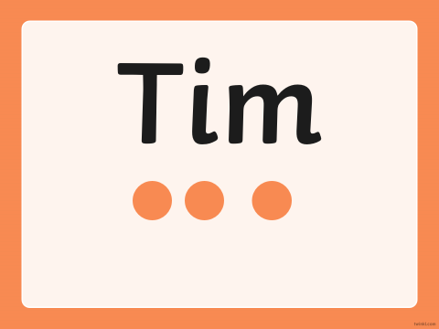
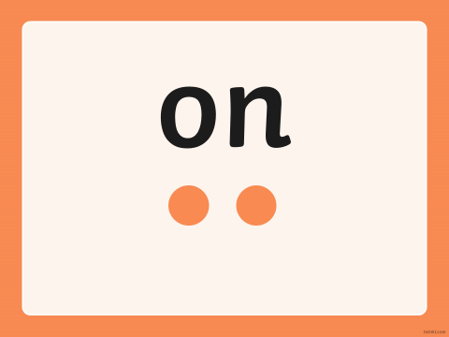
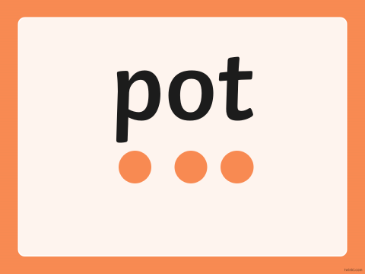
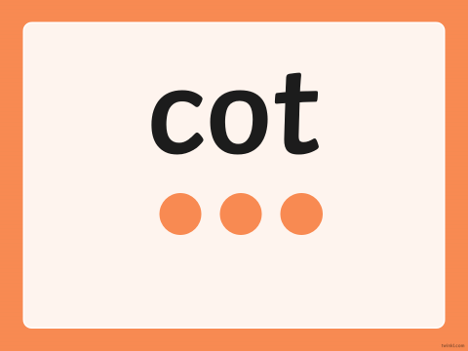
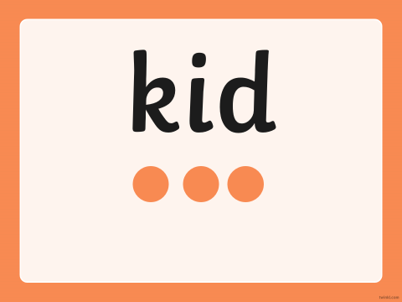

Phase 3 Phonics. Can you sound out each letter in the word and blend the sounds together? Read the word and talk about the meaning of the word. Can you speak a sentence with the word in? Look for any words with capital letters. Can you remember why these words have a capital letter?


