Reading
The children have been reading twice a week in Reception. To support the children’s reading at home we will be sharing a book with you each week. Each day we will look at one page and by the end of the week the whole book will be completed. This means you can read the whole book again by the end of the week.
Monday 11th January 2020
Run, Run!
Look at the front cover. What do you think this story is about? Who can you see and what are they doing?
Share with the children the names of the authors, Alex Lane and Paula Metcalf. These are the people who wrote the story.
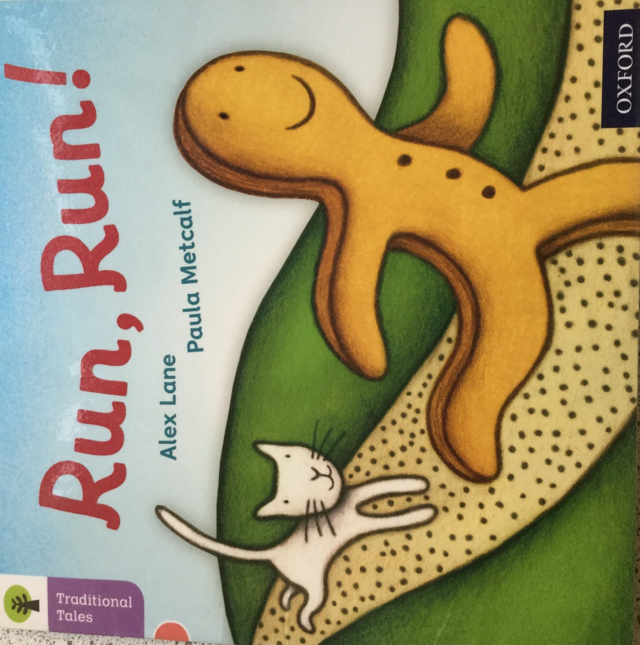
What is happening in the picture? Who can you see? Using words explain what you think has happened.
Look at the speech bubble and read the sound Mmmmm! Why do you think the lady is saying this?
What is the lady thinking and why?
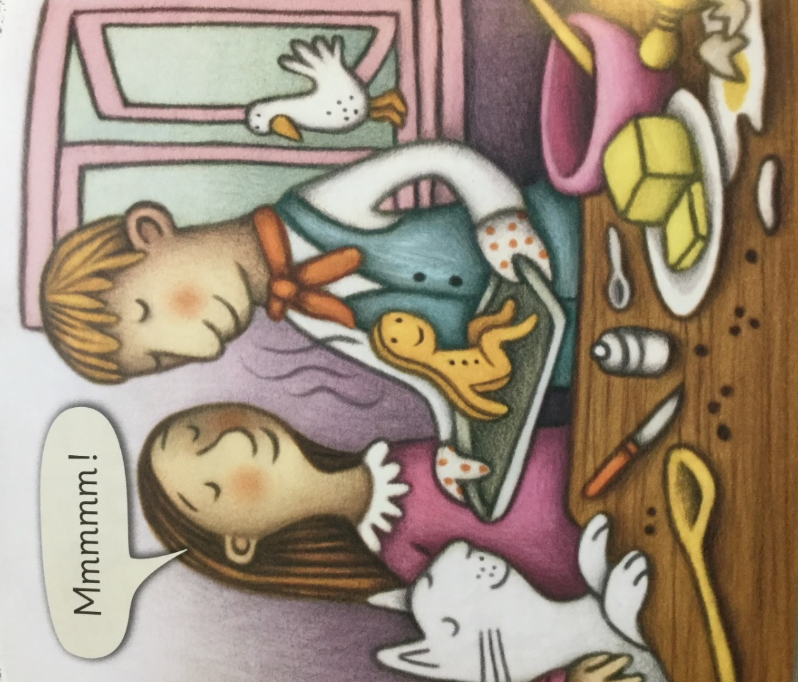

Look at the pictures. Where are the people? Where is the gingerbread man? How do you know? Why is he outside and they are inside?
The gingerbread man is thinking because we can see a thought bubble. Have a go at reading the words. What is he thinking?
Now read the speech bubble. What is the gingerbread man saying?
Why does he want to run? If you were the gingerbread man what would you be saying?


