Reception Home Learning – Tuesday 12th January

Maths
Is this easier? | Try this…  Start with this activity | Challenge yourself…
Practise using the words “nothing there” or “all gone. Use the number name zero and write the numeral 0. | Alive in 5! Week 1 Session2  Watch the video and complete the activity  https://whiterosemaths.com/homelearning/early-years/alive-in-5-week-1/ | Encourage the children to represent numbers including 0. “show me 3 fingers, show me 0 fingers, show me 4 fingers”  Try with claps, jumps or hops.

Literacy
Is this easier? | Try this…  Start with this activity | Challenge yourself…
Say the letter sounds when you see them.  Set Two sounds | Phase 2 Phonics | i n m d sounds | i n m d words - BBC Bitesize | Watch the video and complete the activities.  To map and speak a story (thenational.academy) | Can you write a simple sentence to match to the story? E.g  I am a dog.

PD
Try this…

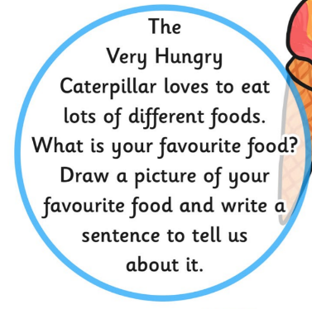
Watch the story of The Very Hungry Caterpillar:
https://www.youtube.com/watch?v=75NQK-Sm1YY

Then try this:

Is your favourite food healthy? Can you think of any
healthy things to eat?

