Tuesday 12th January 2020
Run, Run!
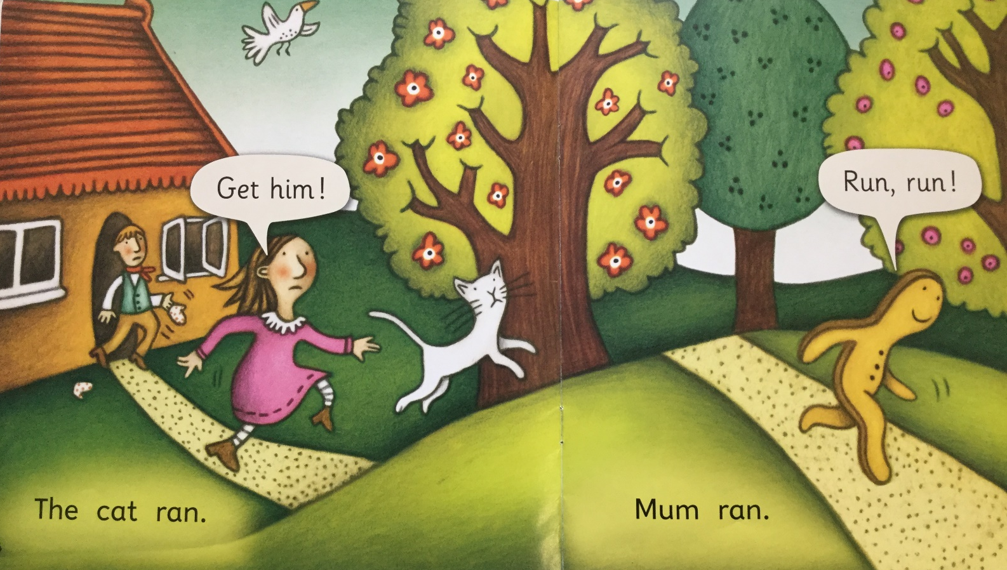

The gingerbread man is running away. Who is chasing him? Look closely at the man. He has something in his hand, talk about what this might be.
How many speech bubbles can you see on this page? Who is talking this time? Have a go at reading the speech bubbles. At the end of the words you will see a ! this is called an exclamation mark. We use expression in our voices when we see this mark. We might say the words “Get him!” in a voice that has more expression as the lady urgently wants to catch the gingerbread man.
Look at the first sentence. Remember a sentence has words. Count how many words are in the first sentence. Remember that the first letter in a sentence is a capital letter. The word “The” is a tricky word. We can’t sound this out we just have to learn it. That’s why it is so tricky! The other words “cat” and “ran” can be read using your phonics. Sound out each letter and blend them together to say the word.
Try reading the first sentence.
Now repeat for the second sentence.

