Reception Home Learning – Wednesday 13th January

Maths
Is this easier? | Try this…  Start with this activity | Challenge yourself…
Play the game but use 3 items to throw. How many land inside and outside the hoop. | Alive in 5! Week 1 Session 3  Watch the video and complete the activity  https://whiterosemaths.com/homelearning/early-years/alive-in-5-week-1/  (use any items you have available at home) | Play the game again, but this time can you write the numeral to represent how many things land inside and outside the hoop.

Literacy
Is this easier? | Try this…  Start with this activity | Challenge yourself…
Say the sounds when you see them.  The g sound | Phase 2 Phonics | g words - BBC Bitesize  The o sound | Phase 2 Phonics | o words - BBC Bitesize  The c sound | Phase 2 Phonics | c words - BBC Bitesize  The k sound | Phase 2 Phonics | k words - BBC Bitesize | Watch the video and complete the activity.  To step and speak a story (thenational.academy) | Draw a picture of your favourite character in the story.

Understanding the World
Try this…
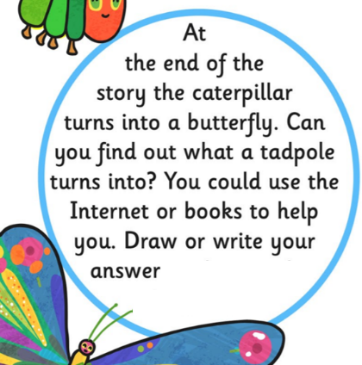
Talk about what happened in the story of
The Very Hungry Caterpillar that you
listened to yesterday.

What happened to the
caterpillar at the end?

Now have a look at this:

