Wednesday 13th January 2020
Run, Run!

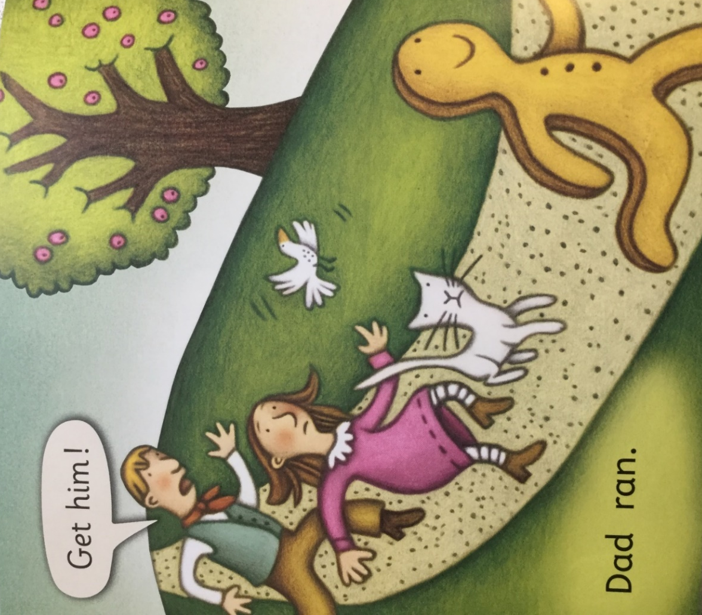

Who can you see? Look at the faces of the characters in the story. Are they all feeling the same? Talk about the expressions on their faces and why they are feeling this way.
Can you describe where they are?
Can you point to the speech bubble? Who is speaking? Can you find the exclamation mark?
Have a go at reading the words, remember to use your phonics and sound out and blend the words together.
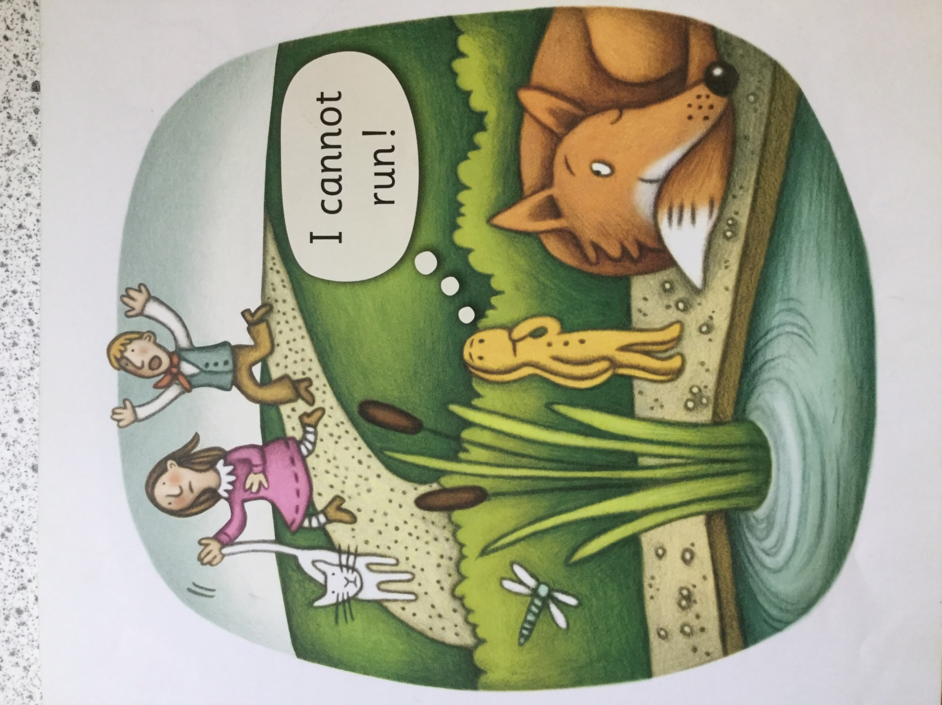

Look at this page and talk about what is happening. Where is the gingerbread man? Look at the expression on his face, how is he feeling now? Explain why his feelings have changed.
There is a new character on this page the fox. What is he doing? Look at the expression on his face. I wonder what he is thinking. Read the words in the thought bubble. Why can’t the gingerbread man run?

