Thursday 14th January 2020
Run, Run!
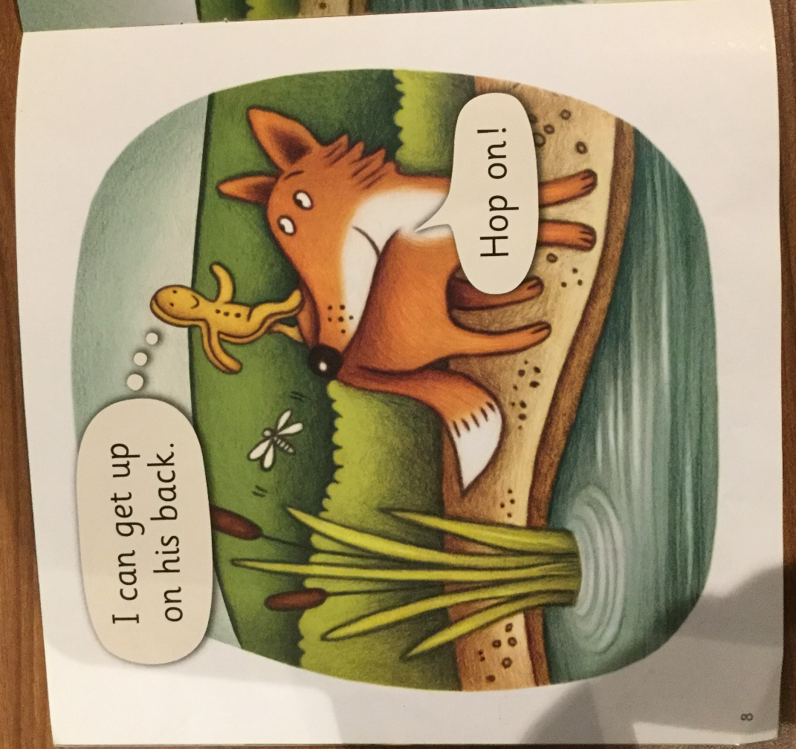

Look at the picture and describe what is happening. If you were the gingerbread man what would you be thinking or saying?
Read the words in the thought bubble and speech bubble.
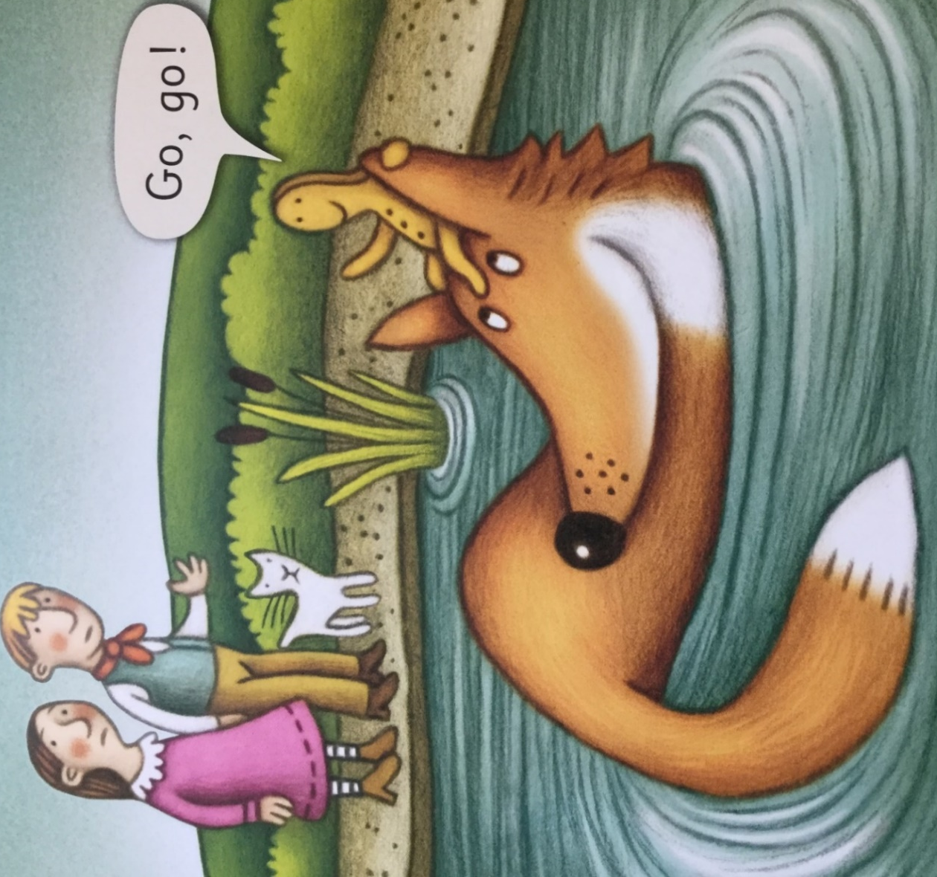

What is happening now? Describe how the characters are feeling and why?
Look at the words in the speech bubble. The word “go” is a tricky word. Remember we can’t sound this out we just have to learn it that is why it is tricky!
Both words are the same but the first letter is different. One is a capital G and the other is not. Remember we use capitals at the start of a sentence and we have a capital letter at the start of our names.
Read the words in the speech bubble.

