Play ‘Flapping Fish’

What to do  - Cut out a large fish shape from a single sheet of newspaper for each player.  - Make paper fans from a second piece of newspaper, again for each player, by folding it in thin zigzags until you have a folded fan.  - Lay the fish on the floor and explore making them move by fanning them. You can try different fanning techniques to see which has most effect.  - Line up your fish and have a race. First fish past the post wins! | What you need  Newspaper and a hard floor  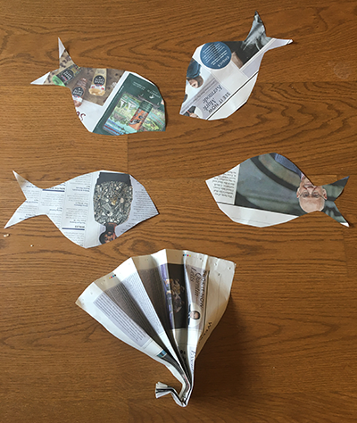
Extension  Make the game a time challenge. How quickly can you fan the fish to the chair and back?  Include some very simple obstacles into the race.  Change the type of fan. Try different shapes, different papers or a balloon pump. | Questions to ask  How can we make a fish shape?  Can we make a paper fan by folding?  Can you feel the air move when you flap the fan?  Can we make the fish move without touching it?  What is moving the fish?  Who will win the race?

Play ‘I went to the shops’

What to do  - Explain that you are going to play a game which will test your memories!  - Start with the phrase, ‘I went to the shop…’ and finish it with something that you can buy. Keep it simple at this point, e.g. ‘I went to the shop and I bought an apple.’  - The next player has to repeat the first sentence and then add a second thing that you bought, e.g. ‘I went to the shop and I bought an apple and a loaf of bread.’  - The game continues with each player adding one item to the string. It is fine to give clues and add actions to support the remembering.  - The list items tend to get more outlandish as you play.  - When the list becomes too long to remember, restart it with a new list. | What you need  Nothing needed
Extension  Make the shop specific, e.g. a bakery.  Make the game about a different place, e.g. ‘I went to the zoo/farm/beach and I saw a…’  Play with several people or over a video call. | Questions to ask  Can you repeat my sentence and add one more thing?  Can you remember all the items?  What else could you buy?  Can you remember…? It was something you draw with.

Play ‘Rock, Paper, Scissors’

What to do  - Talk about how to play the game, practising the different hand shapes, what they are called and how they interact.  - How to play:  - On the count of three, both players make one of three shapes with their hands: rock, paper or scissors  - Scissors cut paper = scissors win  - Paper wraps rock = paper wins  - Rock breaks scissors = rock wins  - If you show the same object it is a draw  - Play the game, facing each other and trying to get the highest score. | What you need  Someone to play with…  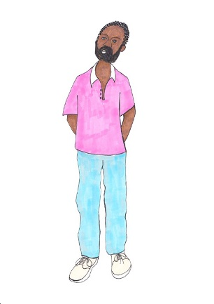
Extension  Discuss which shape is the best to win (none – although most will say rock).  Keep a tally to keep score.  Play remotely over video call. | Questions to ask  What three shapes can we make with our hands?  What happens if you show scissors and I show paper?  Who won that round?  What is the score so far? Who is winning?

Play ‘Which cup?’

What to do  - Start with 3 cups in a row. Show that they are empty and place them upside down on the table.  - Place a small object under one cup and tell your child to keep their eye on the cup.  - Make a show of sliding the cups round, encouraging your child to keep their eye on the cup containing the object.  - When you have shuffled the cups around, ask your child to point to the cup containing the object.  - You can play the game with several guessers watching. | What you need  Three identical cups which will be easy to slide around  A small ball, bead or toy  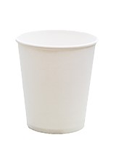  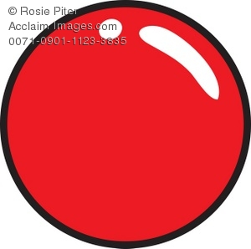
Extension  Play the game with more than one child by placing an object for different children to watch for (e.g. yellow pompom under cup 1 and green pompom under cup 2).  Ask your child to be the cup mover. Can they catch you out?  Keep score – a correct guess ends in a point for the guesser; an incorrect guess scores a point for the cup mover. | Questions to ask  Can you see the ball under the cup before I cover it up?  Can you keep your eye on the cup while I move them around?  Do you know which is your cup?  Can you catch me out?

