Friday 15th January 2020
Run, Run!
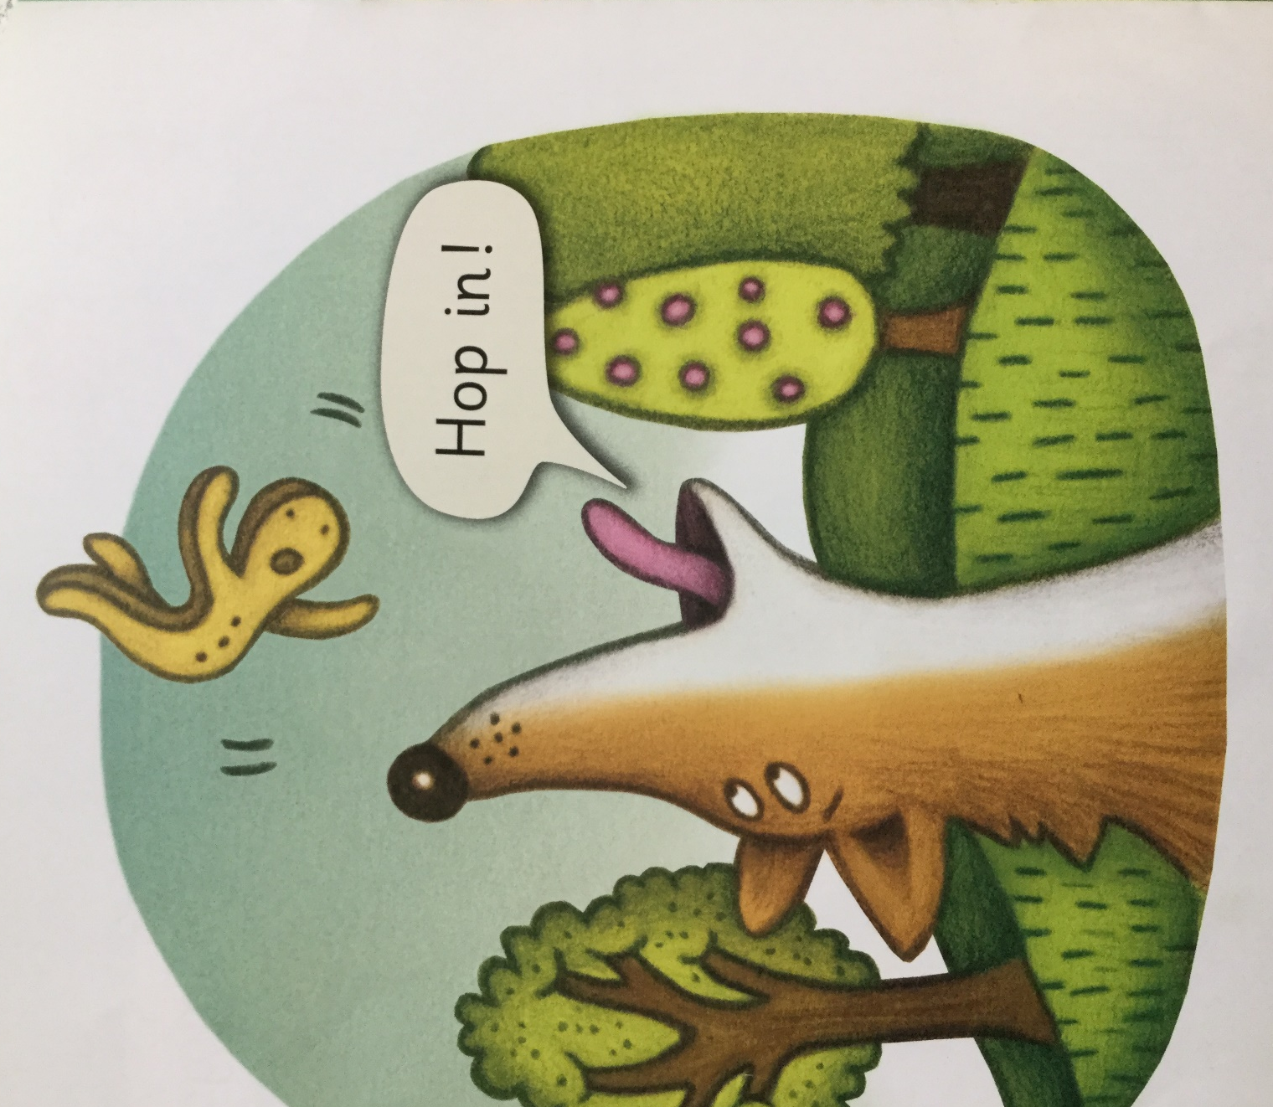
Look at the picture and describe what is happening. Read the words in the speech bubble. Can you point to the capital letter at the start of the sentence?
Imagine being the gingerbread man. What would you be saying or thinking?

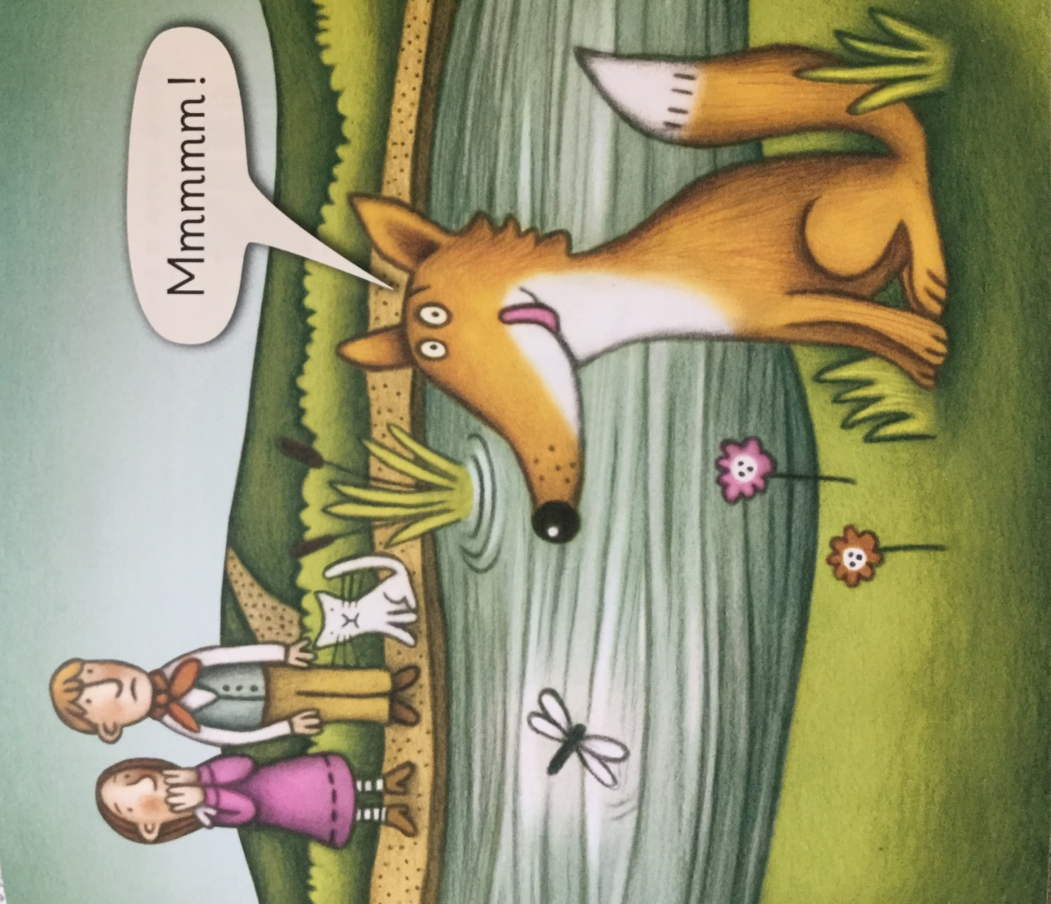

Where is the gingerbread man now? Why does the fox look so happy?
Imagine you were an author and could write another part to this story. Where do you think the fox would go next? What would happen next time he was hungry? You could draw a picture to show your ideas.
You can now read the whole book from the start to the end or you could go back to your favourite page.

