Make a stick person or animal

What to do  - Enjoy reading, watching or listening to Stickman by Julia Donaldson (see below for links if you don’t have the book).  - Look at the twigs you have collected and talk about a person or animal you could make, e.g. Stick Man, Stick Lady, Stick Dog, Stick Horse etc.  - Create the character together, fixing the twigs by wrapping them with string at 90° angle to make cross shapes).  - Add other features like eyes, hair, clothes etc. using leaves, grass, yarn, fabric and any other trimmings.  - Take your stick character on an adventure! | What you need  Twigs, string, leaves, grass  (Optional) fabric, eyes, yarn, glue and / or tape  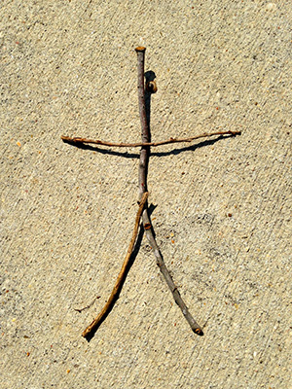
Extension  Try making a family of stick characters.  Make up stories about your character.  Make a scene using your character and other found materials, e.g. on the beach, by a river. | Questions to ask  What different materials have we got?  What sort of character could we make?  How many legs/arms/wings will we need to make?  How can we fix the parts together?

Watch on iPlayer https://www.bbc.co.uk/iplayer/episode/b06t09rk/stick-man
Listen to story being read by Julia Donaldson https://www.youtube.com/watch?v=o3lCfKhsOsY
Make a playdough dinosaur or monster

What to do  - Lay out all of the materials and talk about the different colours, textures and shapes.  - Talk about what sort of dinosaur you could make. It doesn’t have to be a realistic one. This is a chance to use our imaginations.  - Encourage lots of play, shaping, rolling, pinching and making marks with tools.  - When your child is happy with the basic shape, they can start to add decorative features.  - Give your dinosaur a name and take a photo for posterity. | What you need  Playdough & dough tools (or a table knife, rolling pin, fork, etc.)  Any decorative things, such as:  dried pasta shapes, wiggly eyes, feathers, pipe cleaners, lolly sticks, matchsticks,  sequins, buttons, etc.  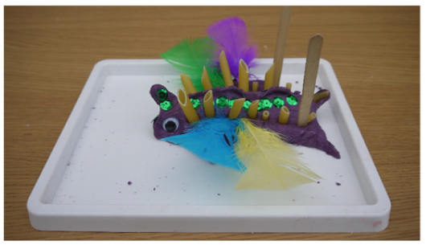
Extension  Make a herd of dinosaurs and create a stampede.  Make the shape with salt dough to make a model which can be painted and kept.  Talk about the dinosaur. Make up facts about it, such as diet, movement and behaviour. | Questions to ask  What will the dinosaur look like? What shape will it be? What textures can we give it?  How many legs/arms/heads will it have?  Will it have horns, frills or spines?  What is its name? How might it move and what might it eat?

Play ‘Twenty Questions’

What to do  - Explain that you are thinking of an animal which your child has to guess.  - They can ask some questions to help them, but they have to be questions which you can answer with ‘yes’ or ‘no’.  - Give them some examples of the type of question, e.g. Does the animal have wings? Does it have fur? Does it live under the water? Etc.  - Start the game, helping your child reframe questions that don’t stick to the rules, e.g. How many legs does it have? → Does it have 4 legs?  - Give your child pointers as to how the answers will help them, e.g. ‘Ah. You have found out it doesn’t have feathers, so it can’t be a bird.’  - If your child is not getting close, give them a question which will help them.  - Swap over and ask your child to think of an animal for you to ask questions. | What you need  Nothing needed
Extension  When you get good at the game, add the challenge of having to guess after 20 questions.  Open out the choices to other topics (food, etc.) – keeping to a topic makes this game more manageable for younger players.  Play with a group of guessers. | Questions to ask  Can you guess my animal?  What questions will be helpful?  Can you say it so I can answer yes or no?  What does that answer tell you? What can’t it be?  If it doesn’t have two legs, could there be another number of legs to ask?

Make up a story by playing ‘Over to You’

What to do  - Say you are going to make up a story. Start the story in a traditional way, introducing the characters, place and what is happening, e.g. ‘Once upon a time there was a little girl called Sorcha who found a strange box under her bed. It was covered in sparkling stones and gold shapes. When she opened it, the strangest thing happened…’  - When you have set up a tempting hook (which will not be too difficult to continue) say ‘Over to you’.  - Now it is your child’s turn to continue the story for a few sentences.  - When they reach an interesting point (probably hard to take up!) they then return the story to you to continue with the words, ‘Over to you’.  - Continue passing the story back and forth until you reach a suitable ending. | What you need  Nothing needed
Extension  Make your child the main character.  Tell the story with several storytellers.  Set ground rules to stop the story becoming too silly or themed around toilets or fighting!  Record the story as you tell it and play it back.  Try with remote family over a video call. | Questions to ask  Who will our story be about?  What sort of story might it be?  What will make our story exciting/fun to tell?  What will happen next?  What will they do now?  What will happen in the end?

