This week you can follow the link below to read a story. You can read one page a day or more. It is up to you. The book this week is called Big, Bad, Bug. There are guidelines to follow for each page below.
Big, Bad Bug (oxfordowl.co.uk)

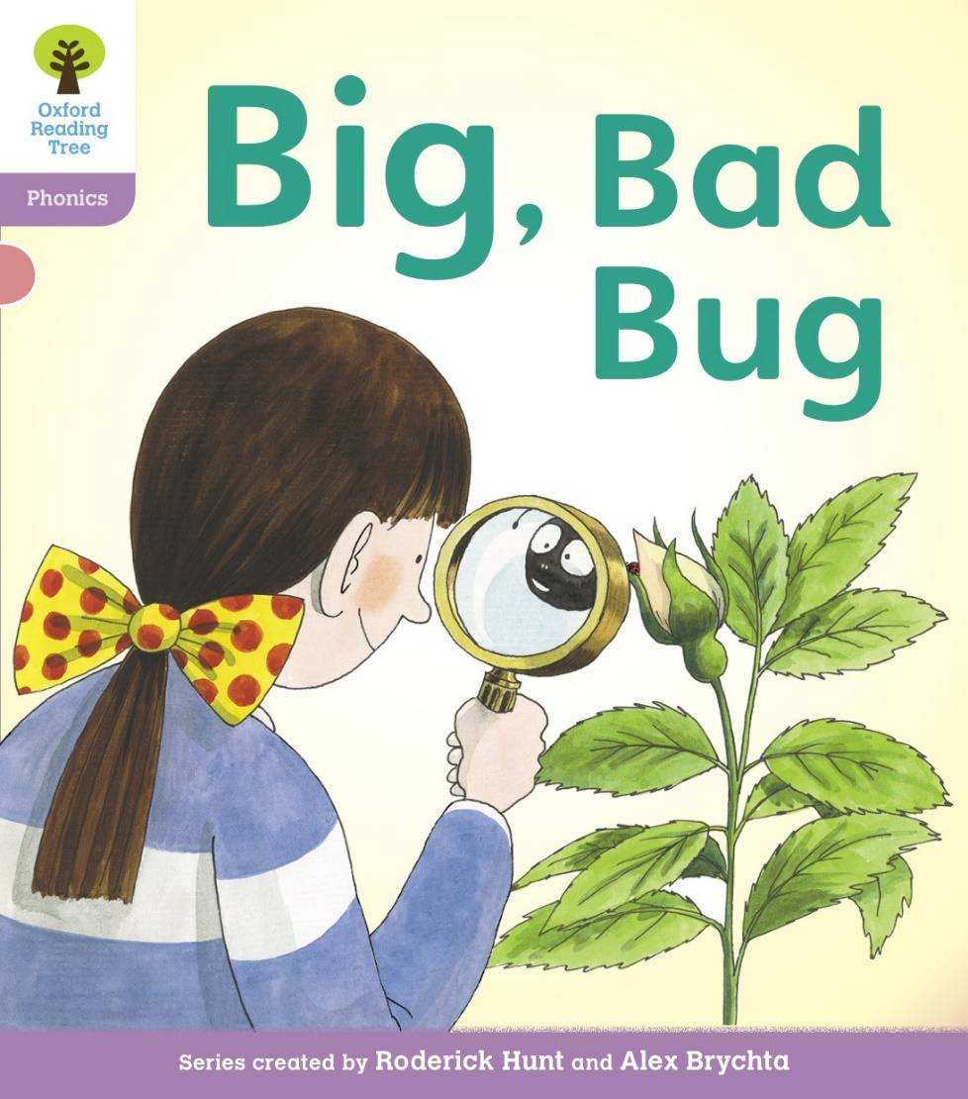

Monday 18th January 2021
Look at the front cover. Talk about what you can see. Who can you see? What are they doing? Count how many words are in the title. Use your phonics to sound out and blend the words together.
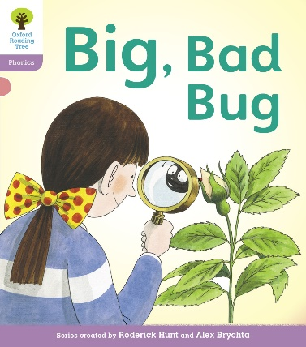
Tuesday 19th January 2021
Look at page 1. Who can you see? Where are they? What are they doing? Share and talk about places you have visited and what you enjoyed while you were there.
Look at the sentence at the top of the page. Count the words and using your phonics sound out the letters and blend together. Remember the “Ch” in Chip is two letters together that makes one sound.
Now find the speech bubble. Who is speaking in the story? Read the words in the speech bubble using your phonics.
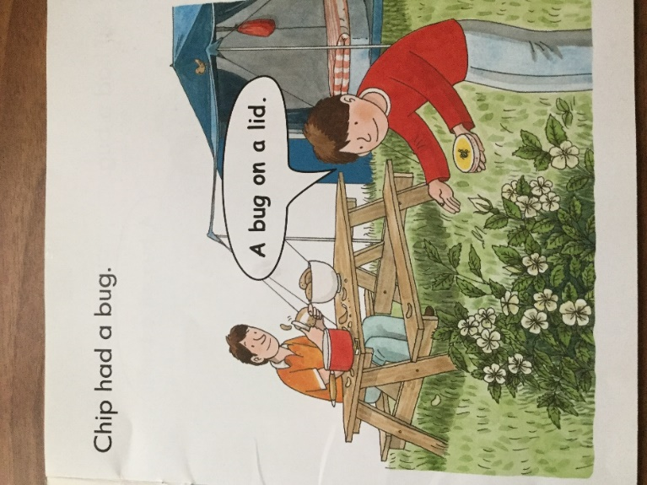

Wednesday 20th January 2021
Look at page 2 and 3. Who can you see? Count how many people you can see. Can you see someone else?
Why is Dad at the picnic bench? What is he doing? Describe what the other characters are doing and why?
Read the words in the sentences and the words in the speech bubbles.
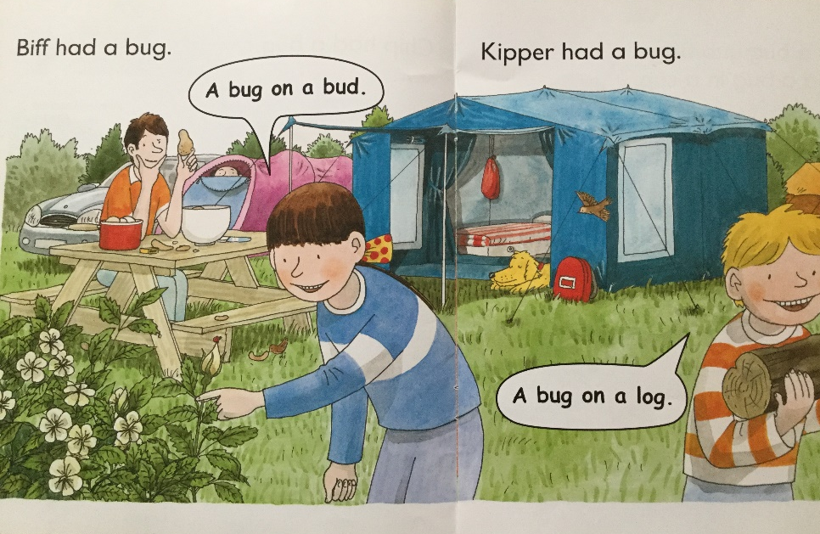
Thursday 21st January 2021
Look at page 4 and 5. What are the characters doing? Talk about and describe what all the objects are on the mat? Why would these be useful in a mini beast hunt?
Talk about mini beasts you like and why?
Read the words in the sentences.
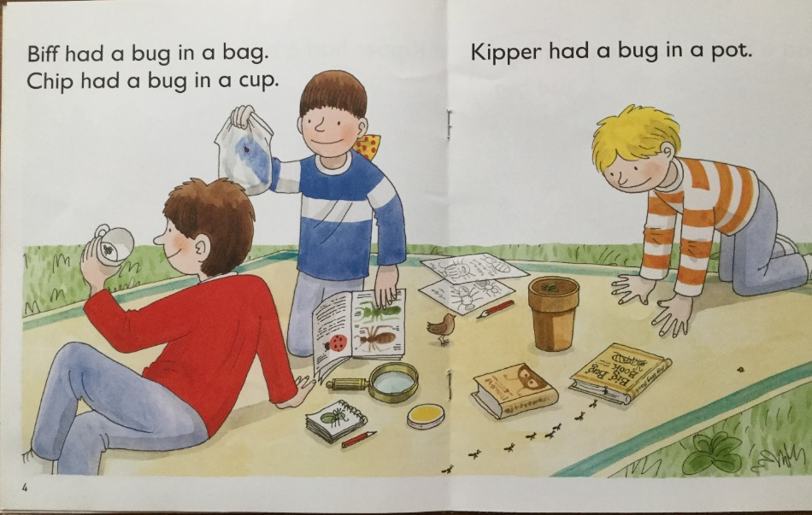

Friday 22nd January 2021
Look at page 6 and 7. Talk about what you can see. Why do you think the man is peeping out of his tent? Who is in the blue tent and what are they doing?
Read the words using your phonics to find out what is happening.
Dad thinks he has a big, bad, bug. Make a prediction before reading the next page. What bug do you think Dad has?
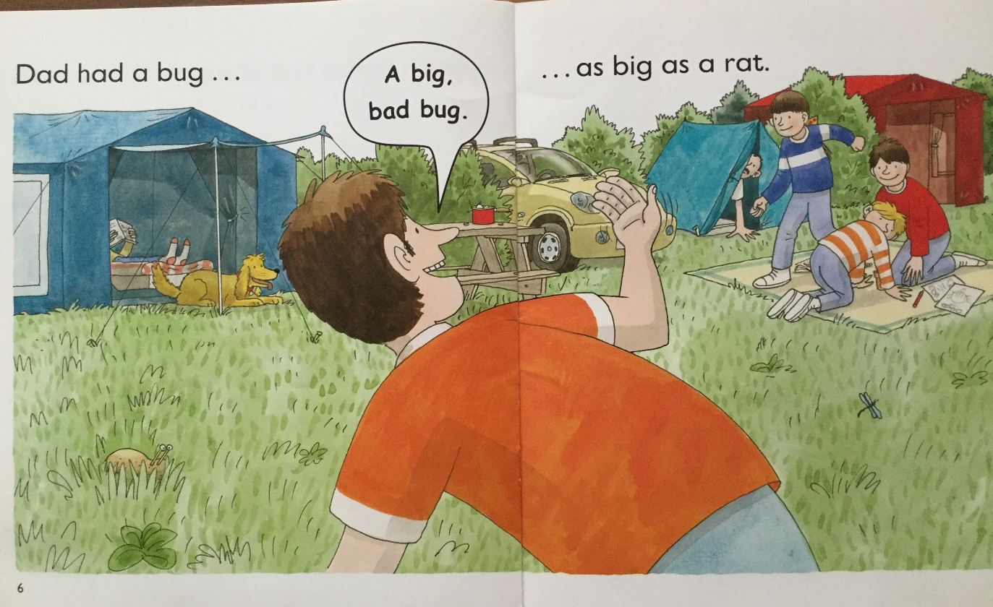

Now turn the page to page 8. Is it a real bug? What did Dad use? Read the word in the speech bubble. What do you think the children are thinking and why?
You could make a potato bug at home using felt tip pens, glue and collage materials.

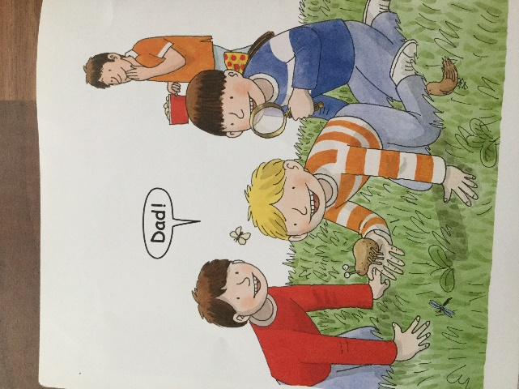

Play Activity
At the top of each page of the Oxford Owl ebook you will see Play Activity 1 and Play Activity 2. Click on these to play games linked to the book. You type a name into a box and the activity will be there for you to complete.

