Activity – Sorting and organising
Sorting and tidying shoes
What to do  - Take a ‘before’ photo.  - Look at the different footwear. Sort into pairs. Who do they belong to?  - Talk about each shoe/boot and what it is for - think about activity and weather.  - Decide if any can be put away and which must stay.  - Talk about how to arrange them in their space. Your child might decide to sort by size, colour, owner or type.  - Take an ‘after’ photo and admire your efforts. | What you need  Messy shoe space/rack/box  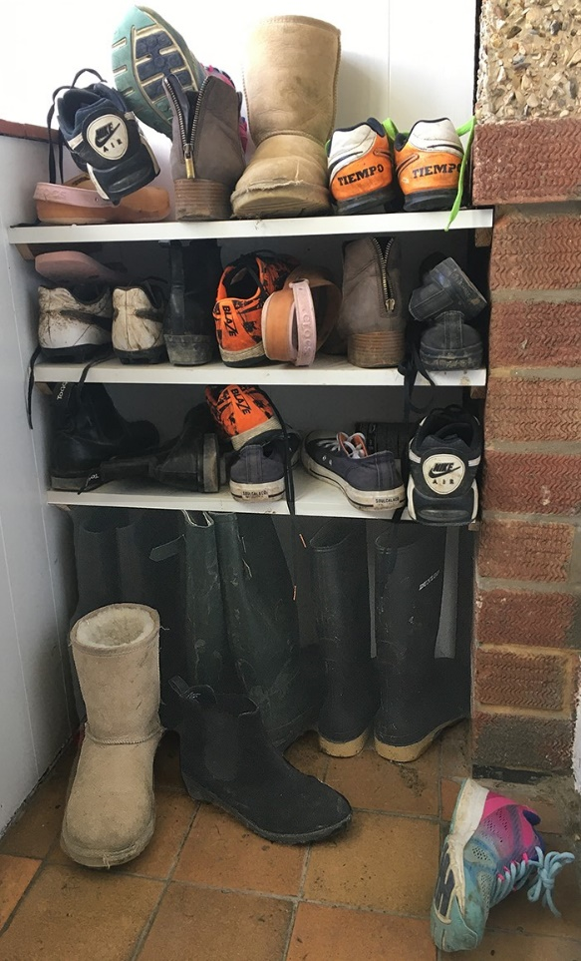
Extension  Count the shoes in pairs/twos.  Put in order of size.  Make labels for the new shoe spaces.  Make a shoe storage space from boxes and decorate. | Questions to ask  Can you find matching pairs of shoes? How many in a pair?  Who do these belong to?  Who has the most/least shoes?  Which shoes are for sport/wet weather/ inside?  Can we put any away for winter/next term?  How could we sort these to make them tidy and easy to find?  Can you see what a difference we have made?

Activity – Preparing meals
Make your own lunch

What to do  - Talk about hand hygiene, getting everything ready first and the best order to carry out each task.  - Allow your child to experiment with the best order of the process. It is likely that they will not think ahead at first but will fine tune as they go.  - Consider which tasks will always need adult input (slicing cheese) and which can be increasingly left to your child as they become more confident (cutting the sandwich).  - Example lunch-making process:  - Washing hands  - Laying the table  - Spreading butter/jam on bread.  - Placing ham, cheese slices on the bread.  - Placing one slice on the other and pressing.  - Cutting into pieces (hard at first)  - Clearing up after eating | What you need  Sliced bread, spread and table knife, sandwich filling (ham, jam, sliced cheese, etc.), bread board and plate  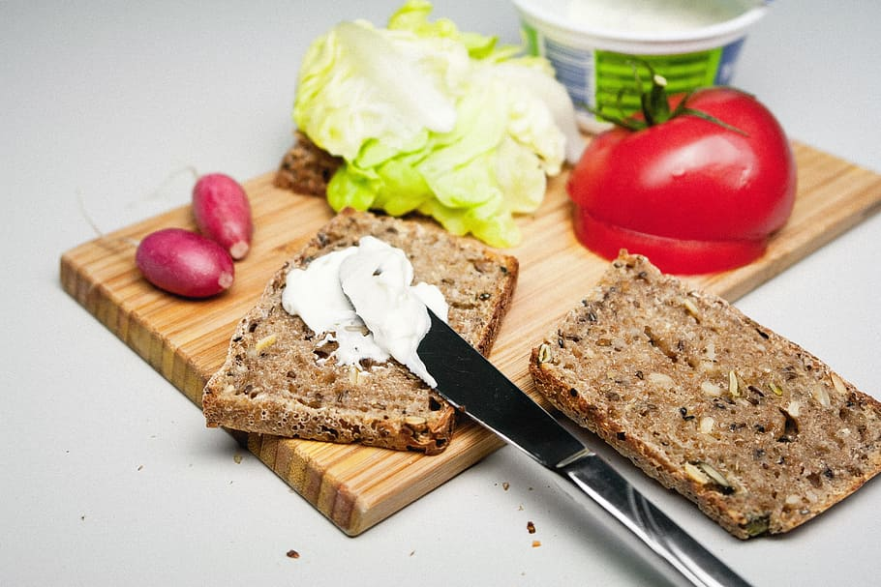
Extension  Create a list of lunches together and encourage your child to choose and organise what they need each lunchtime.  Make lunch for someone else.  Make a sandwich list and ask diners to choose from it. | Questions to ask  What must we always do before cooking and eating? Wash hands!  What things will we need?  What do we need to put on the table?  How can we keep the sandwich together?  What’s your favourite filling?

