Home Learning for Reception
Please find some below some ideas and resources that may help you while school is closed.
This website has a great sequence of learning that can be used if desired, it also have lots of lovely links. Click on the EYFS area of learning.
https://www.robinhoodmat.co.uk/learning-projects/

Mantle of the Expert
- We have been learning about Traditional tales and how stories have a beginning, a middle and an end. When sharing these stories we think about the who, where and what happened, and we talk about what these questions might mean. We look at the pictures in the books and use them to help us to answer these questions.
- In Mantle we have been working in an imaginary forest. We have been lost and found teams, who are working for the Fairy King. He has lost someone special, who is somewhere in the forest. We know this because the shadow on his magic cloak represents the person who is lost……we now know it is Goldilocks!
- Can you design and make your own Goldilocks puppets?
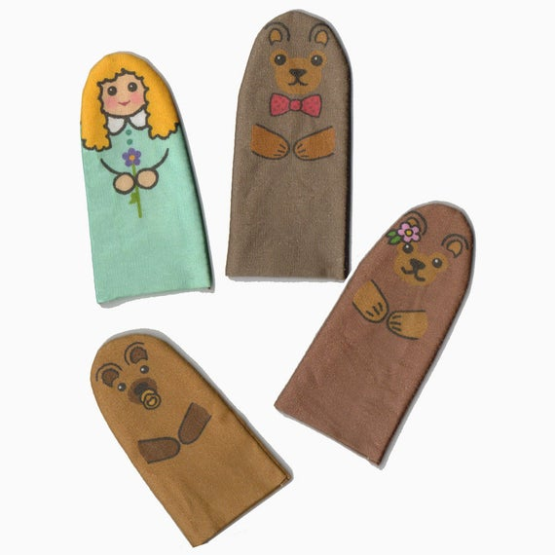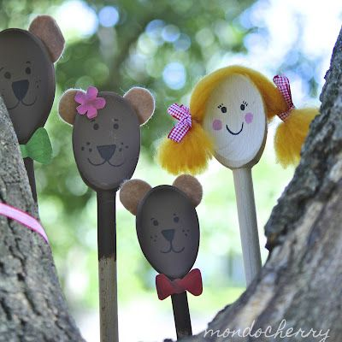

- At home you could research Forests, e.g. The animals that live in there, different names and parts of trees. How many trees can you see from your window? Are they all the same? How are they different? Are there any signs of spring?
- Can you draw a picture of a magical forest? Can you write about it?
- We have also been learning about ice, linked to the forest in the Winter. How do we make ice? What happens when ice gets warm? What does it look and feel like?
- Cooking ideas: making porridge – look at and talk about the changes in the oats before and after cooking, how long does it take to cook? Make some bear toast!
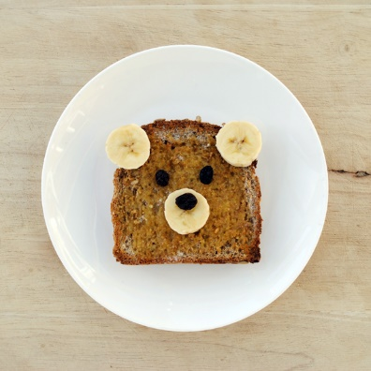

Maths - Number
- Counting from 1 to 20. Go on a number hunt around the house. Can you find the number? Name the number. Make a number snap game. Make 2 sets of numbers on paper/card and play a game of snap.
- Recording numbers from 1 to 20. Writing in sand in a tray, painting numbers, writing in gel/foam on a tray.
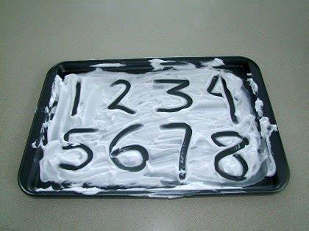
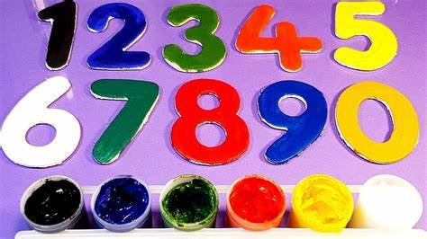
- Using the language more or less. Counting out fruit from a fruit bowl onto 2 plates. Which plate has more which has less? Counting the children’s toys/bricks. Show me what more looks like, show me what less looks like.
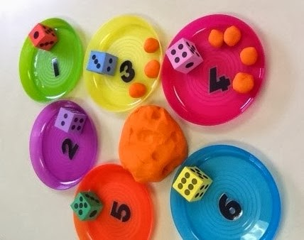
Making play dough and matching play dough shapes to numbers.
- Adding numbers together and taking numbers away. Count out 3 apples on one plate and 2 on another. How many are there altogether? Use the children’s toys and resources to make number adding games. Build 2 towers one with 5 bricks and one with 7 bricks. How many are there altogether? What would one less be? The children can take one away and count to find the answer.
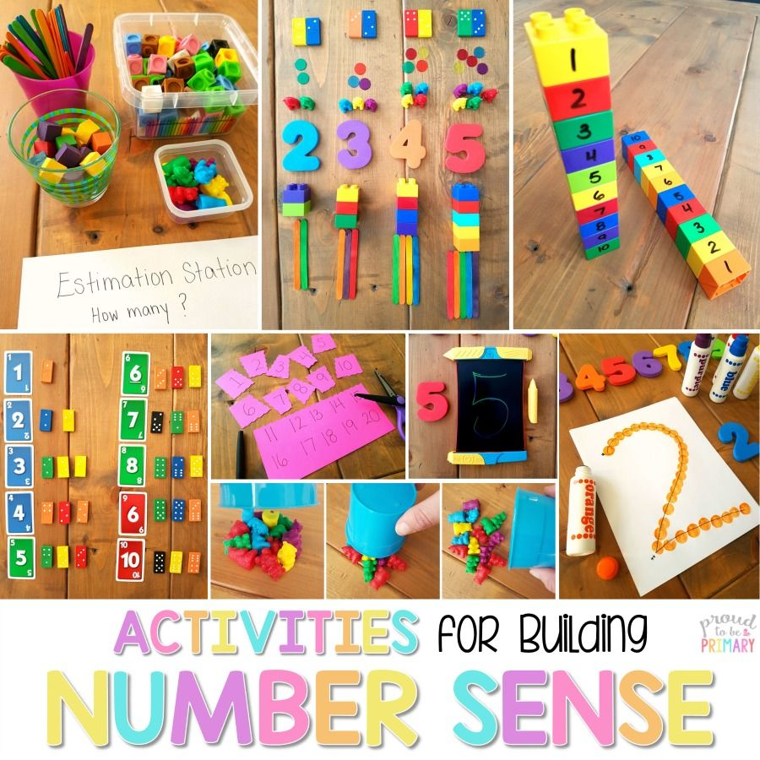

Maths – Shape
- Shape hunt around the house – what shapes can you see?

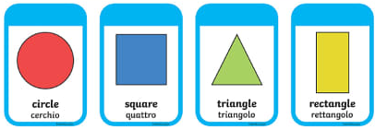

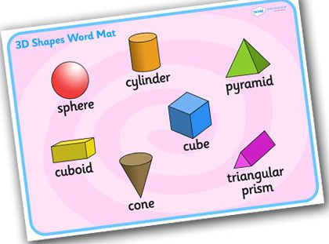
- Make a shape poster – can you label the shapes you have drawn?
- Can you make a picture using only 2D (flat) shapes?

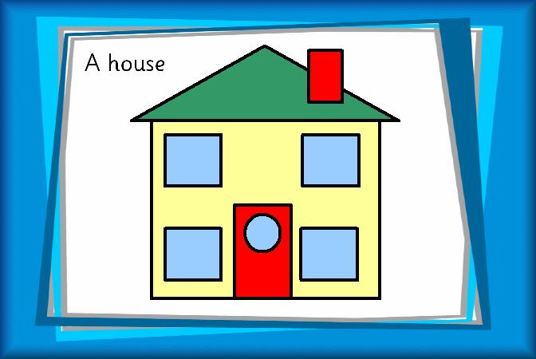

Writing
The children are now beginning to use their phonics to support their writing in class. They write at tables on lined paper and use phonics mats and power words to help them.
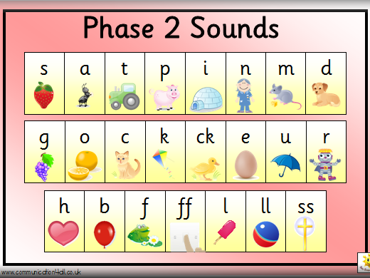
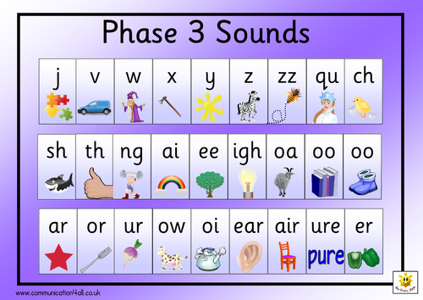

You will notice the following words are called tricky words in the picture but the children know these as power words.
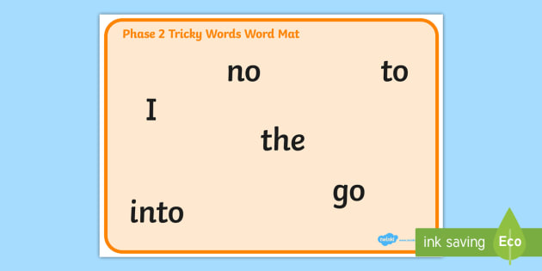
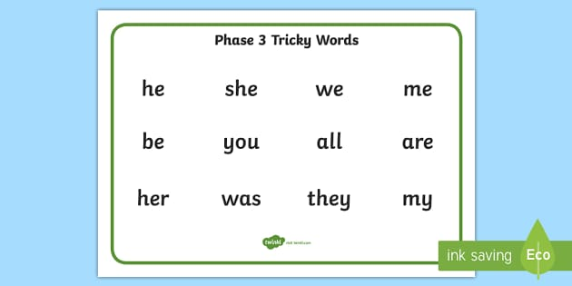
- Encourage the children to draw and write sentences about their pictures.
They will use their phonic knowledge so please do not expect the words to be spelt correctly. For example if the children draw a picture of the 3 bears they may record a sentence like this:
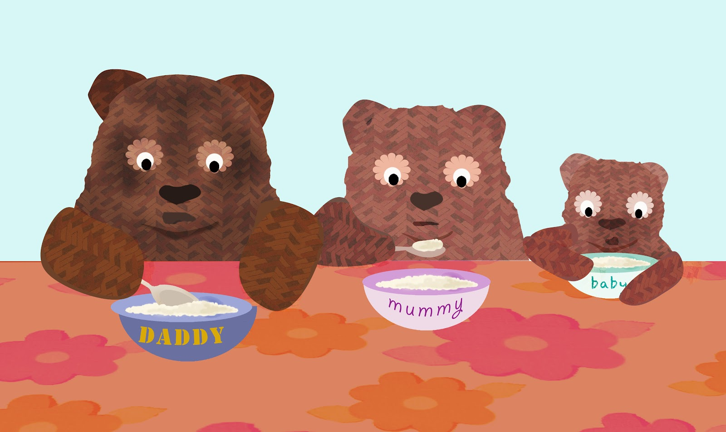

The three bairs are eeting porij.
- Before writing we always speak the sentence together and count the words. The children may say they need a tripod grip or crocodile snap (This describes the way they hold their pencil)
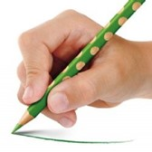
- The children are used to writing on lines so if you have ruler draw these on paper. They also have been taught to write with a pencil and colour with a crayon.
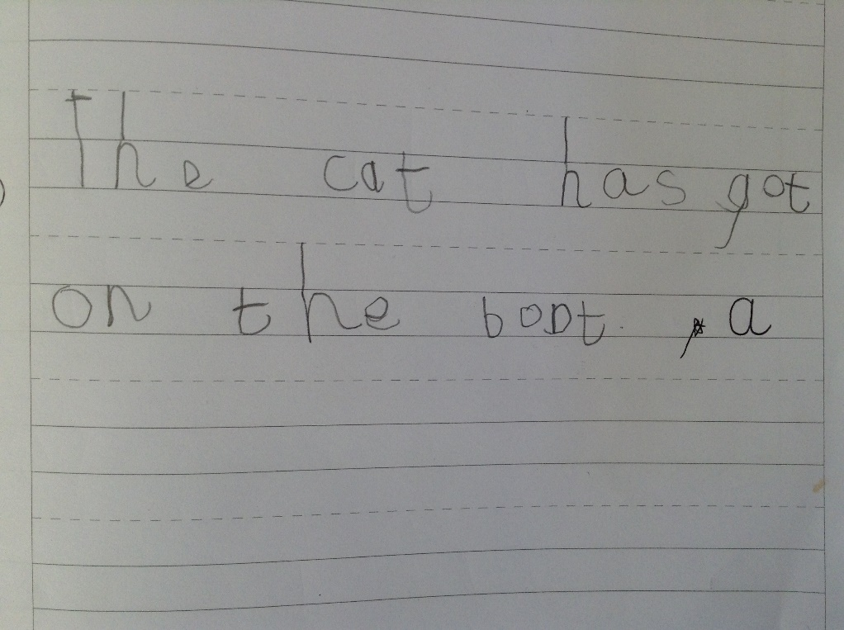

- Practice writing the power words and phonemes in gel, foam and paint.
- Play hide and seek the phoneme. Hide phonemes you have written together.

Reading
- Continue reading every day at home.
- Encourage the children to look for phonemes and power words in their books. This is not just their reading books but any books you read together at home.
- Ask them questions to show their understanding. Who is in the story? How would you describe the character? Where are they? How do you know they are in the garden? What happened? Did you like the end? Why/why not?
- Children can develop their own stories through role play/dressing up. They could plan and put on a show for their families. Encourage this and then write the story down together.

When we return to school we would love to see some of the things you have been working on together!

