Monday 18th Smarties home learning.

Phonics 20 minutes
Exploring the sound ‘ee’ what Geraldine giraffe how many different words can you think of with the ‘ee’ sound.
Can you write the words to match these pictures?
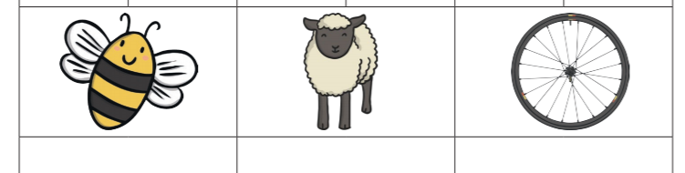
If this is to tricky try this.
New sound ‘g’ watch Geraldine giraffe how many words can you think of the start with ‘g’
Which picture does not start with the sound ‘g’
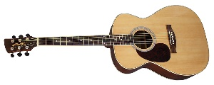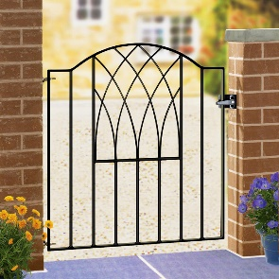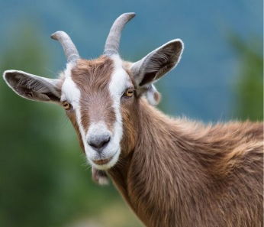
Literacy 45 minutes
We have been looking at the different clothes that we wear in winter. Can you use the word bank to label the items of clothing?
Look for the literacy pictures.
When you have finished you can write a sentence.
In winter I wear black gloves.
Or
In winter I wear black trousers and black gloves.
Maths 45 minutes
Watch the video parts and wholes activities.
Now try these questions
Can you fill in the two parts for each?



