Handwriting 10 minutes
Can you write your capital letters? Can you write your name in capital letters?
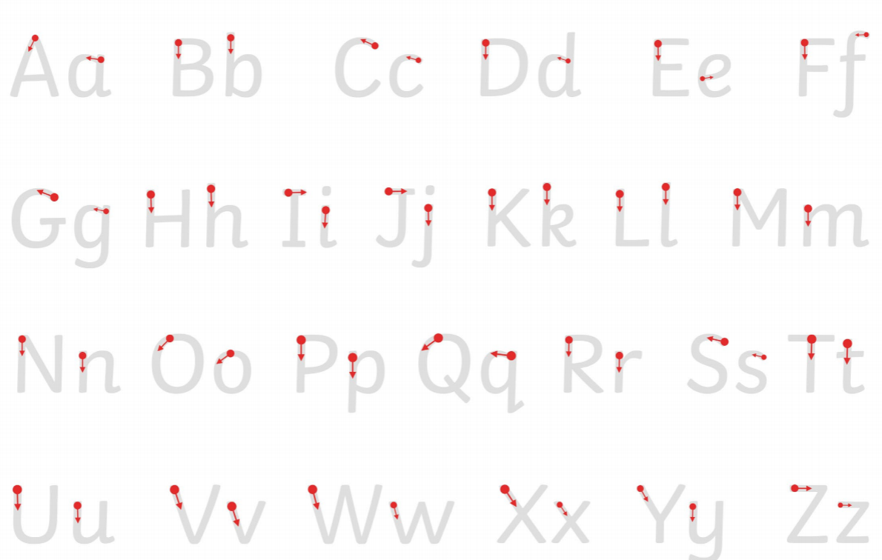
Literacy 30 minutes
In Smarties we have talked about nouns. They are naming words, things that you can touch. Go and find something to touch and shout it out. How many things can you name? Make a list of all the nouns you have found.

We have been looking at the countries England, Scotland, Wales and Northern Isle. What do you notice about these words?
They all start with capital letters, this is because they are ‘proper nouns’ they still name something but start with a capital letter like your name or the a name of a country, can you find any more ‘proper nouns’. Maybe start with the names in your family, but don’t forget the capital letter.
Check these list can you find the ‘proper nouns’
- cat van England web
- Monday fan ten dog
- leg Max sock fox

Maths 45 minutes
Today we are going to learn the numbers 11-20. If you find this tricky then try numbers 1-10.
Can you fill in the missing numbers?
12 |  | 14 |  | 16

10 |  | 12 | 13

16 |  | 18 | 19

There are some counting to 20 and 10 number games for you to try. Click the link provided.

Phonics 30 minutes
Listen to the phonics songs, how many sounds can you remember?
Write the words for each of these pictures.
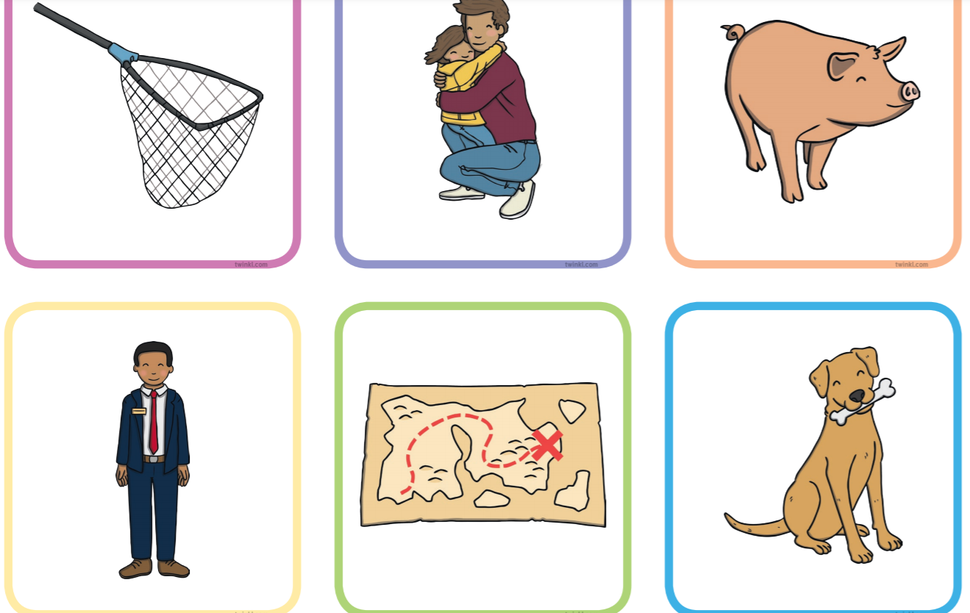

Can you choose two pictures and write a sentence.

