In winter the weather gets colder. What weather do we find in winter?

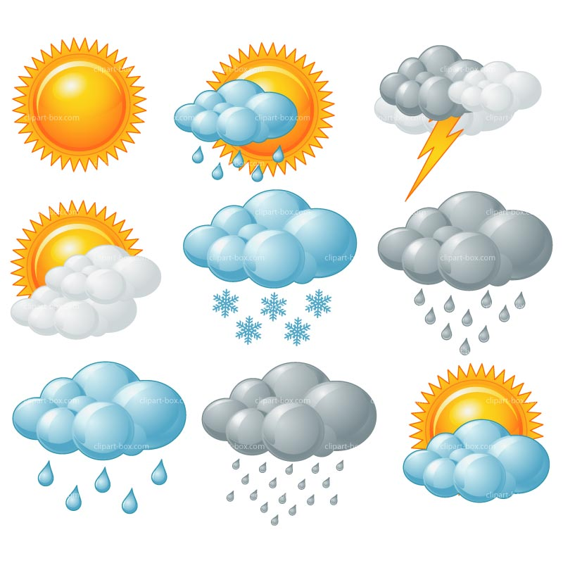
Can you match the correct pictures for winter?
Will I wear a swimming costume in winter?



