Handwriting 20 minutes
Miss Davies has added a video on how to make playdough at home.
You will need:
- ½ cup Salt
- 1 cup flour
- 1 cup Water
Optional
- Oil tablespoon
- Something to colour it paint or food colouring.
When you have made your dough you are ready to join for dough disco. Follow the video I have posted.
Your dough disco challenge is to make a dough tree.
Phonics 20 minutes
Fill in the missing words. look at the picture to help.
Fill in the blanks with the missing words:
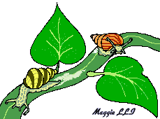
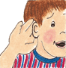
- __________ have a shell on their back.
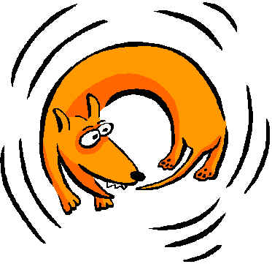
- I’m in __________, my ear hurts.
- The dog is chasing its __________.
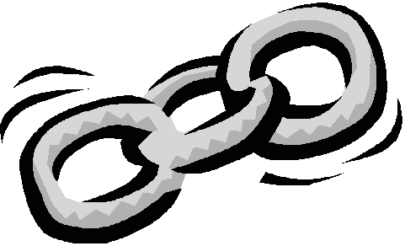
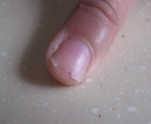
- The __________ is gold.
- I broke my __________.
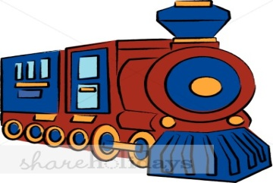
- The __________ is red.
chain train Snails

pain nail tail
If you gave been looking at the sound ‘d’ try this activity.
Can you sort all the pictures under the correct sound? E.g sun I would put under the ‘s’
Maybe you could write the letters on paper and go on a hunt around the house to find items that start with the sounds. Here are some examples: sock, pen, tape, dog, teabag.

s | t | p | m

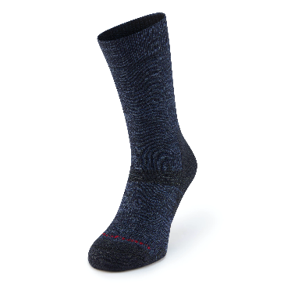 | 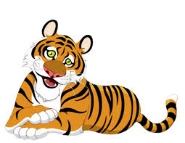 | 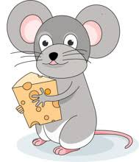 | 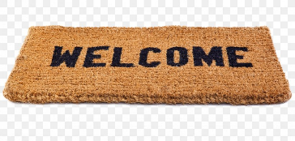
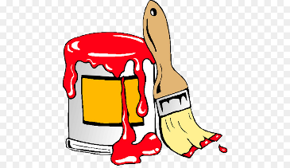 | 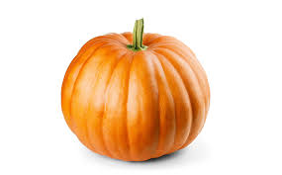 | 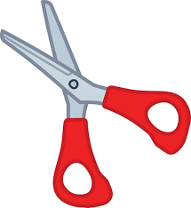 | 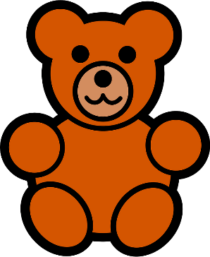

Maths 45 minutes
Starter
Follow the link below and play the game.
https://www.topmarks.co.uk/learning-to-count/underwater-counting
We have been looking at using non-standard measure today we are going to use a ruler to measure. If you have a tape measure or ruler great, if not we can make one.
Ask a grown up to draw you a tape measure like this:
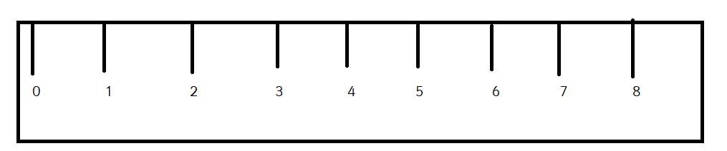
Remember when measuring always start on 0. Your job today is to use your ruler to measure objects in the house. Watch Miss Davies.

