Wednesday 13th January afternoon home learning

PSHE:
Listen to Mrs Bridges read ‘How are you feeling today?’
https://www.youtube.com/watch?v=DHCJPdDNEAI
When the video is playing you may want to stop it with your adult and talk about the different feelings. You might want to share when you felt happy. I felt happy when I play with my friends.
Being in lockdown and not seeing our friends can make use sad. At the end of everyday think of one thing that made you happy on that day. You could help a grownup at home, keep your room tidy, share a book, watched a video of your teacher.
With your grownup you might like to make your own feeling chart or use this one, so that you can discuss how you are feeling each day. It is important to talk about how we are feeling.
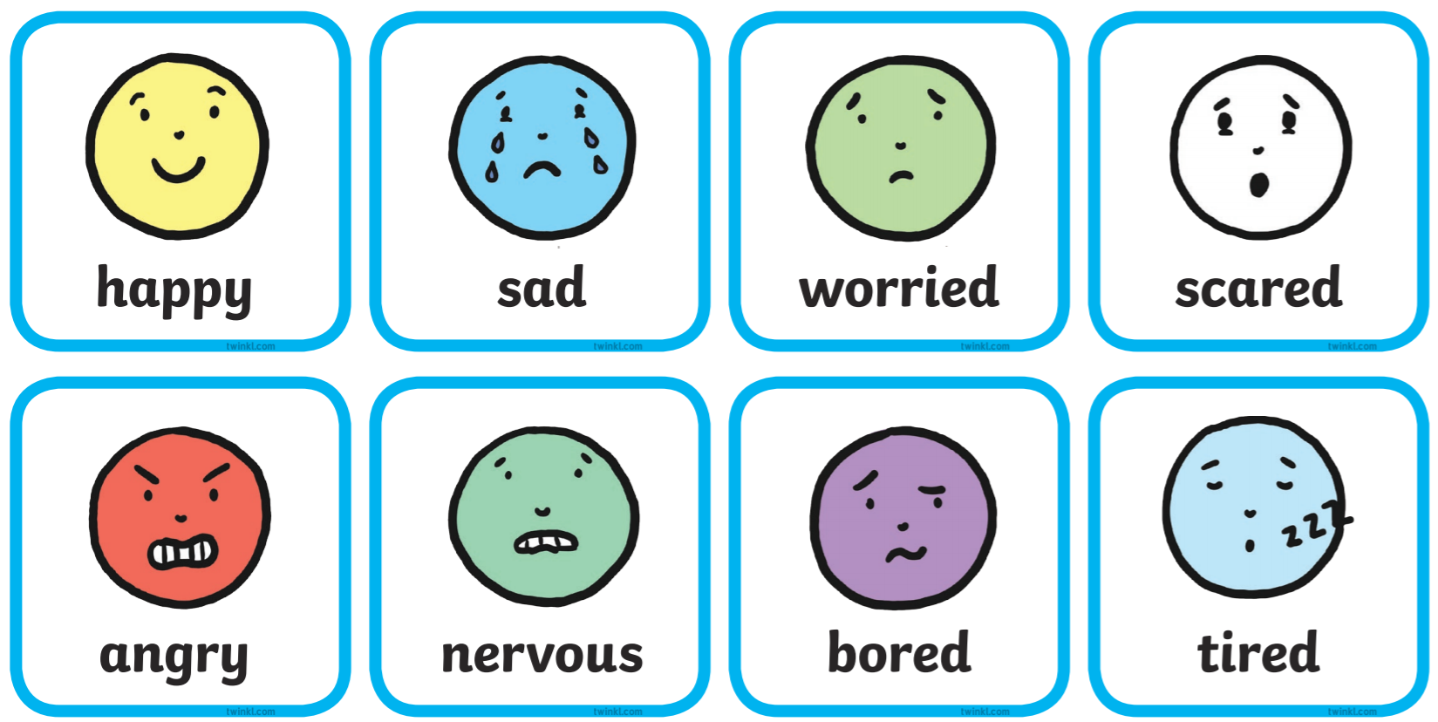

I have provided some examples of different ways to can share your feelings that you could make at home.


