Handwriting 10 minutes
Join in with this video
https://www.youtube.com/watch?v=N6kPcQSSsEY
with a pencil or crayon on both hands on a piece of paper can you try and draw some shapes?
Lets get our hand warmed up before we write today.

Phonics 20 minutes
Tuesday
Can you complete?
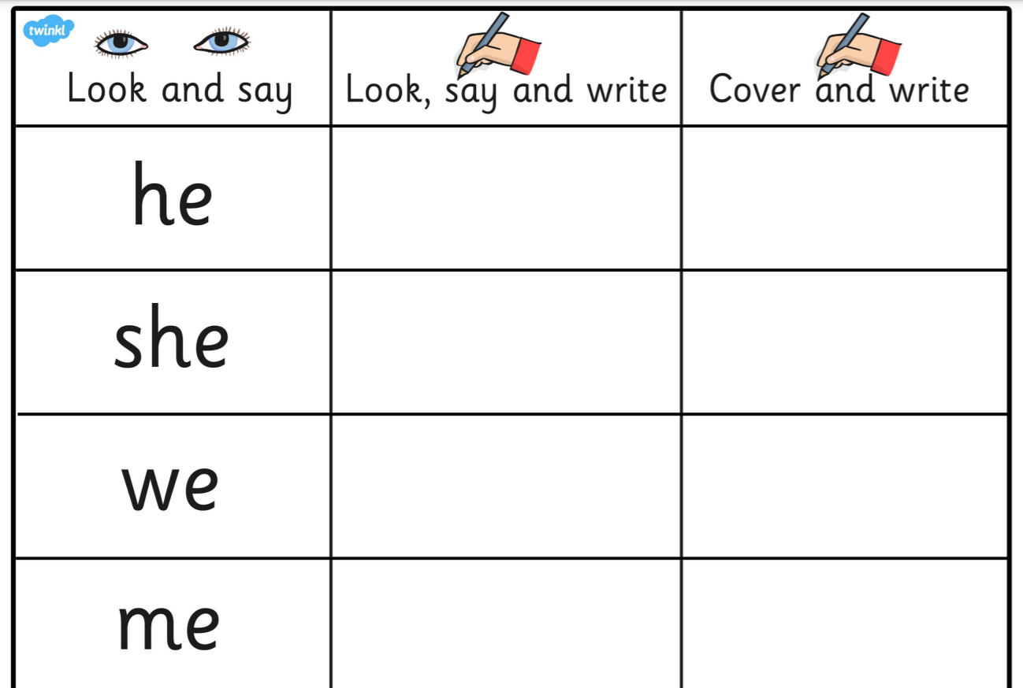

If this is too tricky try this
Write the letter ‘g’
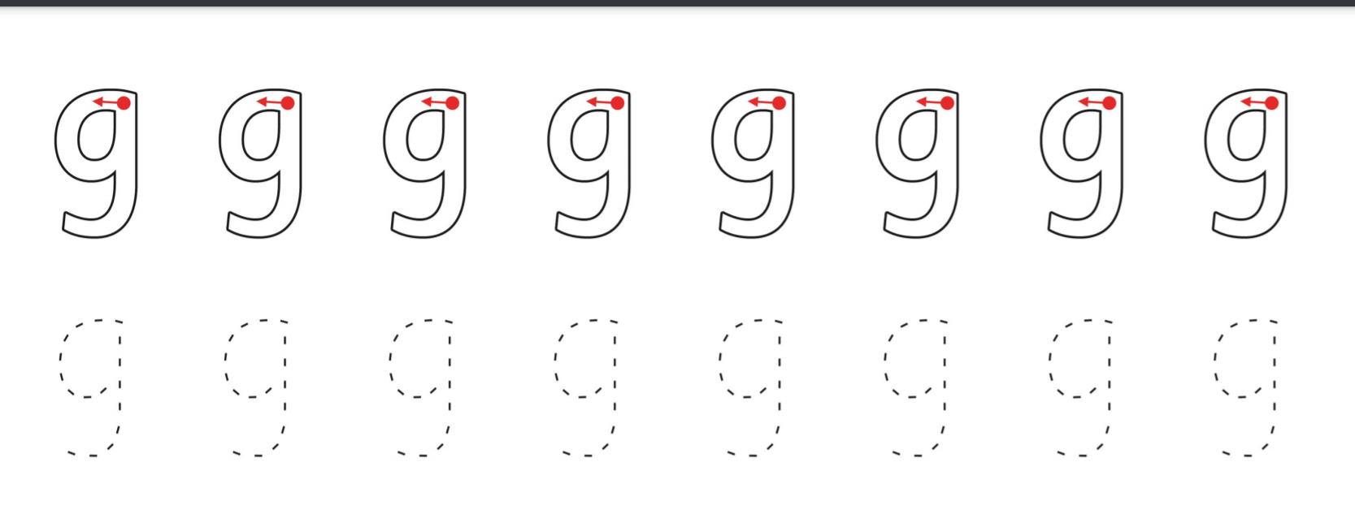
How many things can you find that start with ‘g’

Literacy 30 minutes
Listen to the story the stickman read by Mrs Bridges.
Look at the questions to share with a grown-up about the book I have posted.
When you have done that, can you put the pictures in the correct order? What part of the story came first? When you have ordered the pictures can you think of a sentence for each picture to tell the story?

Maths 45 minutes
Watch the video from yesterday whole, part activities.
https://whiterosemaths.com/homelearning/year-1/week-5/
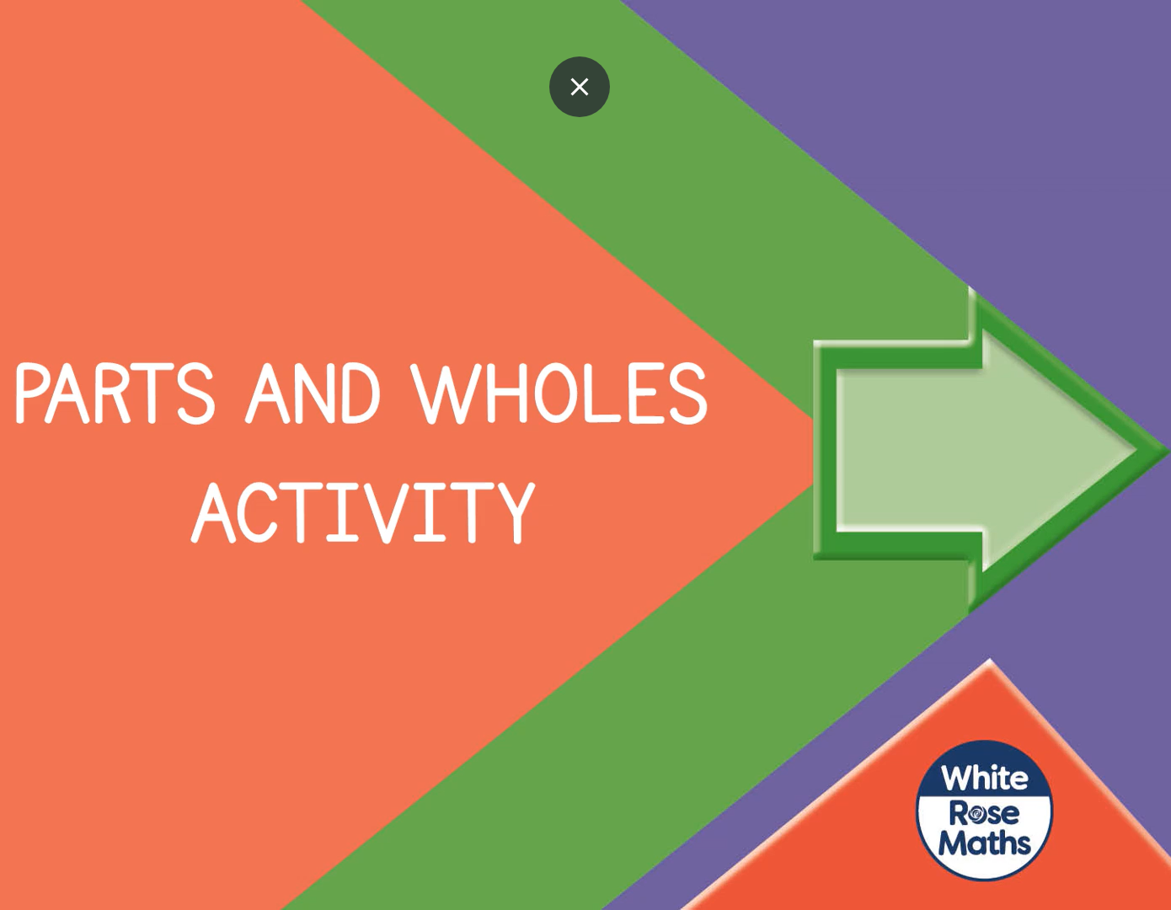
Yesterday I gave you the whole and you needed to find the two parts. Today I have given the two parts can you find the whole.

One part has 2 and one part has 3. The whole is 5.

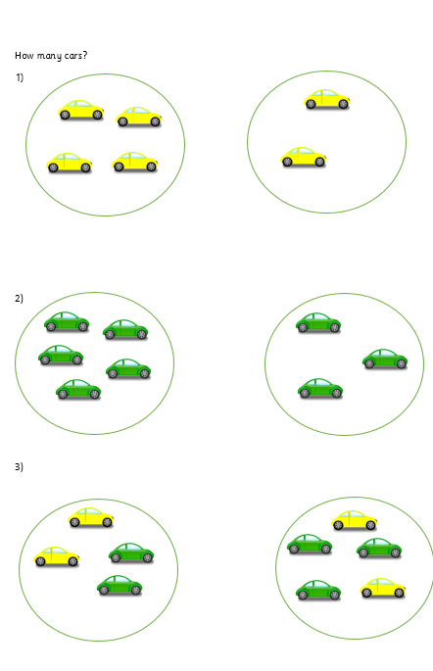
Can you complete questions 1-3?

