Science 45 minutes
Last week we have been looking at the book ‘not a stick’
What do we know about sticks?
The shape, colour, where they come from?
Can you think of any questions we could ask about sticks?
Are all sticks brown?
Are they all the same size?
Where do sticks come from?
Why do sticks fall off the tree?
The question we are going to explore are all sticks the same size?
Why don’t you go for a walk with your grown up or into the garden and collect some stick and bring them inside. I suggest you pick 3 sticks you like.
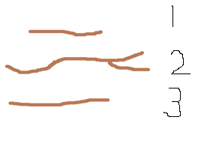
When you have collected your sticks label them 1, 2, 3.

Measure the sticks and record your findings in a chart like below. Remember you can use objects in the house to measure. For my measuring I used paperclips. Stick 2 was 7 paperclips long.
7
6
5
4
3
2
1
 | Stick 1 | Stick 2 | Stick 3

Look at which one is longer and which one is shorter. They might be all the same size? Explain the shorter stick has the smallest number and the longest stick has the biggest number.
Can you answer the question are all sticks the same size? What did you find out?
Maths 45 minutes
Watch the video that I have posted for today finding the longest, shortest and tallest.
Have a look at these questions can you answer them?
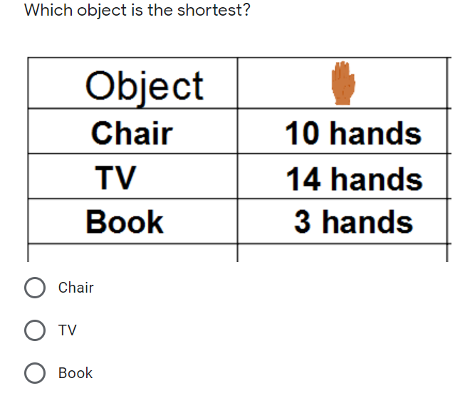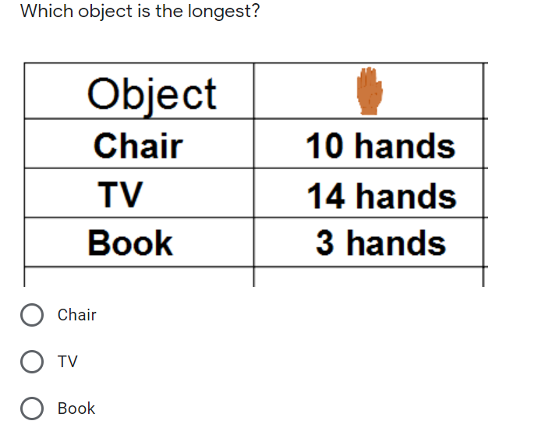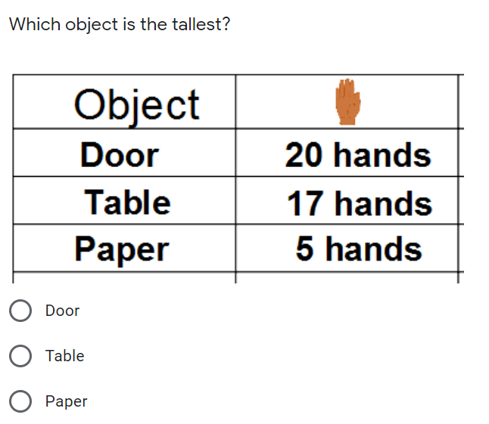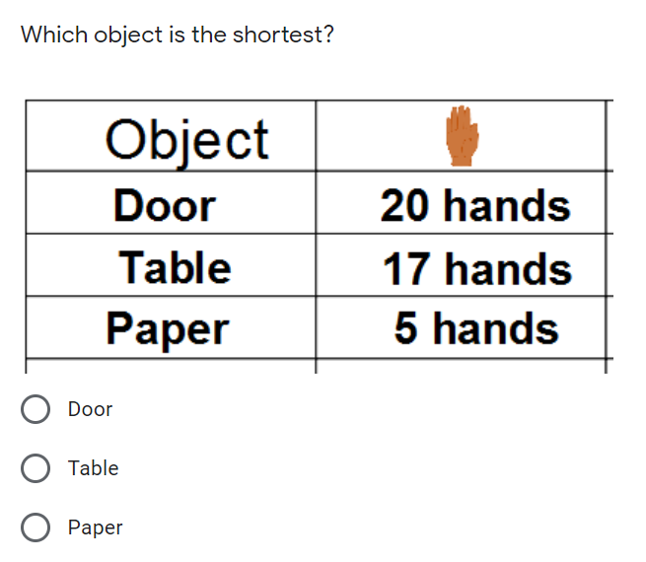
Make your own table and measure some things in your house using your hands. Find which is shortest, longest and tallest
Phonics 20 minutes
Following on with the ‘ai’ sound. With the list of words can the children put on the sound button.
I have done the first one for you.
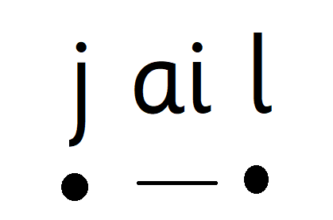
When two letter go together to make one sound we draw a line. When the sound is on its own we put a dot.

snail tail fail paint mail

if you are exploring the sound ‘d’
can you match the words and pictures correctly.
 | 
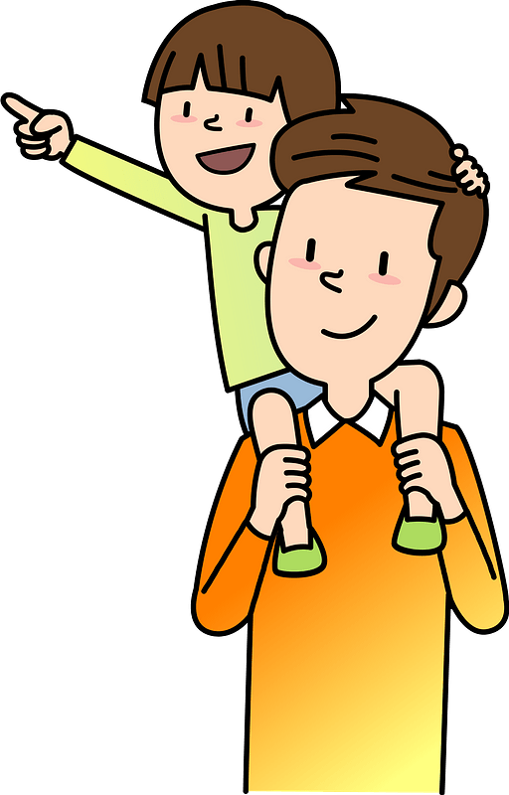 | 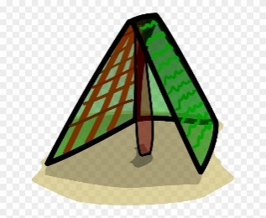

dip | dad
den | dot

