Friday Morning Home Learning

Phonics: 20 mins
Recap the sounds ‘ch’ ‘sh’ ‘ng’ ‘th’ if you are unsure this Youtube video should help. https://www.youtube.com/watch?v=7y60LdTj4gg
Write the sounds ‘ch’ ‘sh’ ‘th’ ‘ng’ on a piece of paper. Say the word from the pictures e.g chick can they select the correct sound ‘ch’. Bath the child will point to the sound ‘th’ shell the child will point to ‘sh’
Activity: children to write the words filling in with the correct sound ‘ch’ ‘sh’ ‘th’ ‘ng’
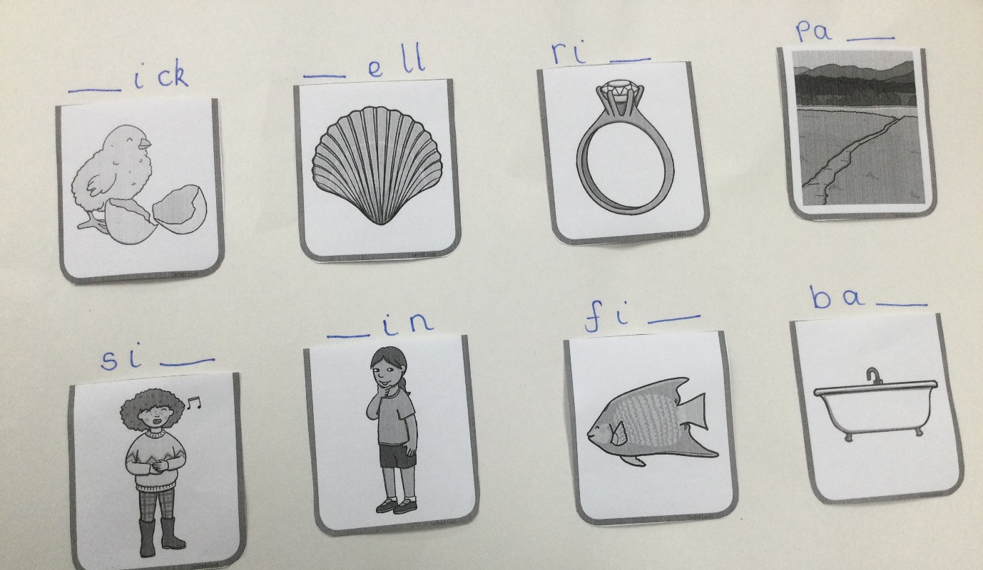
If your child finds this too tricky. Try this;
Listening to the jolly phonics songs: https://www.youtube.com/watch?v=jvAYUvQUrGo
Children to write a word for each picture.
Sit, pit, nip, mit. Can they build the word using the letter cards from Wednesday and copy it down. They may not need to build the word.

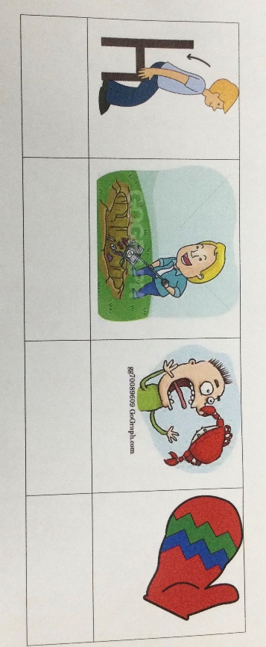
Can they spot which on is the odd one out? Look at the endings of each word. ‘nip’ is different.

Literacy: 45mins
Today we are going to look at who, what and where, to help build a sentence.
Draw the table below.
Who? | What | Where?

Who is in the story of ‘not a stick.’?
Draw the ‘who’ under the heading ‘who’. (pig)
Who | What | Where
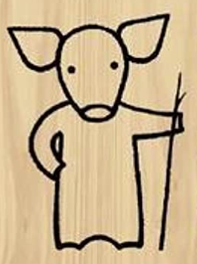 | 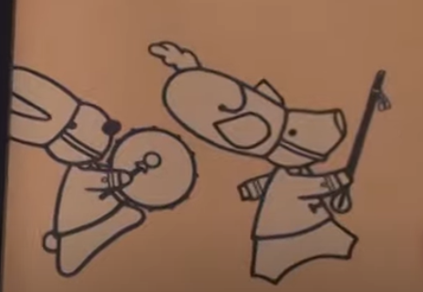 | 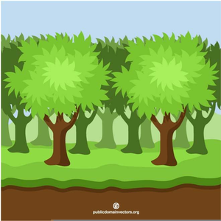
pig | banging | woods

Your child has drawn their own picture of ‘not a stick.’ Think about what is the pig doing with the stick? Is he they painting, running, playing…… draw what the pig is doing under the ‘what’ heading. Next we can think about ‘where’ is the pig. The where can be a castle, the woods, a park you can decide. Finally we can put it all together to make a sentence. We can write the sentence or say the sentence. The pig is banging a drum in the woods.
Another example:
Who | What | Where
 | 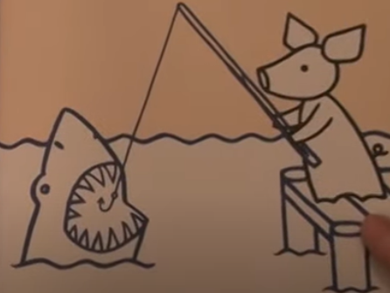 | 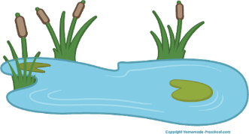
pig | Fishing | pond

The pig is fishing in the pond.
If you have time maybe you could make your own silly sentence.
Who | What | Where
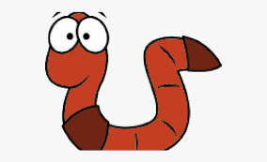 |  | 
Worm | driving | town

The worm is driving to town.
Maths: 45mins
Can you quickly write all the numbers 1-10 remember to get them in the right order and the right way around?
In your family who is taller? Who is shorter? Measuring from top to bottom. Can you find things in the house that you are taller than? Maybe a chair, your bed or a wardrobe?
Watch the maths video on the home learning.
Activity: Find 3 objects in your house.
Choose something you’re going to use to measure the objects.
Write down or draw a picture of the object.
Measure the object and write down the number
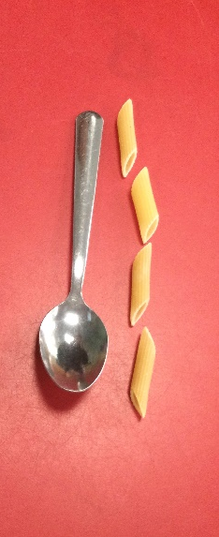
I would write down the number 4.
When you have measured 3 objects decide which one is longer.
When you have finished you could choose different objects to try or find objects that are the same length.
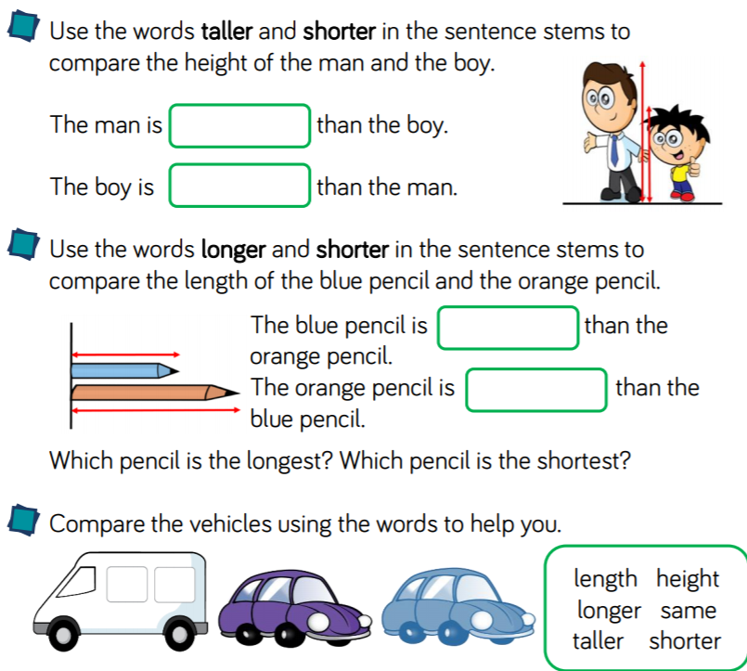
Try answering some of these questions

