Today we are looking at positional language. I have given you some pictures of a fox. Can you tell me where the fox is using the positional language?
Here is an example
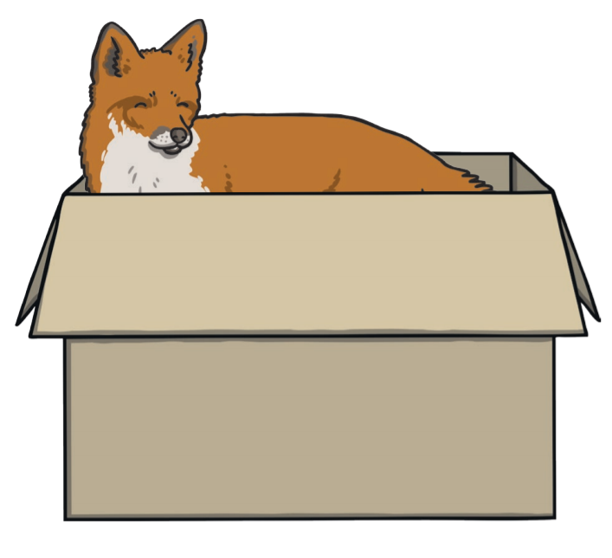
Who? | Where?
fox | in

We can put this into a sentence.
The fox is in.
If you would like you can extend your sentence and tell me what
Who? | Where? | What?
Fox | Inside | box

The fox is in the box.

