Smarties Friday morning.
Maths 45 minutes
Watch the video introducing parts and wholes. The link in underneath the picture. When you have watched this video. Watch the video of Miss Davies for your maths learning.
When you have finished watching can you complete the task below.

How many apples? How many different ways can I part them.

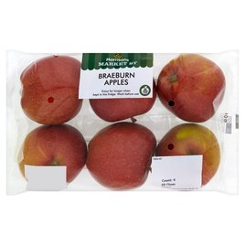

Extra: I have added a game for you to practise you numbers 1-15. Have a look at the link.

Phonics 20 minutes
Can you go on a phonics hunt today in your house the sound is ‘d’ and ‘s’ how many different things can you find in your house that starts with the sound ‘d’ and ‘s’ can you write any of the words for items you have found?

Literacy 20 minutes
If you like you can listen to the ‘Not a stick’ story again. Maybe today you could watch Miss Wilson reading the story.
Think about your stick…. Before you picked it up other people or animals might have touched it too. Look at the 4 people below. Who do you think has touched the stick before you?
Pick 1 of the people and write a sentence about the stick.

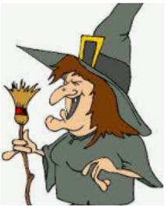 |  |  | 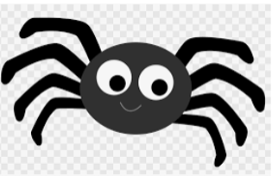

You can draw your who and write what they are doing with the stick.
Who | What doing?

E.g The wolf is playing with the stick.

