Smarties Wednesday Morning

I | to | no | go | into | the
Phonics
Common exception words

Write the common exception words twice on a piece of paper. Place them face down and play a matching game. Play the game again, can the child say each of the words. Use them as flashcards to say the word. Children need to be able to remember these words by sight.
Can the children put the cards in a sentence I go to the______ selecting the correct cards. Finish the sentence with your child.
I go to the _______
park, farm, zoo……..

If your child is finding this too tricky maybe try this.
On a piece of paper write down these sounds and the word ‘it’, cut them out. Say the sounds you can hear.
Place the other letters face down. Select a letter and place it in front of the word ‘it’ to make a new word.
it | a | s | m | p | n | i

Support with sounding out s- it. How many words can the children find? We found 4 real words.
Sit, mit, pit, nit

Literacy
Listen to the story ‘Not a stick’ go on a hunt outside and collect some sticks. Lay the stick on a piece of paper and draw a picture using the stick and write a short sentence.
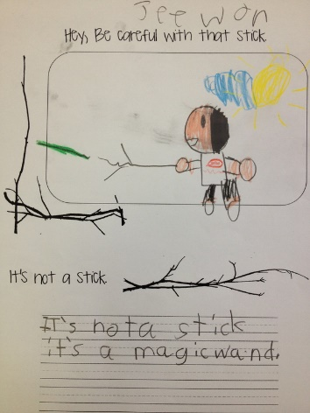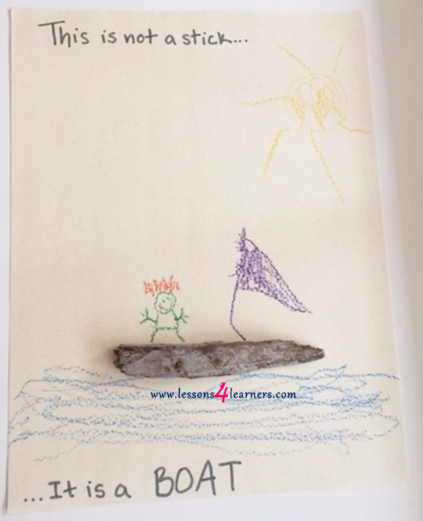

Maths
Look at the maths Powerpoint

