Phonics 20 minutes
Watch the video of the sound m and n can you notice the difference between the two sounds.
Below can you sort the pictures and write what sound you hear first.
e.g what sound can you hear in m-oo-n. we can hear the ‘m’ sound. Write the letter m.

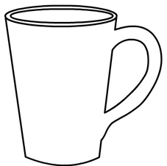 | 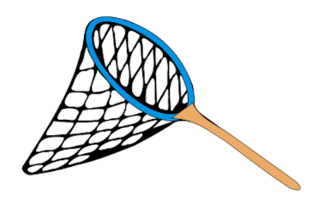 | 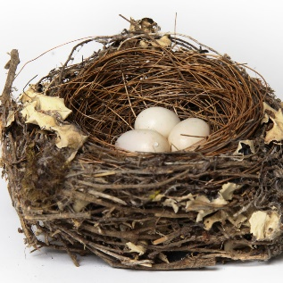
 | 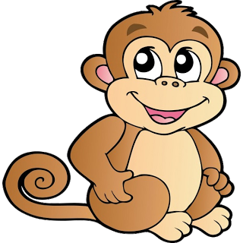 | 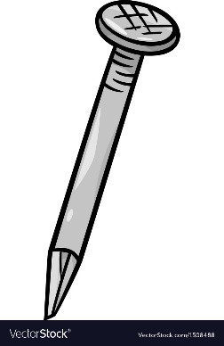
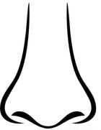 |  | 

Maths 45 minutes
How many different ways can we make 6.
Draw yourself a whole part model. Write 6 in the whole and collect some items to help you count to 6. These could be sweets, pasta or counters.



Place some counters in one part and some counter in the other part.
You can see that I have 1 and 5. How many more ways can you make 6.
What the clip on moving the whole part model and finding the whole.
Have a go at the questions I have provided.
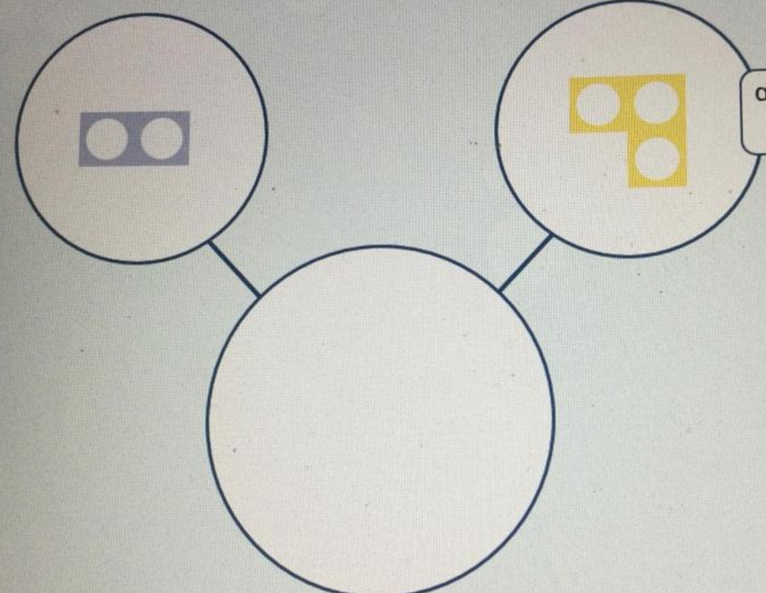
Can you find the whole when given the two parts? Count the numicon to help you.

Literacy 45 minutes
Listen to the story ‘Not a stick’
On the first page of the story the author has written
‘Hey be careful with that stick’

Your task is to make a poster for using a stick safely.

Science experiment 45- 1 hour.

The Stick Man is stuck in the ice how can we get him out. It’s not safe enough to use a hammer or hot water. How else can we free the Stick Man watch and follow the science video.
For the experiment you will need:
- 4 x cubes
- 4x plates
- Salt
- Sugar
- Flour

