Monday 11th Smarties Morning Home Learning

Science: 45 minutes
Task 1: Exploring the weather.
Have a look at the powerpoint all about winter.
Discuss: What is the weather like in winter? How is it different from autumn?
What clothes would we wear in winter?
You might want to draw and label a picture of what you would wear in winter or you could collect the items at home and take a picture. You might like to write a sentence. In winter we wear………..

Task 2: what is the weather today?
This week we are going to look at the weather each day. Below I have drawn a table for you and your grown up to copy.
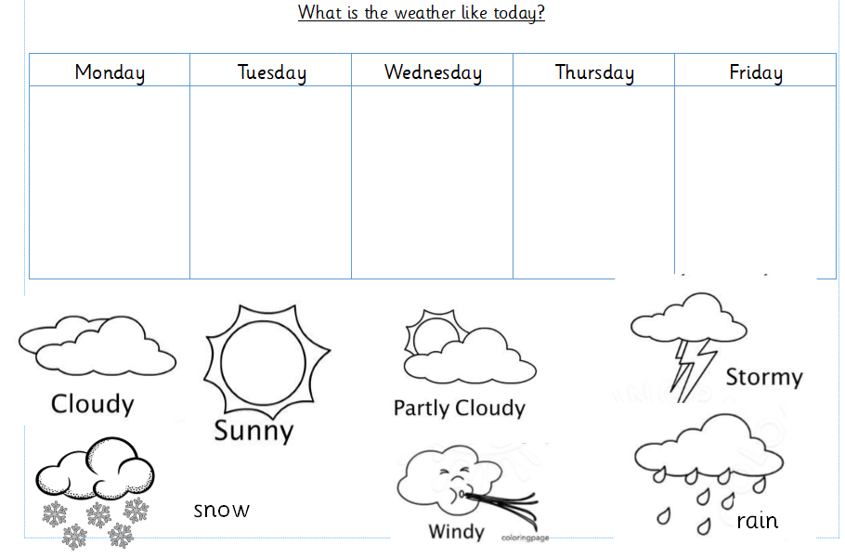
Look outside and decide what the weather is like and record this on your table.

Handwriting: 20minutes
Practise writing the common exception words I, to, no, go, the, into.
Write the words on a piece of paper with a light coloured pen or felt tip. Allow your child to trace over the top. Draw a line underneath each word and copy the word, make sure your letters sit on the line.
If your child finds this too tricky. Practice drawing different shapes.
Triangle, square, circle and rectangle.

Phonics 20 minutes

Recap the sound ‘ai’
Watch this video for some ideas of words with the ‘ai’ sound: https://www.youtube.com/watch?v=LnXaN-CvR9s
Now it’s your turn to write words with the ai sound.

nail, mail, train, snail, rain
if it is too tricky add the sound buttons.
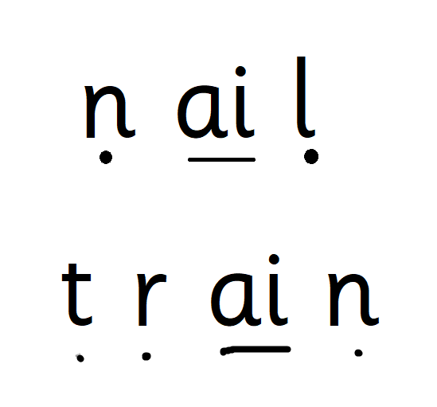
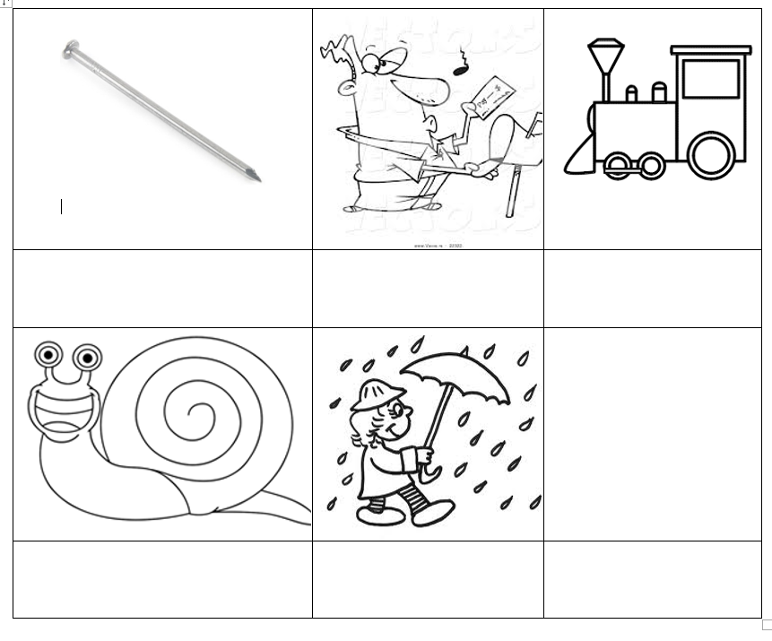

Children can play phonics play buried treasure.
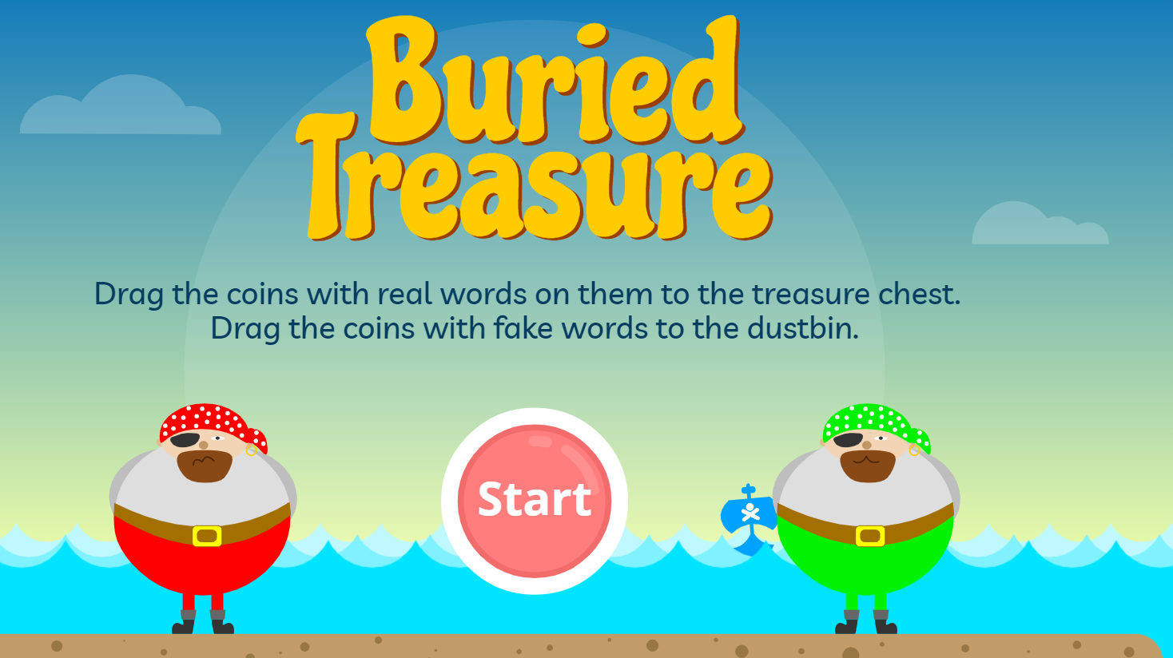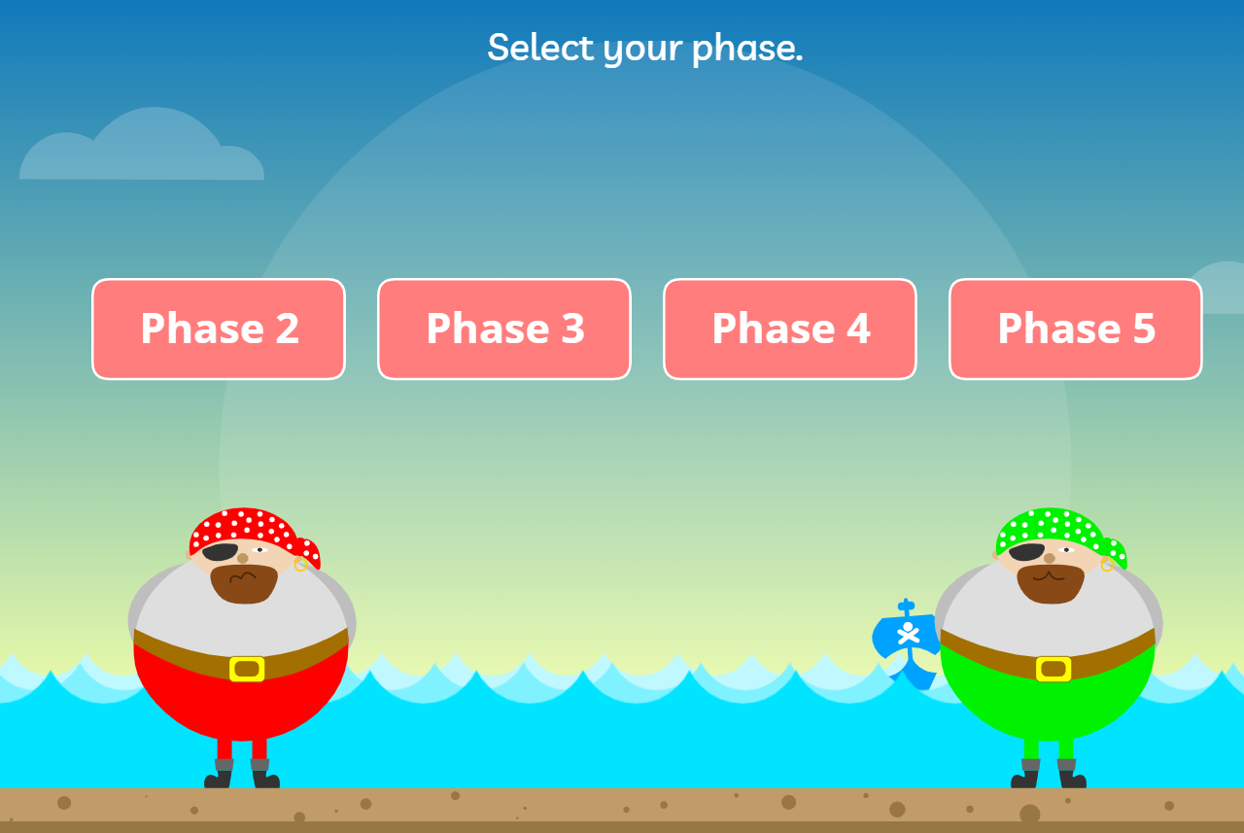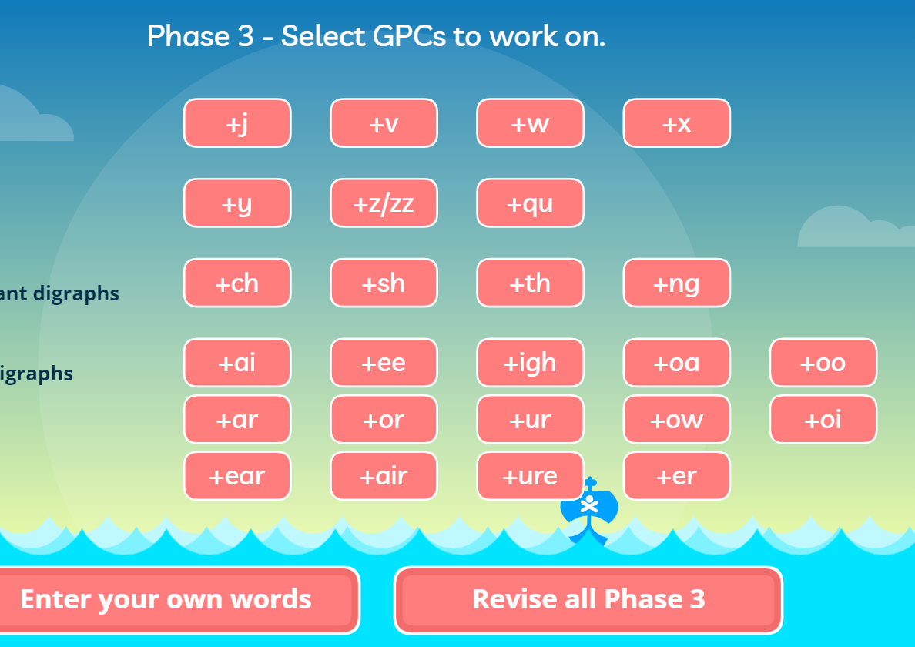
Some children may find phase 3 sounds tricky. Try this phase 2 activity.

The new sound today ‘d’
How many words can you think of that start with the sound ‘d’
Watch this clip: https://www.youtube.com/watch?v=65b3vEfskZ4
Now see if you can write ‘d’?
can you sort these pictures into to piles. Those that have a ‘d’ sound and no ‘d’ sound.
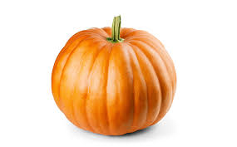 | 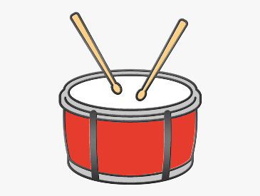 | 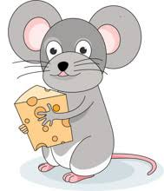 | 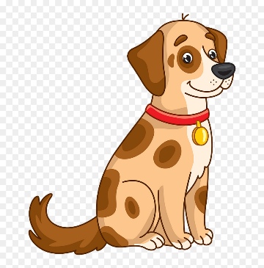
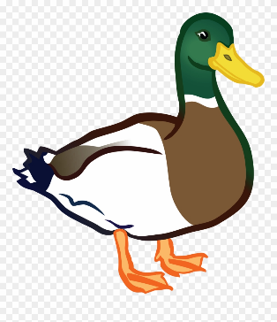 | 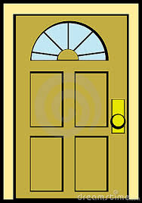 | 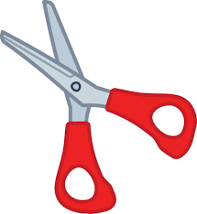 | 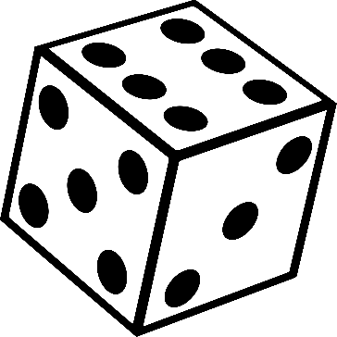

Maths 45 minutes
Have a look at this video and take the quiz.
https://classroom.thenational.academy/lessons/to-measure-lengths-using-non-standard-units-part-2-6ngkac?step=2&activity=video
Your task today is to have a look for these objects in your house and measure them, before you measure them you need to make an estimate. An estimate is having a guess. Before you measure you will guess how long an object is and then measure it. You can use what you have in your house to measure. Remember when measuring you must make sure it is all the same coins, pegs, paperclips.

Object | Estimate | Answer
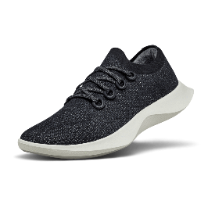
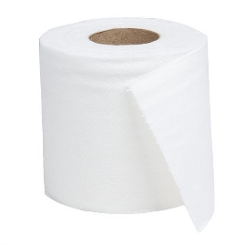
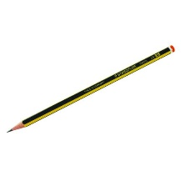

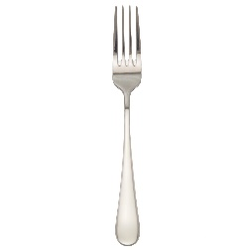

In smarties we have been using our hands to measure big objects. Why don’t you try and measure how many hands tall is a chair or how many hands long a table is.

