Wednesday 20th January

Phonics 20 minutes

Can you write all the ‘ee’ words that you can see in the story?
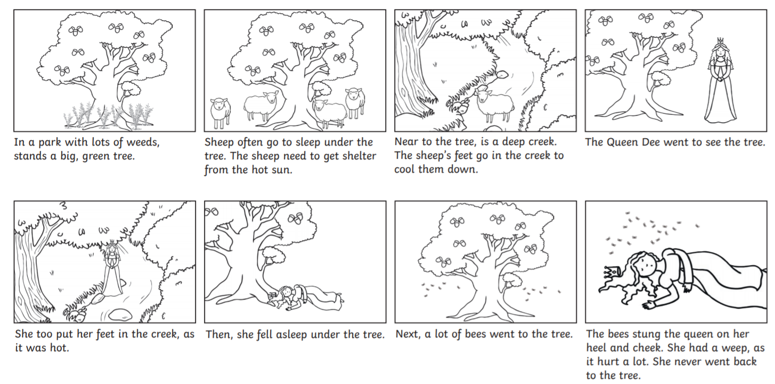
If this is tricky why not try this.
Read the words and match them to the picture. The ‘g’ sound comes at the end of the word.

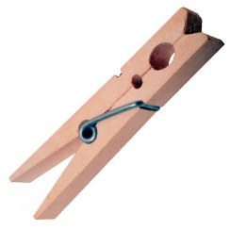 | 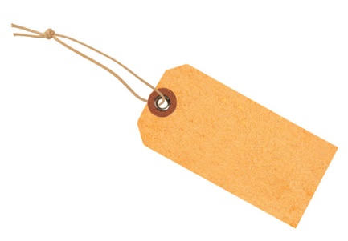 | 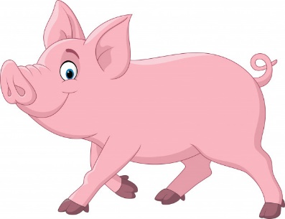
pig | tag | peg

Literacy 45 minutes.
Below I have provided you with some pictures of the different people that found the stick. In the story you are given the ‘who’ and ‘what doing?’ Can you now choose a ‘where’ I have given you some examples below. You can draw the ‘who’, ‘what doing’ and ‘where’.
Here is an example to help you.
Who? | What doing? | Where?
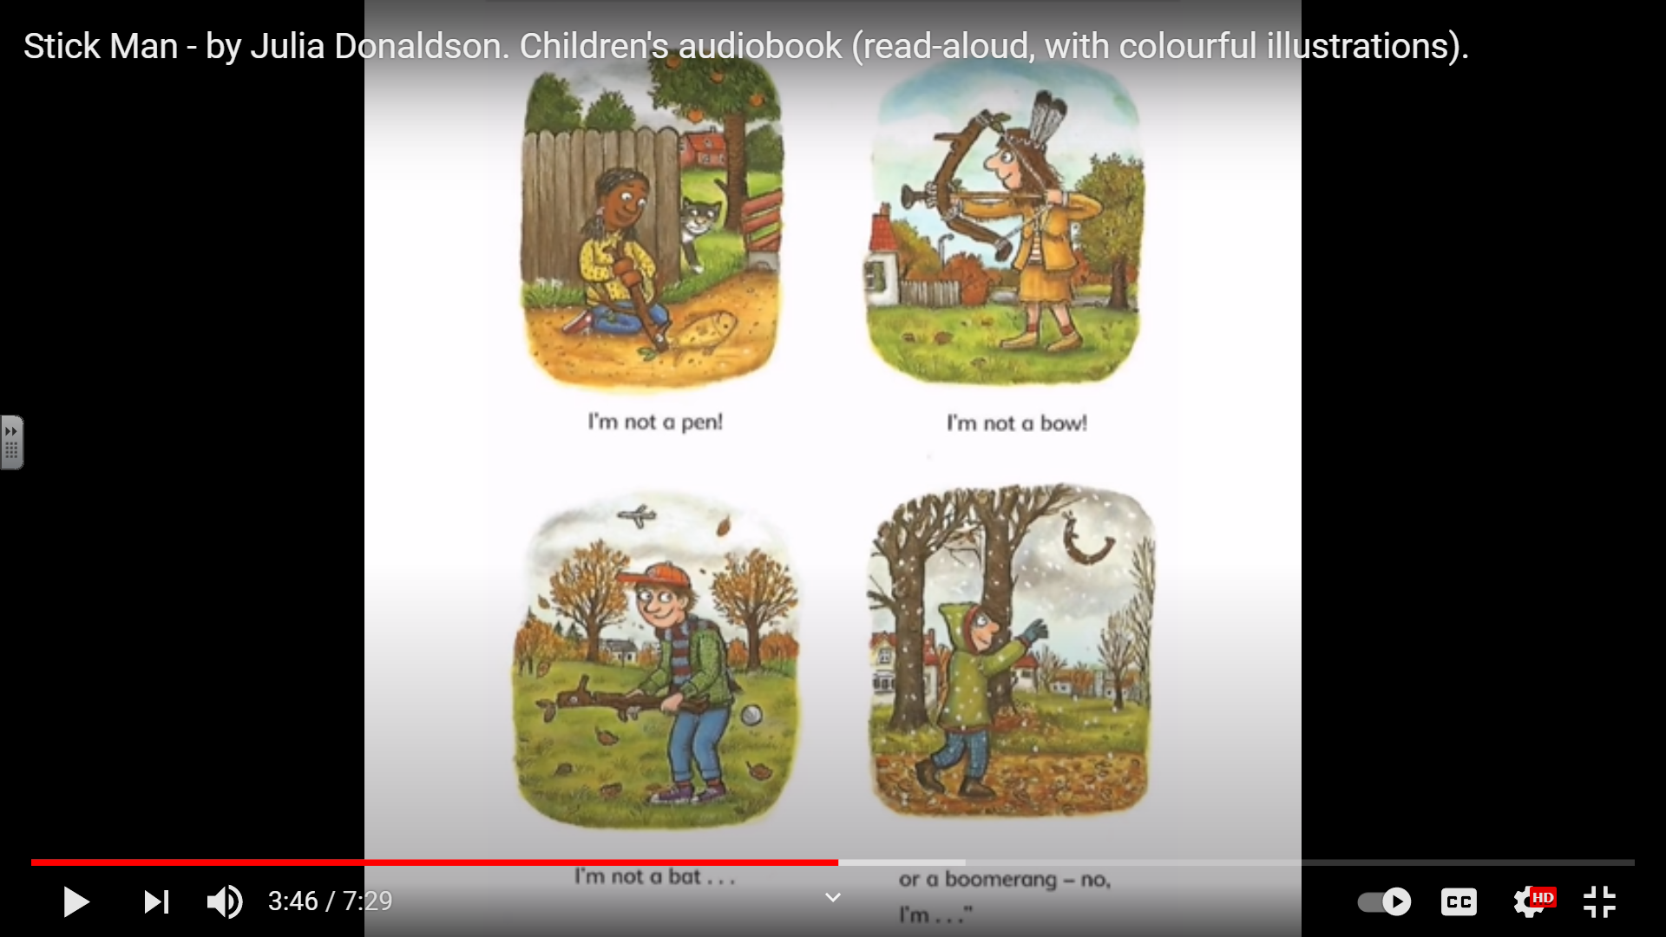 |  | 
The girl | is drawing | on the moon

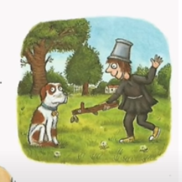
Where
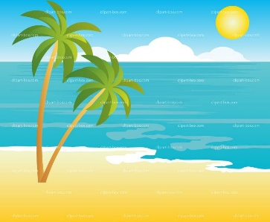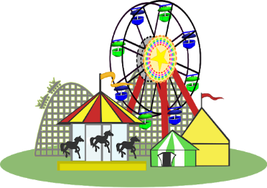

Can you write a sentence to go with your pictures?
Maths 45 minutes

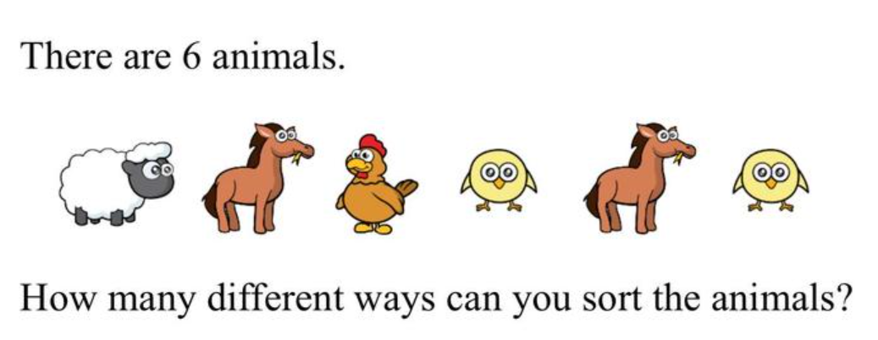
we can sort the animals into two groups.
- Animals with 2 legs and animals with 4 legs. How many in each group?
- Animals with wings and animal with no wings. Hw many in each group.
Can you think of a different way? Maybe look at colour.

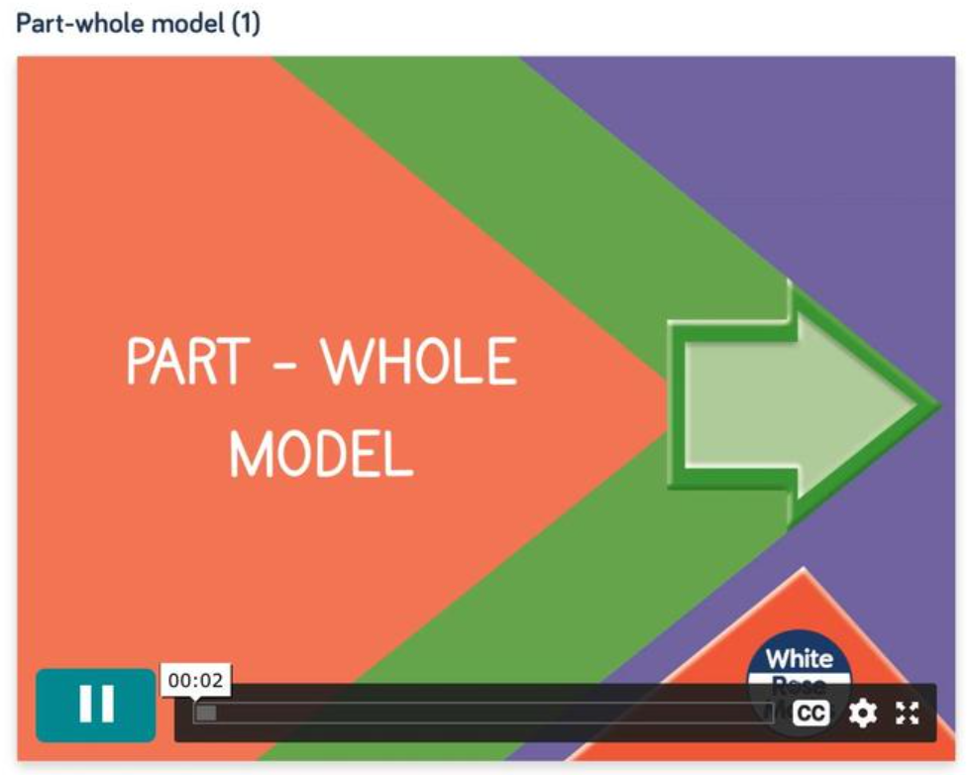
Watch this video clip to help with the next maths tasks: https://whiterosemaths.com/homelearning/year-1/week-5/
Complete the questions


