Smarties Thursday Home Learning

Phonics
Using the same words cards from yesterday can the children look at the word, cover it up and write the word. Repeat for I, to, no, go, the, into. This time can the children write the word without looking?
Read the text. Can the children find the common exception words we have been learning?
You could write out the passage for your child to highlight the common exception words we have been learning. Maybe start with ‘I’
The fat dog had a map to go to the shop. I went to the bus to go into town. The dog had to go into the shop to get a red pen. I had to get a big box to put in a pet. The dog and I go to the bus stop to go back home.
If your child finds this too tricky, try this.
Build cvc words using these letter here are some examples. Encourage segmenting and blending. How many words can you make? Write them down.
sat, sit, sip, tap, tip, tin, pin, pat, nip, nit.
s | a | t | p | i | n

Literacy
Introduce the common exception word ‘my’
can we write it and say the word. Let’s put it in a sentence.
That is my dog.
My cat sat on a mat.

Listen to the story not a stick

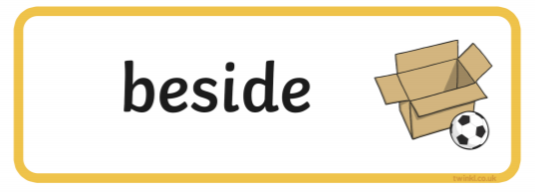
Using one of these words can you say where you found the stick?
Did you find it underneath a tree?
On a chair?
Use your imagination to draw a picture to show where you found the stick?
When writing a sentence start with ‘my’
My stick is under the tree.

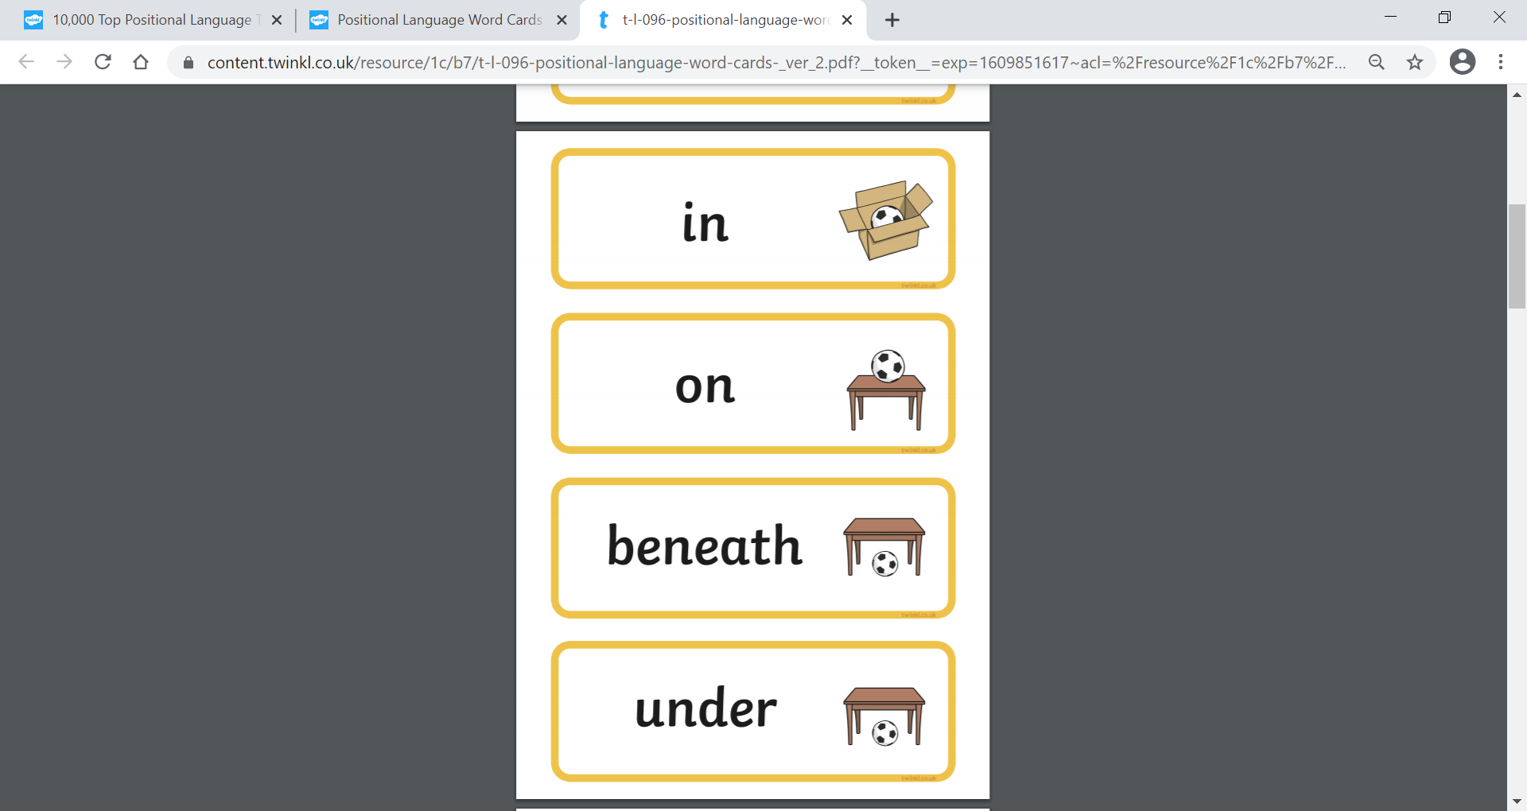


Maths
Watch the first maths video ‘Longer and shorter’ can you answer the questions?
Watch the second video measuring, can you find different items to measure with? You can use pasta, cereal, lego, sweets, buttons, nails and lots more.

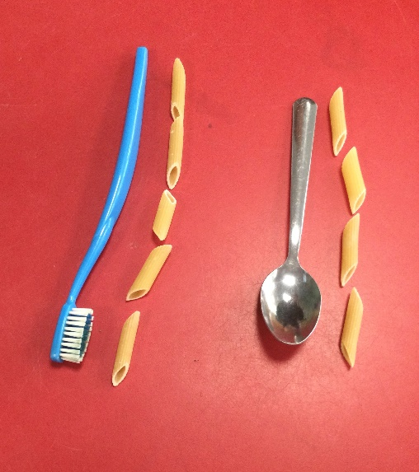

Can the children count how many for each?

