Afternoon learning and activities- about an hour
Today it’s time to find out a bit more about one of the 4 countries of the United Kingdom- Scotland.
Have a look at the power point below.

Hopefully now you know a lot more about Scotland. Did you find out the name of the special material that some Scottish clothes are made from?
We thought you could have a go at weaving your own tartan out of paper. You will need a larger piece of paper and some strips of paper. This could be any paper you can find at home, even newspaper.

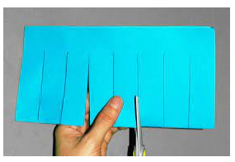
First fold your larger piece of paper in half and cut from the fold to nearly the top.
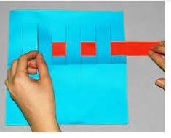
Open out the larger piece and start weaving your strips through.
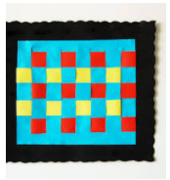
Now you’ll have a lovely piece of ‘tartan’

Now if you want to have a go at making the national flower of Scotland, take a look at Miss Sleem’s video.

https://youtu.be/t9vxKqWkI8o

