‘
Sock Throw
Choose a starting position then see how far can you throw your ball of socks.
Measure your throw to the nearest cm!
Watch a video of this activity to see how to do it.

Sock Keepy Uppies
Can you keep your ball of socks up in the air using just your feet?
How many keepy uppies can you do in 1 minute?
Watch a video of this activity to see how to do it.

Sock Basketball
Put a bucket or laundry basket 4m away. How many times can you throw your ball of socks into the bucket, collect, return and throw again in 1 minute?
Watch a video of this activity to see how to do it.

Sock Catch
Throw your ball of socks to someone and have them throw it back to you. How many catches can you do in 1 minute?
Watch a video of this activity to see how to do it.

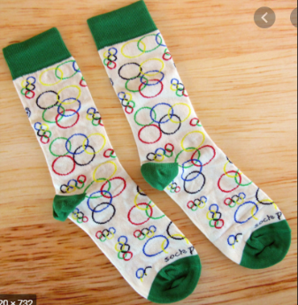
Rainbow Sock Throw
Put your socks into one hand & throw to your other, like a rainbow arch! How many rainbows can you throw in 1 minute?
Watch a video of this activity to see how to do it.

Jump In Your Socks
You can put your socks down for this one (or put them on!). Stand still and jump as far as you possibly can!
Watch a video of this activity to see how to do it.

Sock Jump
Place your ball of socks on the floor and see how many times you can jump over them and back in 1 minute!
Watch a video of this activity to see how to do it.

Sock Bowling
Set up 6 skittles (toilet roll tubes or empty bottles). Stand 3m away & use your ball of socks to knock them down! How many can you knock down in 3 separate throws?
Watch a video of this activity to see how to do it.
!

Woodrow First School
Sock Olympics Activity Card!
Sock Basketball

How many can you score in 1 minute?
Sock Catch

How many can you do in 1 minute?
Sock Keepy Uppies

How many can you do in 1 minute?
Sock Throw

Measure to the nearest cm!
Sock Jump

Measure to the nearest cm!
Woodrow First School
Sock Olympics Score Card!
Name: _____________ Class: ____
Jump In Your Socks

Measure to the nearest cm!
Rainbow Sock Throw

How many can you do in 1 minute?

Sock Bowling

Have 3 goes!

