Half term fun!
As it is half term next week we thought that it would be great if you had lots of fun outdoors. When you go for your daily walks and exercise you could have a go at completing some of these activites. Have fun with your families and remember, stay safe!
Scavenger hunt!  Think about all the letters in your name. Can you find objects (inside your home or outside on your walk) that start with all the letters from your name? Here is an example for you:  Leaf   Oak tree   Umberella   Ice   Stick 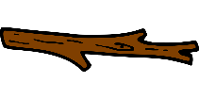  Egg  | 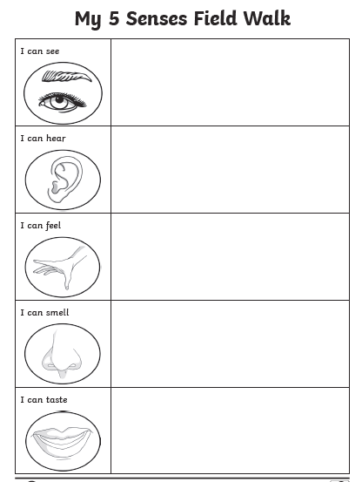

It will be the beginning of Spring in March, but there may be a few signs already that spring is on the way. Use the spring hunt checklist to see if you can find signs that spring is on it’s way!



