Year 1 home learning
Monday 22nd February
Phonics- 20 mins
Can you read these phase 5 tricky words? Watch the video a couple of times and see if you can read them all!

https://www.youtube.com/watch?v=DbcZnb2iz1c

If the phase 5 words are a bit tricky try phase 3 instead.

https://www.youtube.com/watch?v=yM11q1yIdPM

This week we are going to be learning about ow and ou.

Watch this video with Mrs Ryall and see if you can spot, read and spell the words with ow and ou.

https://www.youtube.com/watch?v=-nvjkj-BG-g

Literacy- 45 mins
Practice your curly caterpillar letters.
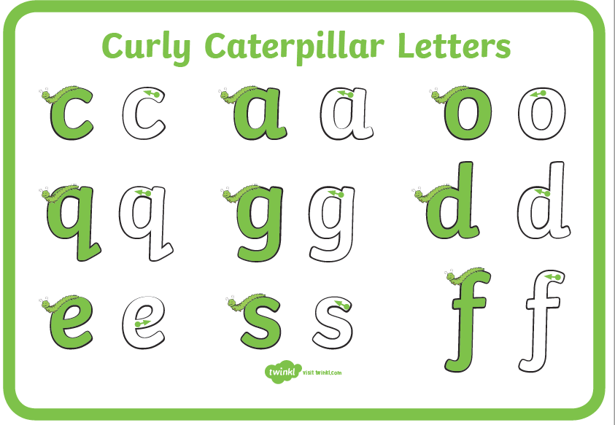
https://www.youtube.com/watch?v=jzuBcoQTC0U

This half term we are going to be looking at a new story. Before we introduce the book, we want you to take a good look at the front cover picture below.

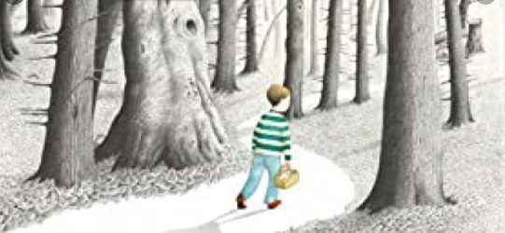

What can you see? What kind of story do you think this might be? What do you think the story will be about?

Take a good look at the boy, where do you think he might be going? Why do you think that?

Fold a piece of A4 paper into four parts and write these headings in each part. Draw picture underneath and write a short sentence to explain you picture
I can see... | I think the story is about...
I think the boy is going... | I think this because...

Now using Lego, bricks, playdough, natural materials or paper make a 3D forest like the forest in the picture. Here are some examples:
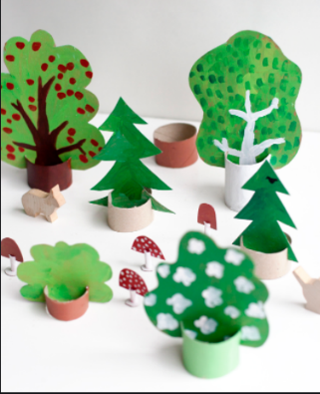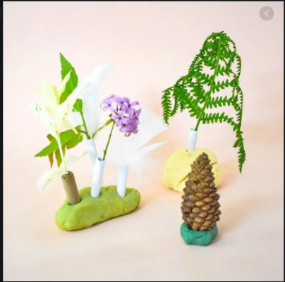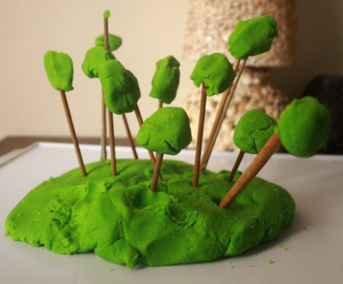
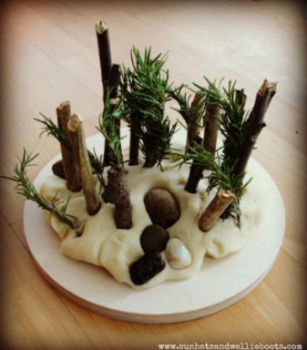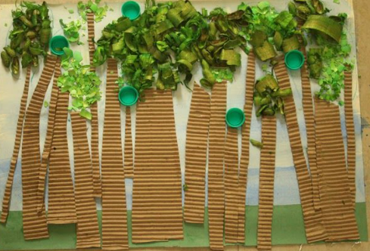
Don’t forget to send us a picture of your forest to our school email address.

If you want to make some playdough for your forest, here is an easy recipe for you to use.
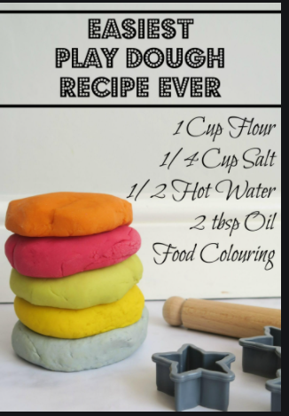

Maths- 45 mins
Quick starter!
Which number is the odd one out and why?
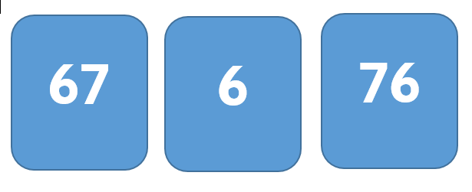

Last half term we looked at counting in tens and ones. Can you remember how to count in tens all the way up to 100?
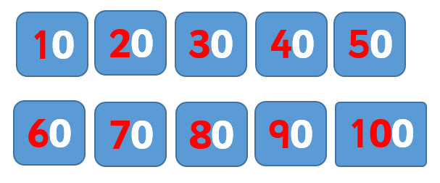
What do you notice about the numbers? Why don’t you make your own tens number cards, mix them up and see if you can put them in the correct order.

Can you count in 2s?
Watch Mrs Paxton’s video, counting in 2s. She has found a fun way to count in 2’s, you could join in with her. All you need is 10 pairs of socks.
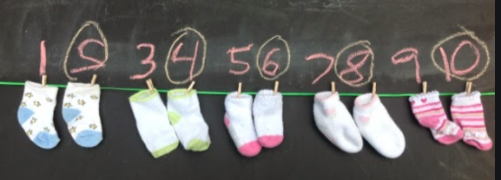
https://www.youtube.com/watch?v=jys6PLhNRyc

Watch the video in the link below. You will need to find some things in your home that you can count in 2s.

https://vimeo.com/507065512

Now you have a go!
Practise counting in 2s by colouring in a 50 chart. What number would come after 50? What about after 64?
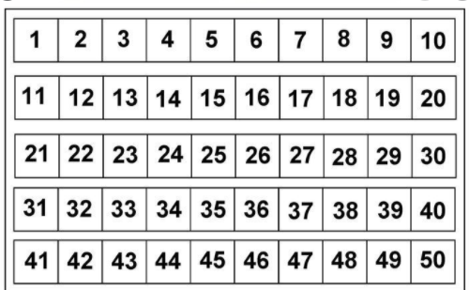

Challenge!
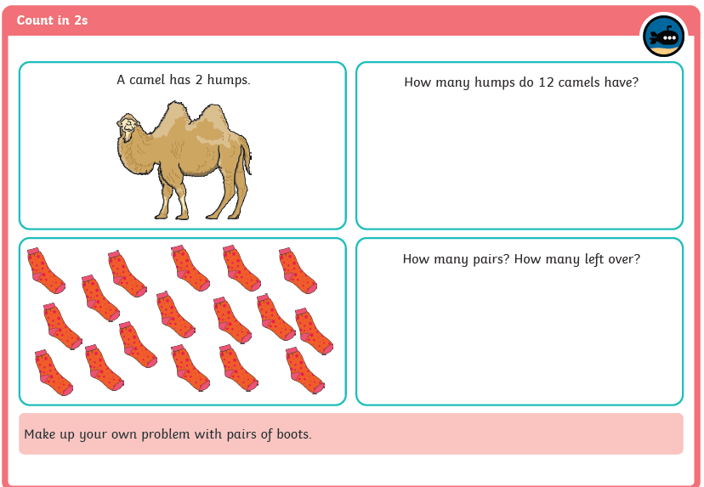

Afternoon learning and activities- about an hour.
Science
Just before half term you were learning all about the different groups that animals belong to. Can you remember the 6 different groups? Watch this funny song to help you remember!

https://www.youtube.com/watch?v=PHYi4fqeEdw

Mrs O’Mahoney and Mrs Matthews found lots of animals at school and tried to sort them into the correct groups. Today watch them sort out the mammals, fish and reptiles. Did they sort them correctly?

https://www.youtube.com/watch?v=dBMWMne6w6E

We’d like you to have a go at choosing one animal from each of these 3 groups’ today- mammals, fish and reptiles. Have a go at sketching each of the creatures and labelling the body parts.
Remember that sketching is when you use just a pencil and press lightly.

Here are some of the words that you might need to label your creature with:-

leg | body | tail | fin
ears | eyes | nose | fur
skin | gills | mouth | teeth
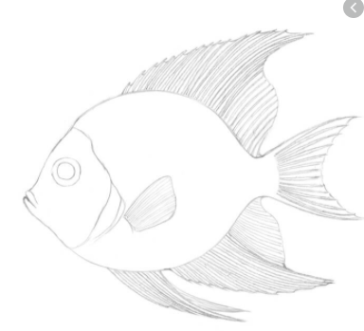
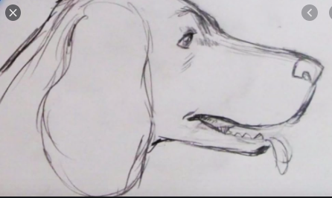
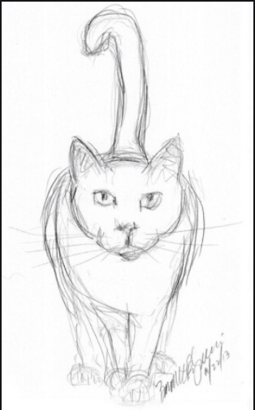

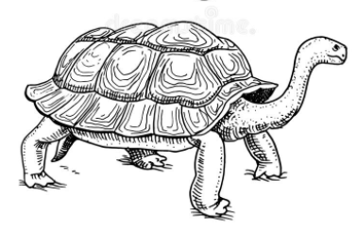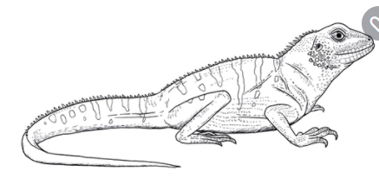

PE
Let’s get moving!
Look for the icon below on the Year 1 home learning page and choose one of your favourites. Cosmic yoga, PE with Joe Wicks, Just Dance or Go Noodle. Make sure you warm up first and then have some fun!



