Year 1 home learning
Wednesday
10th February
Phonics- 20 mins

Let’s play Bingo! You will need a bingo board like mine.
You will need the real words that we found hidden around the room yesterday. There were 8 real words but you only need to choose 6 of them. Write them on your board. Mrs Ryall is going to be the bingo caller. Listen for the words and cross them off when you hear them. Don’t forget to shout BINGO when you have crossed them all off.
Play as many times as you like!

Watch the video here
https://www.youtube.com/watch?v=qQjiAqwV30g

Literacy- 45 mins
Let’s practice our tricky words.
Write these words on some paper twice and play pairs with someone in your house.

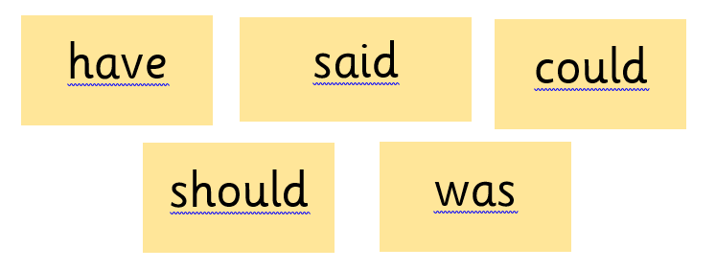

Create your own part of the story.
So far you have become experts in the Stickman story. Today we want you to use your imagination and come up with the next part of the Stickman story. This will start from the next day after Father Christmas drops Stickman back home. It is winter time, there is snow on the floor. Who will Stickman meet in your story and what dangers will happen to him?
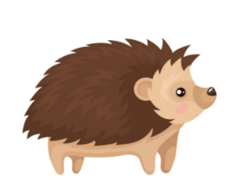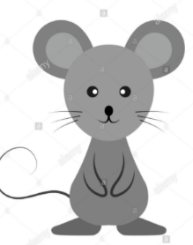
A grumpy squirrel. A sly fox. A prickly hedgehog. A shy mouse.

Use our colourful narrative structure below to help you sequences your sentences.

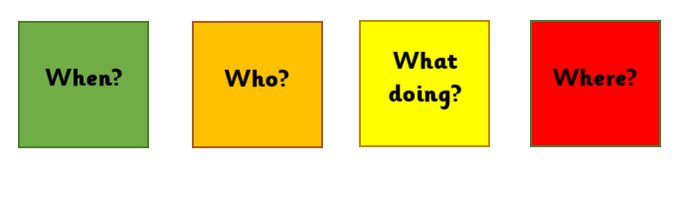
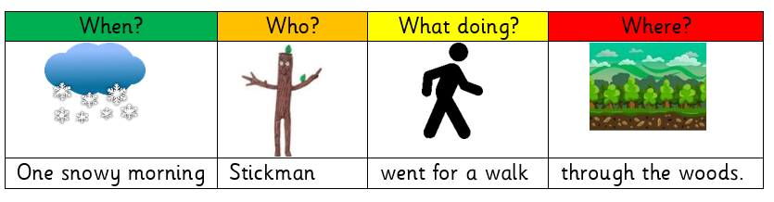
See if you can write three or four sentences for the next part of the story.

Maths- 45 mins
Quick starter!
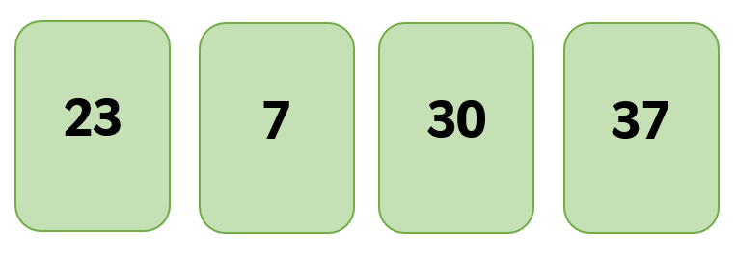
How many number sentences can you make using these numbers? Can you use them all!

Watch the video in the link below. You will need a pencil and some paper to work out some of the problems.

https://vimeo.com/503098045

Now you have a go!
https://resources.whiterosemaths.com/wp-content/uploads/2019/12/Y1-Spring-Block-2-WO4-One-more-one-less-2019.pdf
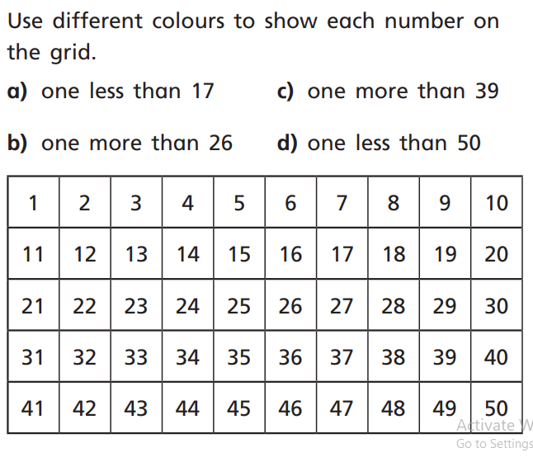

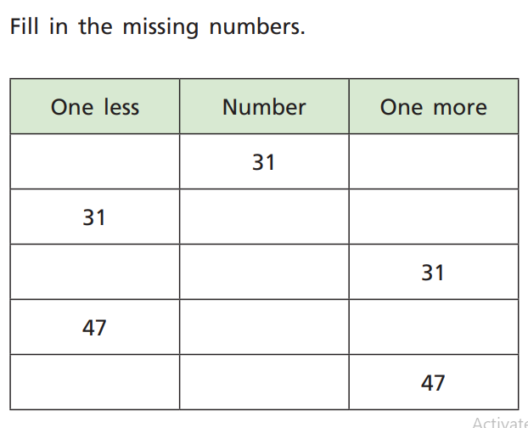

Challenge!
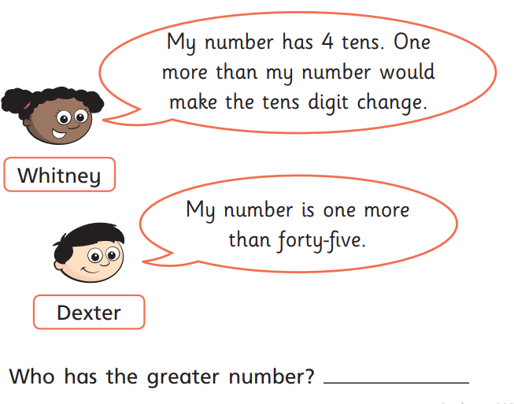

Afternoon learning and activities- about an hour
PSHE
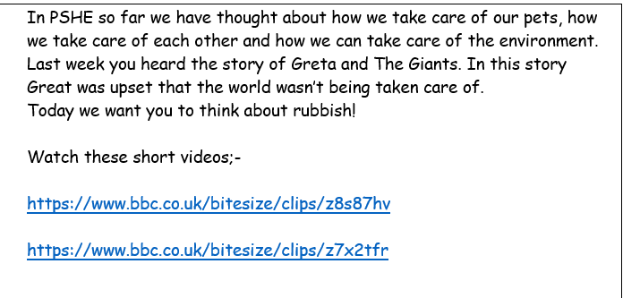

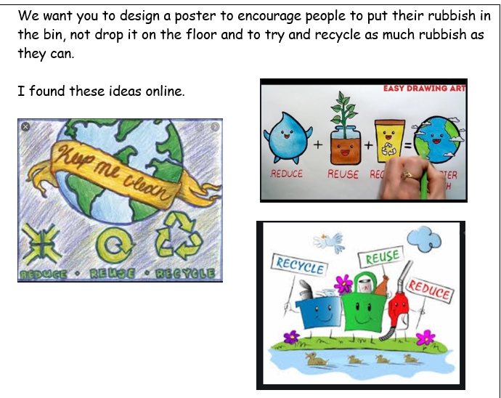

PE
Let’s get moving!
Look for the icon below on the Year 1 home learning page and choose one of your favourites. Cosmic yoga, PE with Joe Wicks, Just Dance or Go Noodle. Make sure you warm up first and then have some fun!



