Year 1 home learning
Thursday 11th February
Phonics- 20 mins
This week we have been looking at the alternative sounds for igh. We have looked at the phase 5 ‘ie’ phoneme, so today we are going to be looking at the third phoneme which makes the ‘igh’ sound and it looks like this ‘y’.

Watch Mrs Paxton’s video to find out more.
https://www.youtube.com/watch?v=rPmDRMN7Wos

Have a look at Mr Thorne does phonics. he is looking at the phoneme ‘y’ which makes the ‘igh’ sound.

https://www.youtube.com/watch?v=t0C01G_sCsQ

Literacy- 45 mins
Let’s practice our Zigzag Monster Letters.
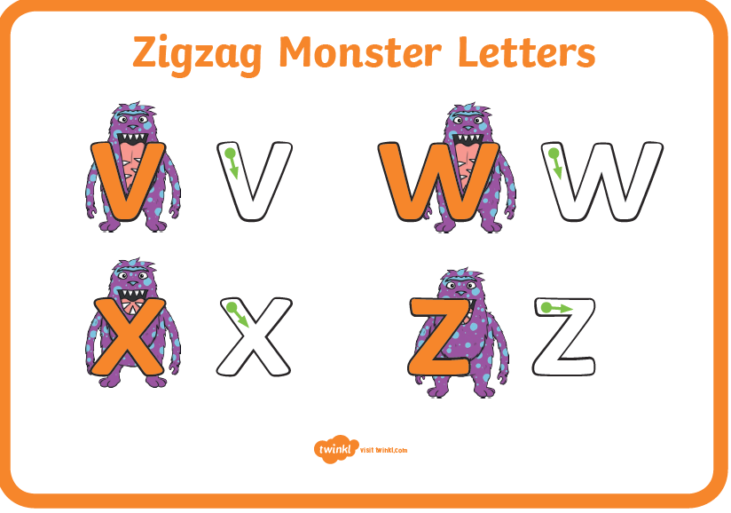
https://www.youtube.com/watch?v=f12e5YrYIXI

Write an acrostic poem

Last term we became experts in poetry. We learnt all about list poems, rhyming couplets and rhyming stings. Today we would like you to have a go at writing an acrostic poem.

An acrostic poem is a poem where the first letter of each line spells out a word or phrase. Usually, those letters would be bigger or bolder or coloured in some way so you can easily see the word and spot that it is an acrostic poem.
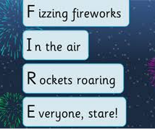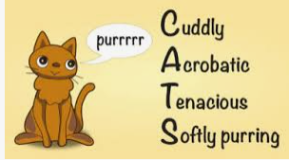

Can you see which words were used in these poems?
FIRE CATS

Your poem is going to be about Stickman. First brainstorm words or phrases that describe Stickman.
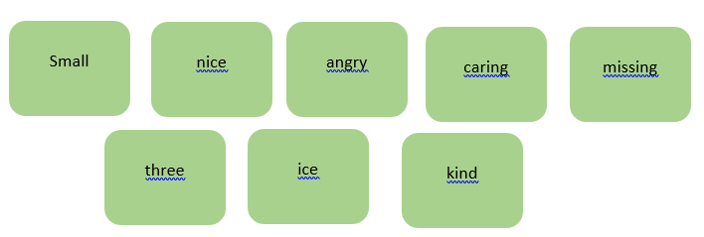

Place your brainstorm words or phrases on the lines that begin with the same letters. Fill in the rest of the lines to create a poem.
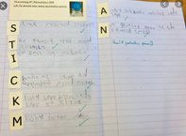
When you have written your poem add some pictures to make it look nice and colourful.

Stickman Poem
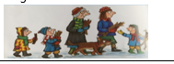
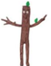
Small Stickman.
Three children.
Ice and snow.
Carried away.
Kind and caring.
Missing his family.
Angry at the people.
Nice to be home!
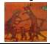

Maths- 45 mins
Quick starter!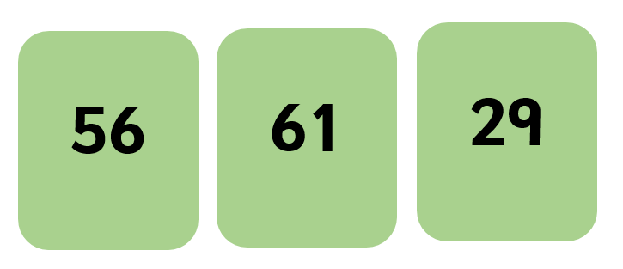
Look at these numbers, can you write one more and one less than each number.

Watch the video in the link below. You will need a pencil and some paper to work out some of the problems.

https://vimeo.com/503099894

Now you have a go!

https://resources.whiterosemaths.com/wp-content/uploads/2019/12/Y1-Spring-Block-2-WO5-Compare-objects-within-50-2019.pdf
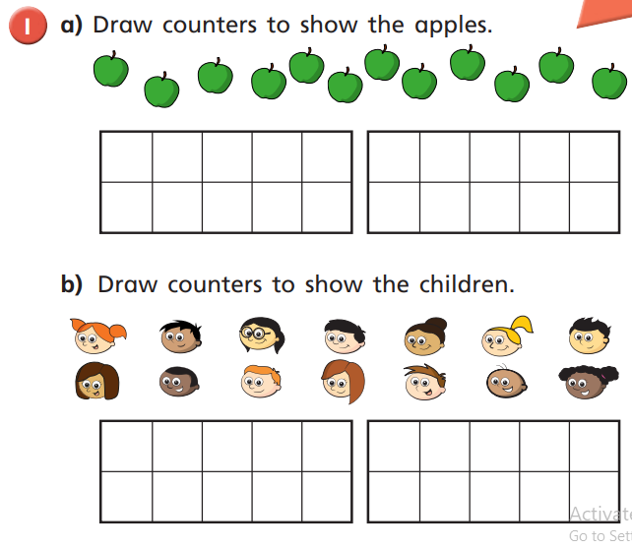

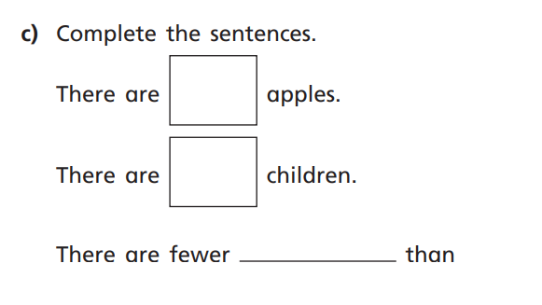

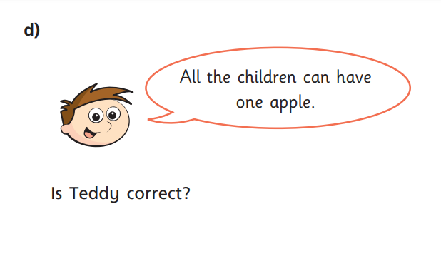

Afternoon learning and activities- about an hour
Science / art
This week you have been sorting animals out into the right groups.
Have a look at these parts of animals. Can you guess which animal the part belongs to?
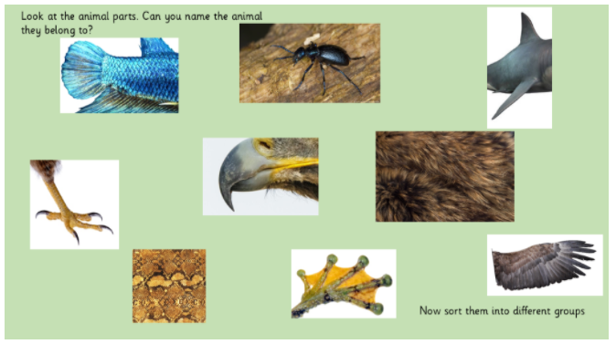
Now can you sort the creatures into the right group? Here are the groups again to remind you.
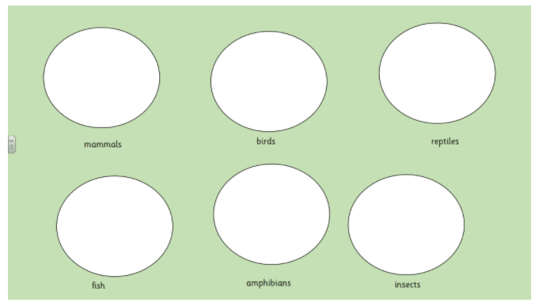
Play this fun game with a partner to draw some crazy creatures!

https://www.youtube.com/watch?v=VRtB7UOb38Q

Now it’s time to have some fun with these animal body parts. We want you to have a go at creating a new creature of your own! Try and use a body part from each group.

Have a look at my crazy creatures!

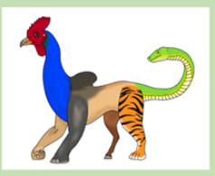
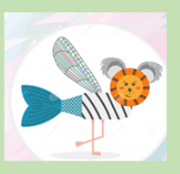

I wonder what these creatures would be called?

Have a go at drawing your own, make them as crazy as you can! Have fun.

