Year 1 home learning
Friday
Phonics- 20 mins
Use the power point called ‘phase 3 letters and sounds’ say each sound as it appears. Play the sound to make sure that you are saying them correctly.
For a challenge try all the sounds in the ‘phase 5 power point’

Look at the pictures here, can you write the oi words to match?

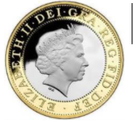 | 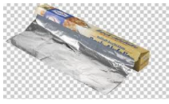 | 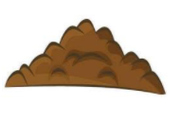

The words were coin, foil and soil. Did you get them right?

Now try these oy words

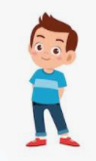 | 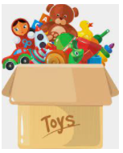 | 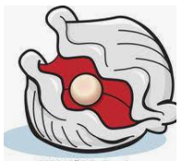
These were a bit harder weren’t they! The words this time were boy, toy and oyster

join, boil, coin, foil, point, toy, boy, joy, oyster

Using these words, can you come up with a short story?
e.g. One day the boy was playing with his toys when suddenly the oyster came with a bag of coins. The day was full of joy. Make it as silly as you like!

Literacy- 45 mins
Remember yesterday that you talked about words that are called ‘nouns’? They are naming words, things that you can touch. Today you’re going to find out about ‘proper nouns’ these are still naming words but these are names of things that have to start with a capital letter like your name, the name of a country or a day of the week. Can you make a list of 10 proper nouns that need to start with a capital letter?
If you fancy a challenge you could try this game, there are some tricky words in this game to try and catch you out.
https://www.sheppardsoftware.com/grammar/games/nouns/

If you like you can listen to the ‘Not a stick’ story again. Maybe today you could watch Miss Wilson reading the story.
Think about your stick…. Before you picked it up other people or animals might have touched it too. Look at the 4 people below. Who do you think has touched the stick before you?
Pick 1 of the people and write some sentences to describe the person you have chosen. You might write things like ‘She has brown hair’ or ‘he has a big nose’ or maybe you’ll write about the clothes they have on.

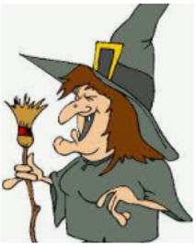 | 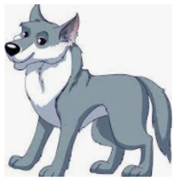 | 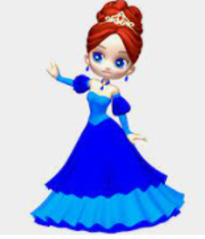 | 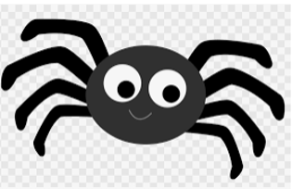

Maths- 45 mins
Watch the video in the link below. You will need a pencil and some paper to work out some of the problems.

https://vimeo.com/480769444

Look at this picture, has Mo made 16 in 3 different ways or has he made a mistake? Count and check!

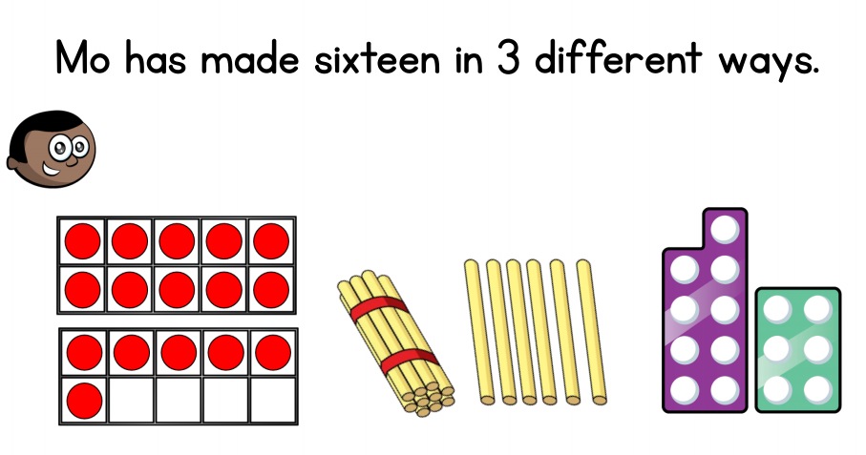

For this next part you are going to need some 10p coins and some 1p coins.
Can you make these amounts using your coins?

11p | 19p | 14p | 12p | 13p | 15p | 17p | 18p | 16p

Remember to use your 10p and the 1ps. I made this number, can you work out what I made?

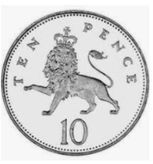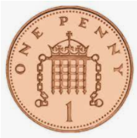

Now get your grown up to challenge you, they need to build you a number and you are going to see if you can work out what number they have made. Write the number down, did you remember to put the ten first?

Afternoon learning and activities- about an hour
So far this week you have found out a bit more about Scotland so today it’s time to find out about another country that makes up the United Kingdom, Northern Ireland.

Click on the picture below to open the power point which will tell you all about Northern Ireland. Read the story and look out for something fun to have a go at making.

Miss Sleem has made another lovely video for you to watch. This time you can have a go at making a shamrock, the national flower of Ireland.

https://youtu.be/BiVwE9nCXKA

