Year 1 home learning
Tuesday 2nd February
Phonics- 20 mins
Have a look at Geraldine looking for some ‘ea’ words around the house.
https://www.youtube.com/watch?v=L6F4KRdhqak

We’re going on a real and not real word hunt with Mrs Ryall. Here are the words that she has hidden.
team | dream | meat | bean
steag | seat | cream | tea
treat | cleam | zeat | peam

https://www.youtube.com/watch?v=13j1ElsOCUw

Why don’t you write down these words on pieces of paper and get a grown up to hide them around the house. Can you find them all? Can you write down only the real words? There are 8 real words! Have fun!

Literacy- 45 mins
Let’s practice our capital letters.
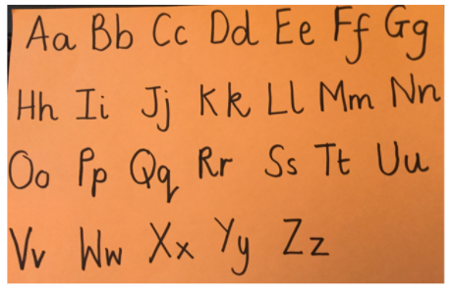

https://www.youtube.com/watch?v=9xSaINX-fdc

You know a lot about the Stickman story now and you are very good at retelling the story. Let's put your skills to the test!

Look at this selection of pictures. Can you put them in order of the story – look at the PowerPoint if you need help.
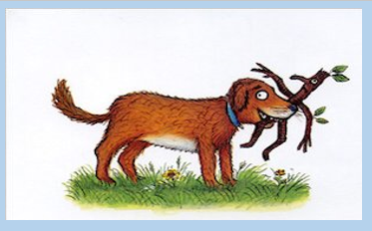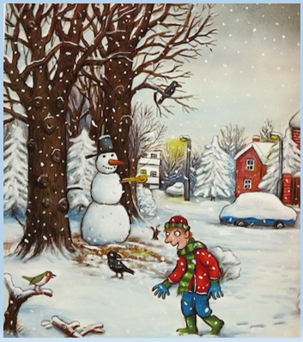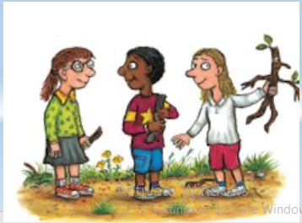
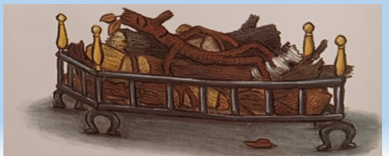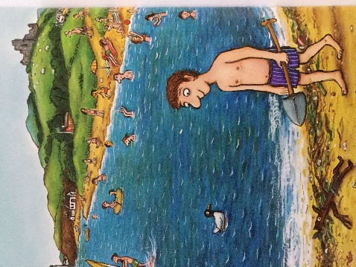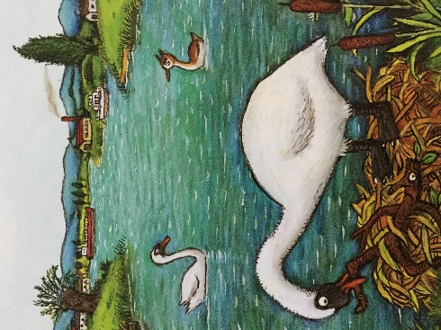
Question: what picture comes first? What picture comes next?
Now it is your turn to sequence the story. Take your time and look at all the pictures before you stick them down. You can use the table to draw the pictures or you can use the table with lines to add a simple sentence to match the pictures.
To sequence a story

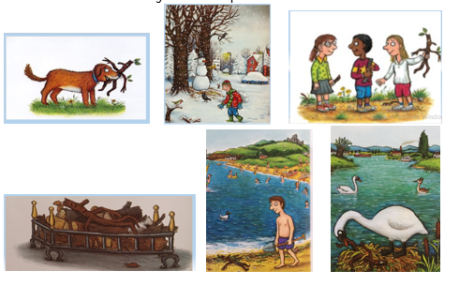

To sequence a story

Maths- 45 mins
Quick starter!
Play the game ‘Blast off!’ Click on the play game.

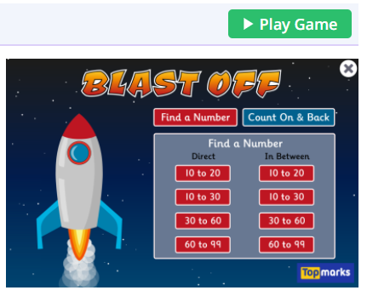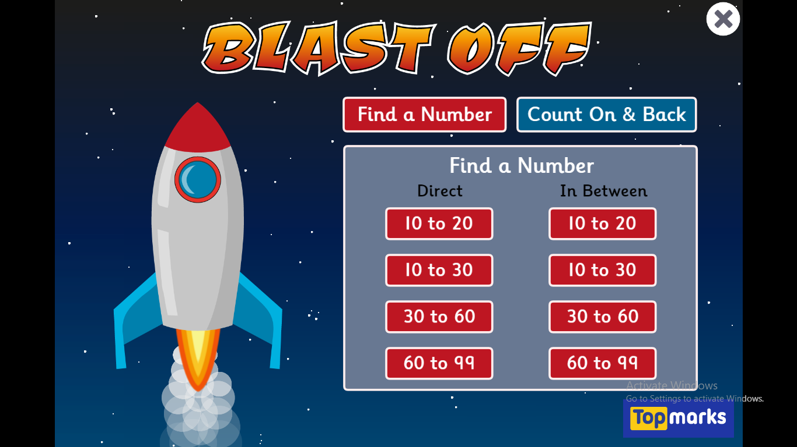

Select numbers 10 to 20 first, you can choose another game once you have completed these.
https://www.topmarks.co.uk/learning-to-count/blast-off

We are now going to be moving on and looking at counting to 50 by using 10s.

Watch the video in the link below. You will need a pencil and some paper to work out some of the problems.

https://vimeo.com/500465193

Now you have a go!

We are going to work practically today, that means we are just having a practice at working with 10s. You can use 10p’s, pasta on some sting, bundles of pencils or straws. Have a look at Mrs Paxton’s video, she has used some cereal to make her stings of 10.

https://www.youtube.com/watch?v=RRMmZUi7hhw

Afternoon learning and activities- about an hour
Hopefully yesterday you managed to see some birds. Can you remember the names of the birds you found?
Today you are going to have a go at making a bird feeder that will hopefully attract more birds into your garden If you don’t have a garden you could hang it from a tree if you go out for a walk.
Miss Davies is going to tell you how to make it.

https://www.youtube.com/watch?v=TOMf6w9mgls

Bird craft- have a look at this video to show you how to make a rocking bird. You will need;-paper, scissors, glue and a pen.

https://www.youtube.com/watchapp=desktop&v=a80VcYzQQE4

We’d to love to see photos of anything that you make.

