Year 1 home learning
Friday 26th February

Phonics- 20 mins
Today you’re going to read the sentences and draw the pictures to match.
Watch Mrs Ryall show you the sentences, see if you can read them and then draw the pictures to match.
You can draw your own pictures or use my chart here.

https://www.youtube.com/watch?v=jrdLwX-7eSI

An owl in the town. | I can count six cows. | The crown cost ten pounds.
A clown with a sad mouth. | He fell down on the ground. | A brown mouse in the house.

Literacy- 45 mins
Sing the alphabet song.
https://www.youtube.com/watch?v=XCezxDycD80
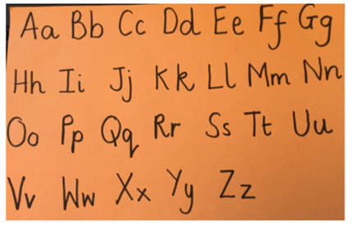
Now practice writing your capital letters.
https://www.youtube.com/watch?v=9xSaINX-fdc

We are going to be looking at the next part of the story.
Take a look at the first five pages of the book in the power point.

The boy missed his dad. He left messages all over the house.
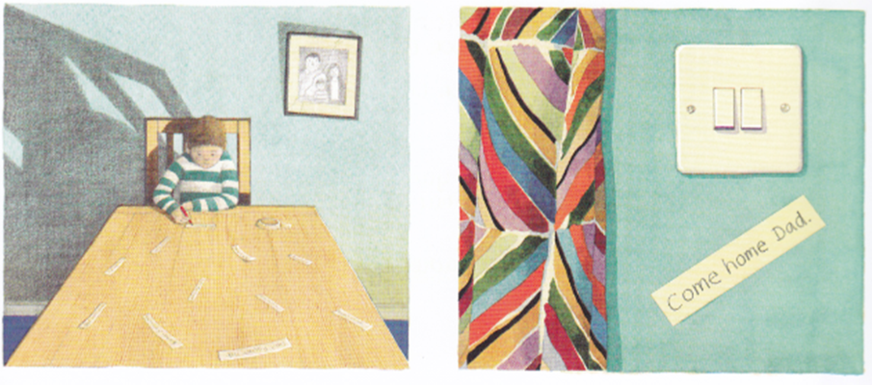
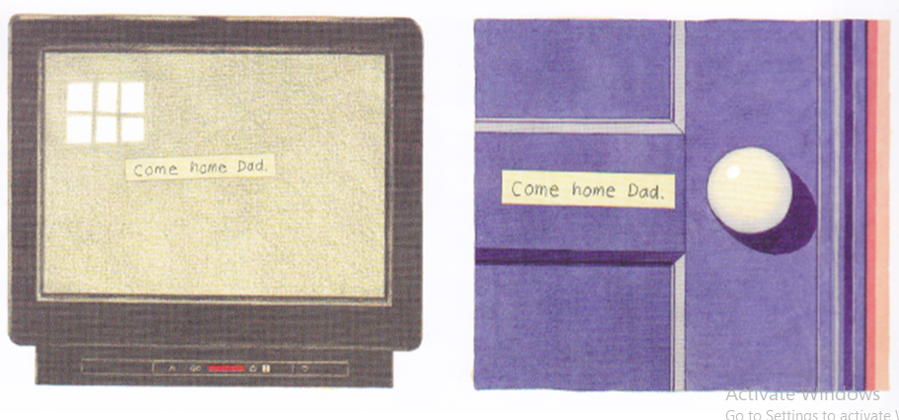

We are going to be writing an email in role as the boy, asking his dad to return home. Focus on the boy's feelings and fears. Think about the storm the night before and how the boy was feeling and then having breakfast without his dad in the morning. You could include your thought and speech bubbles from yesterday.
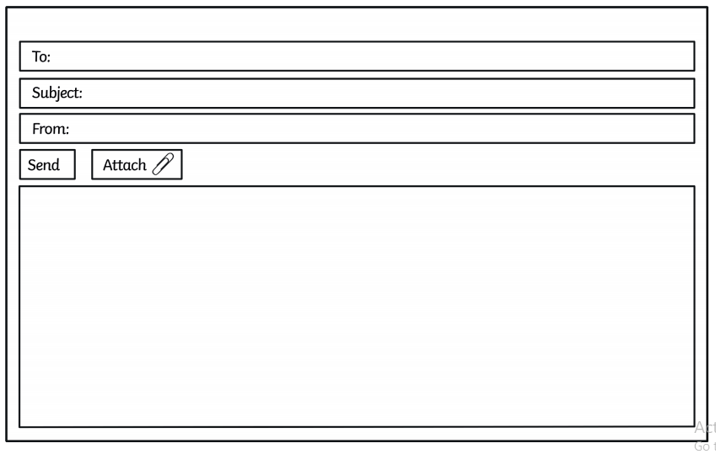

Maybe you could write an email to Mrs Ryall or Mrs Paxton and send it to the home learning email address. See if you can do all these things:
•Can you use the @ key and type an email address?
•Can you type your ideas using a keyboard?
•Can you use the spacebar, back space, enter, shift and arrow keys?

Maths- 45 mins
What number is missing?
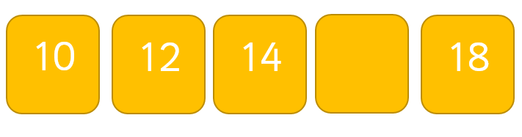
Which is the odd one out? Why?
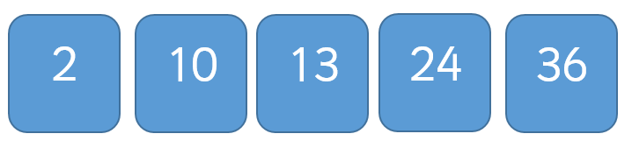

Make a counting by 2s number maze for one of your toys. Draw squares and put your 2s numbers next to each other to make a track. See if anyone in your family can follow the 2s numbers all the way to the end. Here are some examples!
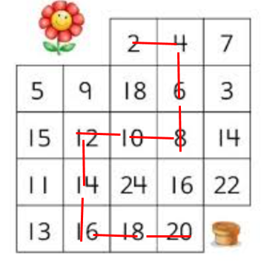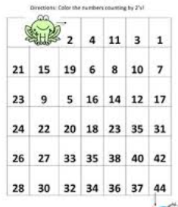
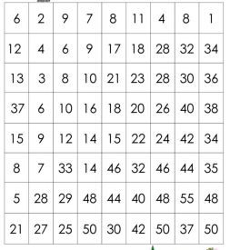

Afternoon learning and activities- about an hour
As it’s Friday afternoon we thought that you could do some activities that were away from screens. Below is a selection of activities that you could do. You can complete one activity or do them all – it's up to you!

Have fun!

Play your favourite game.

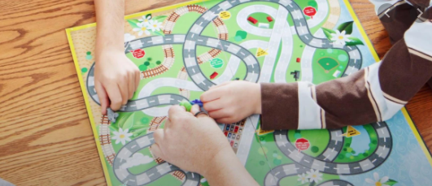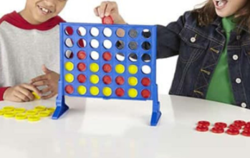

Draw some shadow pictures.
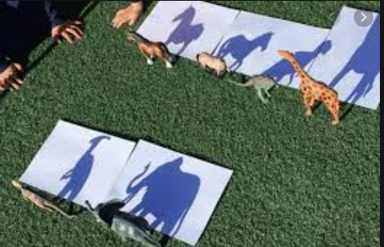

Make a walking paper animal with Mrs Heynes
https://www.youtube.com/watch?v=k2ZINcal0Dg

Make a den.
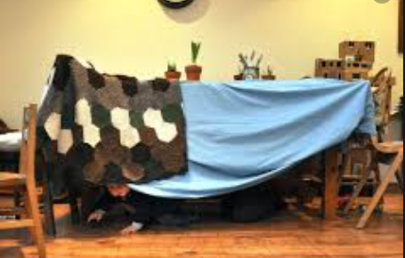

You could read your favourite book in your den!

Draw a picture of anything that you like. It could be of your favourite film, toy, story character.
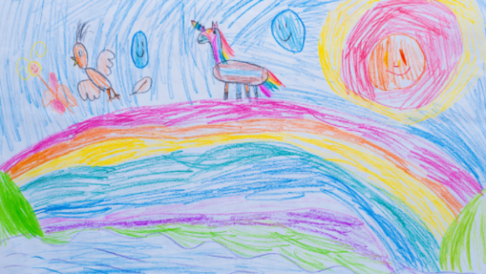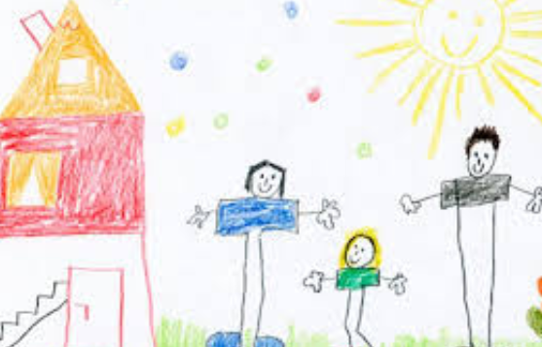

Colour in a picture.
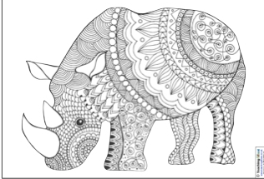
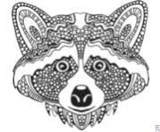

Build something amazing with Lego or building bricks. here are some ideas.


