Year 1 home learning
Monday 1st March
Phonics- 20 mins

This week we are going to be learning about or, aw and au.

Watch this video with Mrs Ryall and see if you can read and sort the words with or and aw and au.

https://www.youtube.com/watch?v=sQsfRojP0Rs

If you want to see more about aw and au you might like to watch this.

https://www.youtube.com/watch?v=GHpyJ5svbgM

Literacy- 45 mins
Practise your curly caterpillar letters.
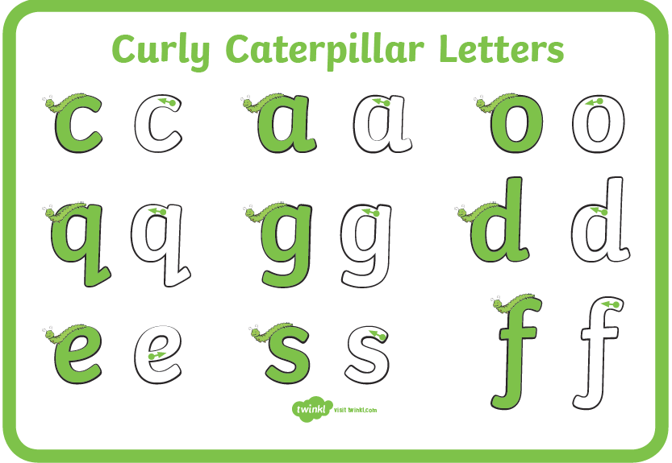
https://www.youtube.com/watch?v=jzuBcoQTC0U

Look carefully at the next picture of Into the Forest story. Do you know of any stories that have a child and a basket like these? Was it a girl or a boy in that story?
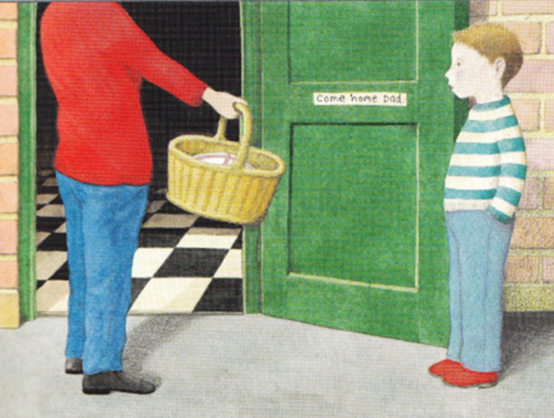
Who was Little Red Riding hood taking her basket too? What did she have in her basket? Maybe you could find out by reading the story or you could watch this story that I found.
https://www.youtube.com/watch?v=0W86K1jBJFI

Who do you think the boy’s basket is for?
Why do you think the boy is taking the basket and not his mum?
What could be inside his basket?

Draw all the things that you think could be in the basket. Can you label them? Try to write some noun phrases for the items:
Chocolate cake
Juicy strawberries

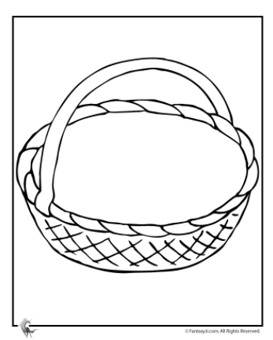

Maths- 45 mins
Which is the odd one out? Why?
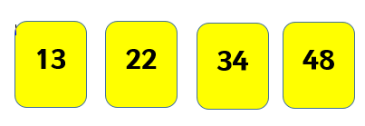

Can you count in 5s?
Watch this video with Mrs Ryall, can you count in 5s with her?

https://www.youtube.com/watch?v=vF6amK-qBiU

Watch the video in the link below. You will need to find some things in your home that you can count in 5s.

https://vimeo.com/507067325

Now you have a go!
You could draw around your hands or do hand prints to help you.
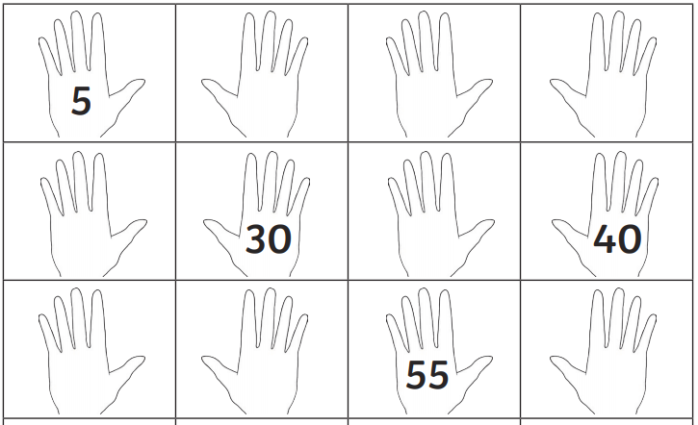

Challenge!
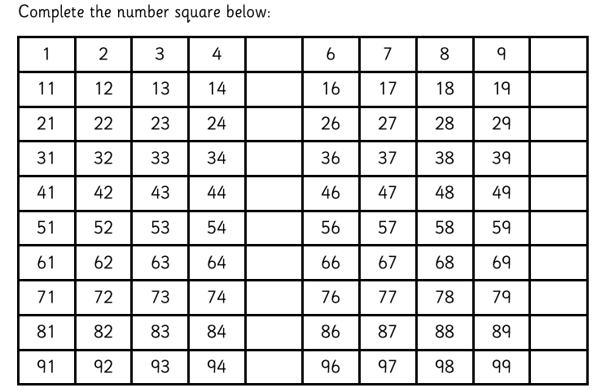

Afternoon learning and activities- about an hour.
We are really looking forward to seeing you all next week, to celebrate we are going to fill the school with rainbows! We’d like you all to make a rainbow to bring with you on your first day back, we’re going to turn our rainbows upside down to make beautiful colourful smiles.

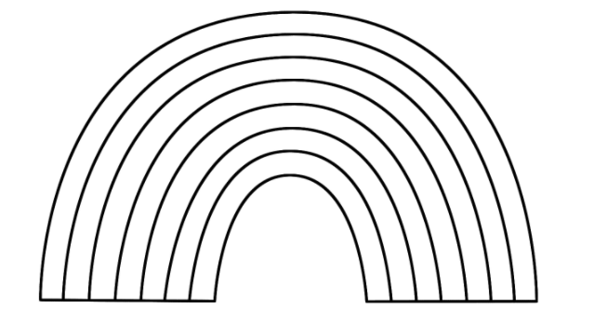
We need you to add a ‘tab’ on each end of your rainbow so we can attach them all together.
You can make your rainbow as big as you like, you can paint, colour, cut and stick- be as creative as you like! We can’t wait to see them.
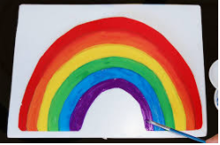
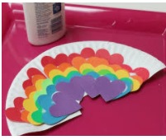
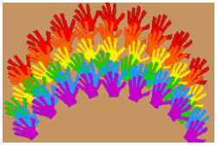
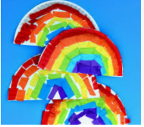

PE
Let’s get moving!
Look for the icon below on the Year 1 home learning page and choose one of your favourites. Cosmic yoga, PE with Joe Wicks, Just Dance or Go Noodle. Make sure you warm up first and then have some fun!



