Year 1 home learning
Wednesday 3rd March

Phonics- 20 mins
It’s time to look around the room and find the real words that I've hidden! There are 8 real words with the aw and au phonemes. Get a piece of paper and write the real words down.

https://www.youtube.com/watch?v=d6OAJh-s2DM

Literacy- 45 mins
Practice writing your one armed robot letters.
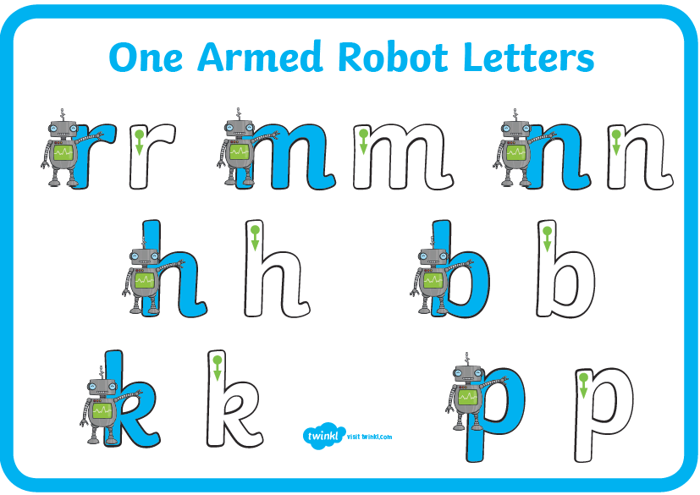

In this picture the boy says ‘for the first time, I chose the quick way’. Why do you think he decided to ignore his mums warning? 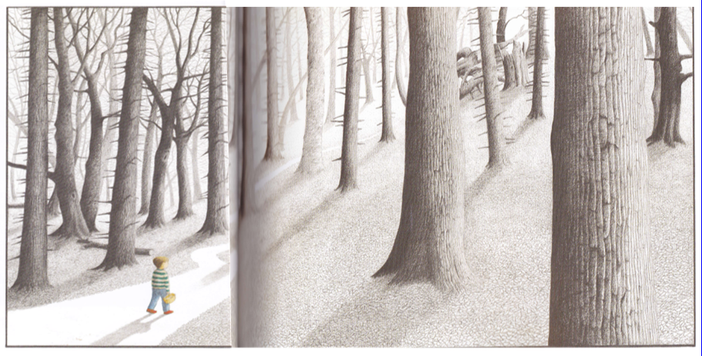

If there were some warning signs, do you think the boy would have gone into the forest? These are some signs that might be displayed.
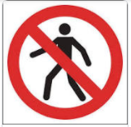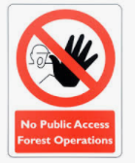

What sign would you put up to warn the boy? Make a warning sign to show some of the dangers that can happen in the forest.

Maths- 45 mins
Watch this song and sing along in fives!
https://www.youtube.com/watch?v=EemjeA2Djjw

Watch the video in the link below. You will need a pencil and some paper to work out some of the problems.

https://vimeo.com/507075995

Now you have a go!
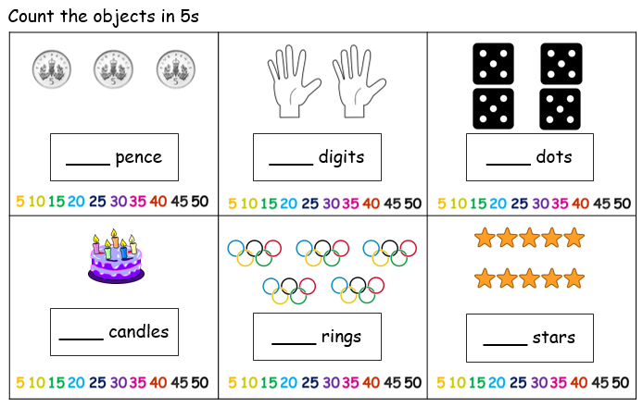

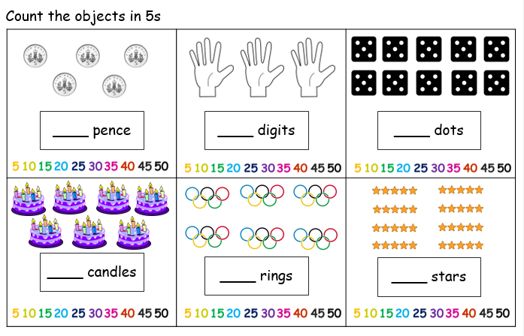

Afternoon learning and activities- about an hour
PSHE
Last week you thought about your strengths, the things that you are good at, the things that make you you! When you grow up you will use your strengths to help you get a job. Different people are suited to different jobs.
Over the next few weeks, we are going to be thinking of different jobs that people in our community might have.

Watch this video and see if you can work out what job each person is doing.
https://www.youtube.com/watch?v=ptZKKmydpc4

We’d like you to think about what job you would like to have when you grow up. Here are some ideas.
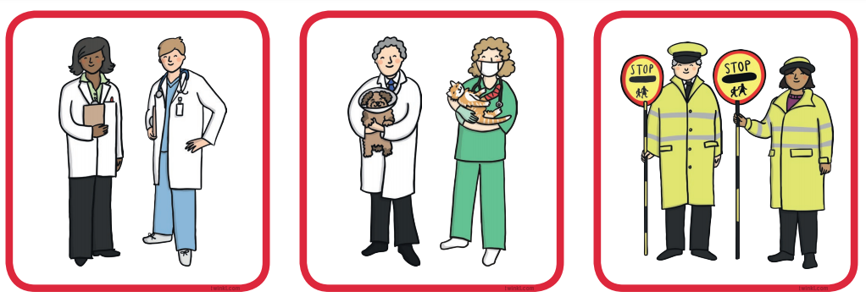
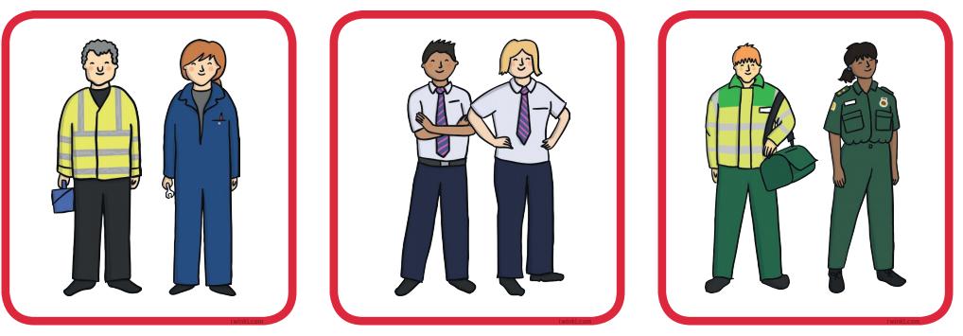
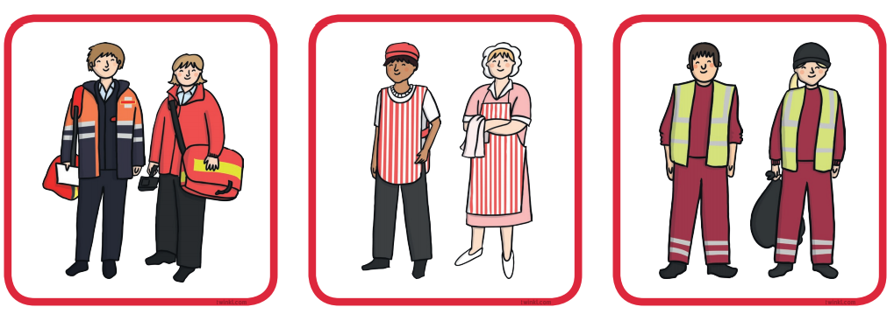
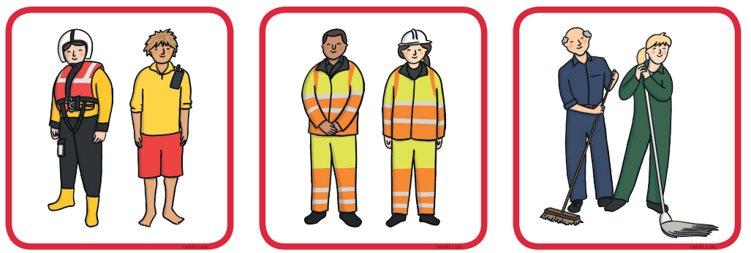

Draw a picture of you doing your job. Why do you think you would be good at this job? Don’t forget to draw any special equipment you might need to do your job.

