Year 1 home learning
Thursday 4th March

Today is world book day. We have thought of some literacy and maths activities to do with traditional fairy tales. We hope you have lots of fun with these activities based around books.

Phonics- 20 mins
Play bingo! Choose 6 out of 8 of the real words that you found yesterday. Write them on your bingo board then watch this video and cross off the words.
Here were the 8 real words that you found.

https://www.youtube.com/watch?v=dKaFL04_SLs

haunt | draw | saw | claw
launch | straw | August | pause

Literacy- 45 mins
Practise writing your zigzag monster letters.

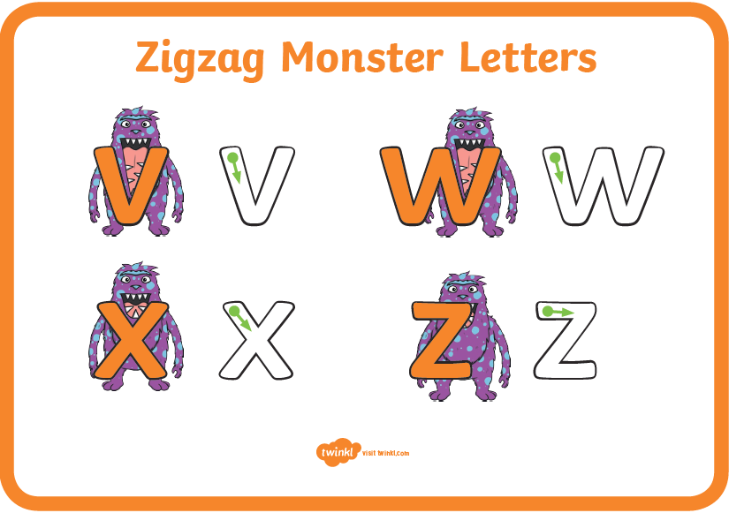

https://www.youtube.com/watch?v=f12e5YrYIXI

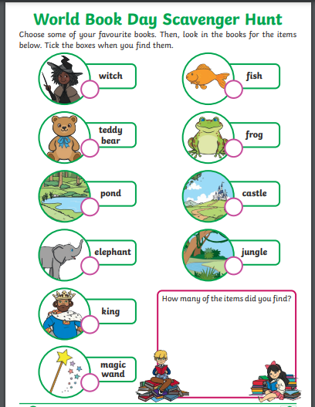

Take a really, really good look at this picture. There are lots of hidden objects that belong to some of our favourite fairy tales that have princesses.
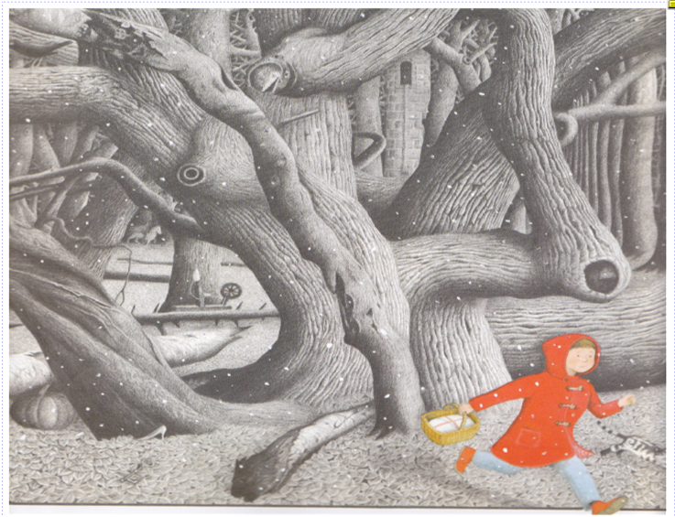

Draw pictures of all the objects that you spot and write down what fairy tale they are from. You might need a magnifying glass to help you find them!!


Maths- 45 mins
We have been learning the new skill of counting in 5s. Take a look at the PowerPoint before you have a go at the tasks below.

Can you help Little Red Riding Hood pack the basket of snacks for Grandma?
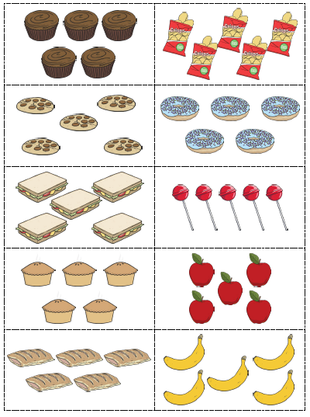

How many snacks does Grandma want?
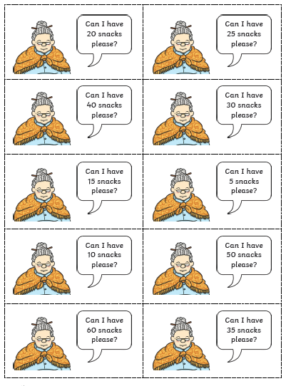

Afternoon learning and activities- about an hour
World Book Day!
World Book Day is recognised by over 100 countries around the world. Its purpose is to encourage reading and a love of books in children. It would be great if you could get involved at home. Here are a few activities you might like to take part in.
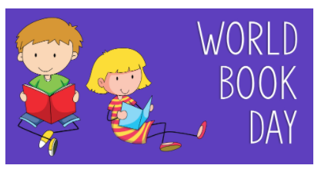

Share your favourite book with someone at home and then talk about:
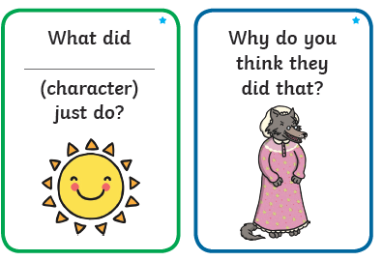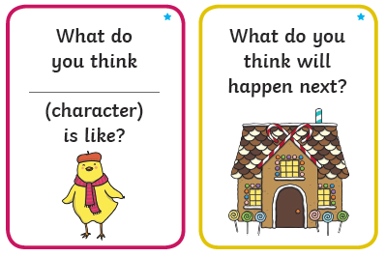

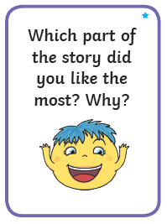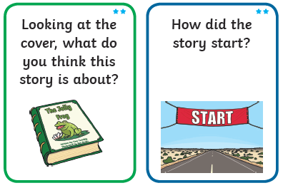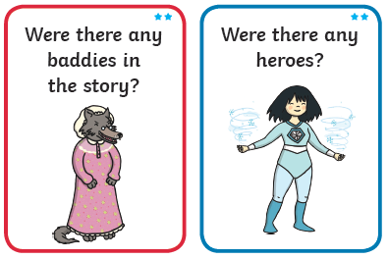

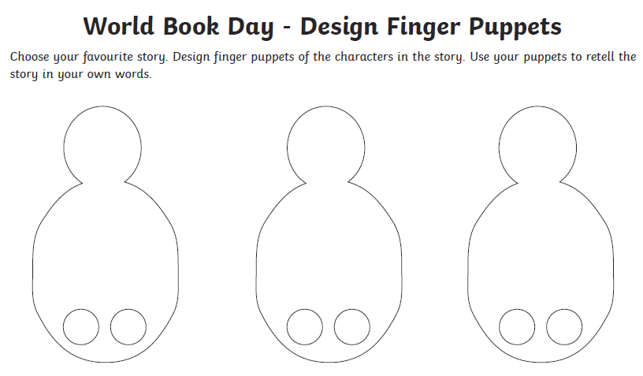

Play ‘guess the character’ with this card on your face game.
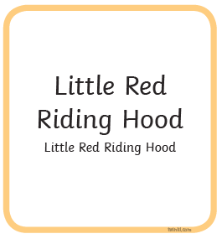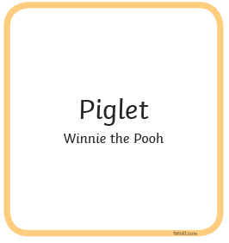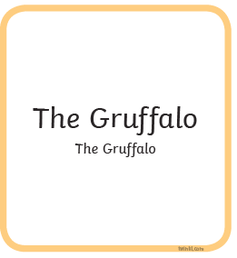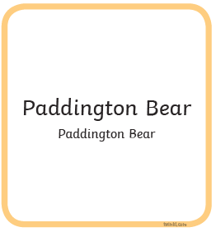
Can you think of any other characters? You could choose the ones from your favourite book!

